SIMON DIEDONG DOMBO UNIVERSITY OF BUSINESS AND INTEGRATED DEVELOPMENT STUDIES

AN IMPROVED HIDE - AND - SEEK AUGMENTATION TECHNIQUE FOR IMAGE CLASSIFICATION USING CONVOLUTIONAL NEURAL NETWORKS

WISDOM NAGAYE

2025

DECLARATION

Student
I, hereby, declare that this dissertation/thesis is the result of my original work and that no part of it has been presented for another degree in this University or elsewhere:
Candidate’s Signature: ............................................................................
Date: .........................................................................................................
Name: Wisdom Nagaye
Supervisors
I, hereby, declare that the preparation and presentation of the dissertation/thesis is by the guidelines on supervision of dissertation/ thesis laid down by the SIMON DIEDONG DOMBO UNIVERSITY OF BUSINESS AND INTEGRATED DEVELOPMENT STUDIES.
Principal Supervisor’s Signature: ...........................................................
Date: .........................................................................................................
Name: Dr. Yaw Afriyie
Co-Supervisor’s Signature: ........................................................
Date: .........................................................................................................
Name: Dr. Sulemana Bankuoru Egala

ABSTRACT
In the field of image recognition, data augmentation plays a pivotal role in enhancing the learning capabilities of computer vision models. However, traditional augmentation techniques such as rotation, cropping, or jittering, may fall short in scenarios where key image regions are occluded in real-world environments. To address this limitation, this study introduces Flip-and-Hide, a novel augmentation strategy that builds upon the established Hide-and-Seek method by incorporating random horizontal flipping alongside strategic occlusion of image patches during training. The Flip-and-Hide approach encourages models to diversify their attention across an image, reducing over-reliance on dominant or easily visible features. By hiding random regions while simultaneously flipping the image, the model is guided to extract generalized and robust feature representations. This technique was empirically evaluated on three benchmark datasets, MNIST, Fashion-MNIST, and CIFAR-10, demonstrating consistent improvements in classification accuracy, particularly on the more visually complex CIFAR-10 dataset. The proposed Flip-and-Hide augmentation technique outperforms the existing Hide-and-Seek method, achieving accuracies of 99%, 94%, and 88% on MNIST, F-MNIST, and CIFAR-10 respectively, compared to 99%, 90%, and 71% obtained by Hide-and-Seek. Beyond its quantitative merits, Flip-and-Hide enhances model resilience in real-world domains like autonomous driving, medical diagnostics, and surveillance by enabling learning from partially obstructed or altered images. A study in the future can examine the scalability, robustness, and generalization of Flip-and-Hide using large datasets and domain-specific tasks, and explore its integration with advanced architectures and adaptive strategies.

ACKNOWLEDGEMENTS
I would like to express my deepest gratitude to my family for their unwavering love, encouragement, and patience throughout this research journey. Their constant support has been the foundation that allowed me to persevere through challenges and celebrate milestones.
I am profoundly thankful to my supervisors, Dr. Yaw Afriyie (main supervisor) and Dr. Sulemana Bankuoru Egala (co-supervisor), whose guidance, insightful feedback, and expertise have shaped and strengthened the quality of this work. Their mentorship has not only enriched my academic growth but also inspired me to strive for excellence.
A special note of appreciation goes to my mentor, Mr. Ophelius Mhaaneeh Yinyeh whose wisdom, encouragement, and personal guidance have been invaluable. Their belief in my potential has motivated me to push boundaries and approach research with curiosity and dedication.
I am also grateful to my colleagues, whose collaboration, discussions, and friendship have made this journey both intellectually rewarding and personally fulfilling. The shared experiences and collective efforts have been an integral part of this achievement.
To all who contributed directly or indirectly to the completion of this research, I extend my heartfelt thanks.

DEDICATION
In loving memory of my parents and my grandfather, Mr. Alexis Domapielle, whose wisdom, love, and sacrifices continue to inspire and guide me.

TABLE OF CONTENTS
Declaration ii
Abstract iii
Acknowledgements iv
Dedication v
List of figures ix
List of tables x
CHAPTER ONE 1
INTRODUCTION 1
1.1 Background of the Study 1
1.2 Problem Statement 5
1.3 Research Questions 6
1.3.1 Main Research Question 6
1.4 Objectives 7
1.6 Chapter Summary 9
CHAPTER TWO 12
LITERATURE REVIEW 12
2.1 Introduction 12
2.2 Foundations of Artificial Intelligence and Computer Vision 12
2.3 Architectural Mechanisms of Convolutional Neural Networks 13
2.4 Geometric Transformations in Image Augmentation: The Role of Image Flipping 14
2.5 Categories and Evolution of Data Augmentation Techniques 17
2.6 Occlusion-Based and Masking Strategies 18
2.7 Foundational Works on Hide-and-Seek Augmentation 19
2.8 Advanced Variants and Enhancements of has 20
2.9 General CNN Data Augmentation Strategies 21
2.10 Modern Data Augmentation Techniques 31
2.11 The Role of Data Augmentation in Generalization 34
2.12 Applications of Convolutional Neural Networks (cnns) 34
2.13 Gaps and Positioning of Flip-and-Hide 36
2.14 Chapter Summary 37
CHAPTER THREE 41
RESEARCH METHODOLOGY 41
3.1 Introduction 41
3.2 Convolutional Neural Networks (cnns) 41
3.2.1 Convolutional Neural Networks for Image Classification with Data Augmentation 41
3.4 Datasets 49
3.5 Preprocessing Steps 51
3.6 Theoretical Background of Data Augmentation 55
3.7 Ethical Consideration in Data Augmentation 59
3.8 Data Augmentation Techniques 62
3.9 Control Group 66
3.10 Convolutional Neural Network Architecture 66
3.10.6 Implementation Details 71
3.10.7 Chapter Summary 75
CHAPTER FOUR 78
RESULTS AND ANALYSIS 78
4.1 Introduction 78
4.2 Experimental Setup 79
4.3 Quantitative Results 81
4.4.4 Test Accuracy and Loss of 91
4.5 Discussion of Results 96
4.5.2 Comparison with Recent Works 101
4.6.1 Operational Mechanisms 104
4.6.2 Semantic Preservation versus Disruption 106
4.6.3 Feature Learning Implications 107
4.6.4 Spatial and Geometric Diversity 108
4.6.5 Summary of Theoretical Insights 110
4.6.8 ROC-AUC Score Analysis 112
CHAPTER FIVE 118
SUMMARY, CONCLUSION AND RECOMMENDATIONS 118
5.1 Introduction 118
5.2 Summary of the Research 118
5.3 Key Findings 119
5.4 Contributions of the Study 120
5.5 Application Scenarios and Use Cases of this Study 121
5.5.1 Medical Diagnostics and Radiological Imaging 121
5.5.2 Autonomous Driving and Intelligent Transport Systems 122
5.5.3 Industrial Inspection and Quality Control 122
5.5.4 Surveillance and Security Analytics 123
5.5.5 Broader Implications Across Computer Vision 123
5.6 Limitations 124
5.7 Recommendations of the Study 125
References 127
Publication of the Author 147

LIST OF FIGURES
Figure 3-1: Architecture of a Convolutional Neural Network (CNN) for Image Classification 44
Figure 4-1: AUC-ROC curves for the improved augmentation techniques 85
Figure 4-2: AUC-ROC curves for Hide-and-Seek (HnS) augmentation techniques 87
Figure 4-3: Training and test accuracies/losses of the improved technique on the datasets 88
Figure 4-4: Training and test accuracies/losses of the traditional (Hide-and-Seek) technique on the datasets 90
Figure 4-5: Precision-Recall of the improved HnS augmentation curves for the datasets 93
Figure 4-6: Confusion matrices for the datasets on the original HnS technique 94
Figure 4-7: Confusion matrices for the datasets on the improved HnS technique (Flip-and-Hide) 95
Figure 4-8: Confusion matrices for the datasets on the Random Erasing (RE) technique 114
Figure 4-9: Confusion matrices for the datasets on the improved HnS technique (Flip-and-Hide) 115

LIST OF TABLES
Table 1: Experimental Groups 68
Table 2:Model Architecture 81
Table 3: Baseline experiment results 83
Table 4: ROC AUC results of Flip-and-Hide and Hide-and-Seek methods 84
Table 5: Classification Report - MNIST - FLIP-HIDE 98
Table 6: Classification Report - FASHION MNIST - FLIP-HIDE 99
Table 7: Classification Report - CIFAR-10 - FLIP-HIDE 100
Table 8: Comparison between baseline classification and Flip-Hide 101
Table 9: Comparison between HnS and Flip-Hide 101
Table 10: Comparison with recent works 103
Table 11: Summary of theoretical insights 111
Table 12: Comparative test accuracy of Random Erasing and Flip-and-Hide techniques 112
Table 13: Macro-Averaged ROC-AUC Scores Random Erasing and Flip-and-Hide techniques 113
Table 14: Summary of comparative insights 116

CHAPTER ONE

INTRODUCTION

Background of the Study
In today’s digitally connected world, visual information is a critical enabler for human–machine communication, data processing, and decision-making. It plays a central role in domains ranging from autonomous vehicle–pedestrian signaling (Fratini, 2024) to multimodal augmented-reality manufacturing workflows (Mageswari & Raja, 2025), adaptive decision-making in cyber-physical systems (Dafflon et al., 2018), and AI-enhanced medical diagnostics (Maghsoudi et al., 2025). Modern systems increasingly rely on visual cues and interfaces to bridge human cognitive processes and machine algorithms, improving interpretability, responsiveness, and trust in automated decision-making processes. At the center of this shift are two deeply connected but historically distinct fields: computer graphics, which focuses on creating synthetic visual content, and computer vision, which empowers machines to understand and analyze visual data. While computer graphics is traditionally concerned with image generation, building scenes, models, and animations from geometric and photometric rules, computer vision is focused on image interpretation, extracting meaning and structure from visual inputs (Tewari et al., 2020) . However, recent technological advancements have begun to blur the boundaries between these domains. Increasingly, the creation and understanding of images are being treated not as separate problems but as two sides of a shared visual intelligence pipeline. This convergence is enabling major strides in areas such as autonomous driving, robotics, augmented reality (AR), and digital healthcare (Solanes et al., 2024). For instance, the use of synthetic images generated through graphics rendering engines has become a powerful tool for training machine learning models, especially in scenarios where real-world labeled data is scarce or costly to obtain. Studies like Render for CNN by Su et al. (2015) demonstrated that synthetic images rendered from 3D models can effectively train convolutional neural networks for viewpoint estimation and object recognition, performing comparably to models trained on real-world data (Su et al., 2015). This strategy, known as synthetic data augmentation, has proven valuable for tasks such as semantic segmentation, 3D scene understanding, and object detection, as shown in works like Tulsiani et al. (2017), which used synthetic multi-view supervision to reconstruct 3D geometry from single 2D images. (Tulsiani et al., 2017)
Conversely, computer vision techniques are now informing the design of graphics systems. Innovations in inverse rendering, where machine learning is used to recover 3D structure, lighting, and materials from 2D images, have opened new doors for photorealistic simulation and content generation. This paradigm reverses the traditional rendering pipeline, allowing machines not just to see, but to understand how visual scenes are composed. For example, neural networks trained for inverse rendering can estimate 3D object shapes, textures, and lighting from a single photograph, a technique with significant implications for mixed-reality applications and virtual modeling (Kato et al., 2018). Further evidence of this merging comes from differentiable rendering frameworks like Neural Mesh Renderer (Kato et al., 2018) and Soft Rasterizer (Liu et al., 2019), which integrate deep learning directly into the graphics pipeline, enabling end-to-end training of models that both generate and interpret images. These systems allow vision and graphics tasks to share gradients and jointly optimize for visual accuracy and semantic understanding (S. Liu et al., 2019).
Convolutional Neural Networks (CNNs) are a specialized type of deep learning model designed to process data that comes in the form of arrays, especially images (Phil Kim, 2017). Originally inspired by the structure of the visual cortex in animals, CNNs have become a foundational tool in the field of artificial intelligence for recognizing and classifying patterns in visual data.
At their core, CNNs operate through a series of convolutional layers that scan an input image using filters (also called kernels). These filters are capable of identifying features such as edges, textures, and shapes (Awasthi et al., 2024). As an image moves through the network, deeper layers capture increasingly complex patterns, starting from simple edges in early layers to full object recognition in the final layers (Lecun et al., 1998). What sets CNNs apart from traditional neural networks is their ability to preserve spatial relationships in data while reducing the number of parameters. Through components like: Convolutional layers (feature extraction), Pooling layers (dimensionality reduction), Activation functions (non-linear decision-making), and fully connected layers (classification), CNNs form a powerful architecture for learning directly from raw pixel data with minimal need for manual feature engineering.
A comprehensive introduction to CNN architectures and their innovations can be found in the landmark paper by Krizhevsky et al. (2012), which introduced AlexNet, a deep CNN that revolutionized image classification by winning the ImageNet Large Scale Visual Recognition Challenge (Krizhevsky et al., 2017).
CNNs are particularly well-suited for computer vision, a field of Artificial Intelligence focused on enabling machines to understand and interpret visual information. In essence, computer vision aims to replicate the visual recognition abilities of humans using computational models, and CNNs have proven to be the most reliable tool for this task (Chen et al., 2024) . Due to their hierarchical structure, CNNs can automatically learn which parts of an image are most important for making predictions. This capability is crucial in various vision tasks, such as Image classification, Object detection, Semantic segmentation, Facial recognition, and Medical image (Elyan et al., 2022) .
The success of CNNs in computer vision can be attributed to their ability to generalize well on visual data. For instance, ResNet, introduced by He et al. (2015), solved the degradation problem in deep networks using residual learning (He et al., 2015). Another significant model is VGGNet (Simonyan & Zisserman, 2014), which showed how increasing convolutional layers could enhance recognition performance (Simonyan & Zisserman, 2015). As computer vision continues to grow, CNNs are being fused with other Artificial Intelligence technologies such as attention mechanisms, transformers, and generative models, further pushing the boundaries of machine perception. Hybrid systems are emerging where CNNs are coupled with synthetic data generated via computer graphics, enabling models to learn from simulated environments and generalize better to real-world conditions. CNNs have become indispensable in numerous real-world applications due to their superior ability to process visual data. One of the most impactful areas of deployment is medical artificial intelligence (AI). CNNs are widely used in analyzing medical images such as radiographs, magnetic resonance imaging (MRI), and histopathology slides. For instance, deep learning models have been trained to detect pneumonia from chest X-rays with accuracy levels comparable to those of experienced radiologists (Rajpurkar et al., 2017). Similarly, Esteva et al. (2017) demonstrated that CNNs can diagnose skin cancer from dermoscopic images with dermatologist-level precision, marking a significant advancement in dermatological diagnostics.
The research underscores the generalizability of Flip-and-Hide across various dataset types. By demonstrating consistent performance improvements on both grayscale and color-rich datasets, the method proves adaptable to tasks with differing levels of visual granularity and semantic density. This versatility highlights Flip-and-Hide’s potential as a scalable and domain-agnostic augmentation strategy, contributing meaningfully to the advancement of training methodologies in deep learning-based computer vision.

Problem Statement
Image augmentation techniques, such as cropping, flipping, and colour jittering, are commonly used to enhance the robustness of CNN models (Kumar et al., 2025). While these traditional methods improve model performance, they have limitations. They fail to introduce significant changes to the image data, which limits their effectiveness in addressing real-world challenges such as occlusion, making the model prone to overfitting. Occlusion-based augmentation is a powerful technique designed to improve the robustness of deep learning models by randomly occluding image regions during training, thereby forcing models to learn from the remaining visible features. The ability of models to make decisions based on this approach enhances generalization and prevents overfitting (Singh et al., 2018). Occlusion-based augmentation techniques have been explored in research, each with its strengths and limitations (Kumar et al., 2025). For instance, the main limitation of most occlusion-based augmentation techniques in CNN-based image classification is that they lack control over the placement and extent of occlusion, which can result in covering important object features essential for accurate recognition and classification. This uncontrolled removal of important visual information can lead to degraded learning, slower convergence, and, in some cases, reduced performance. One notable occlusion-based augmentation method is Random Erasing (RE), introduced by Zhong et al. (2017). This technique randomly selects and removes a rectangular region from an image during training, replacing it with random values or mean pixel values. The goal is to simulate real-world occlusions and prevent CNNs from overfitting to the most salient object (image) parts. Random Erasing (RE) has been shown to improve classification accuracy on datasets like CIFAR-10, CIFAR-100, and ImageNet, as well as enhance robustness in person re-identification tasks. However, because RE erases a single, continuous region in an image, it does not necessarily encourage the network to explore multiple relevant object features. Instead, CNNs may still rely on available dominant object parts. Masking image patches has been utilized in various computer vision tasks, including object localization (Zeiler & Fergus, 2014), self-supervised feature learning (Pathak et al., 2016), semantic segmentation (Hariharan et al., 2014), generating challenging training examples through occlusion for object detection (Wang et al., 2017), and interpreting what a convolutional neural network (CNN) has learned. Specifically for object localization, studies such as “Self-taught object localization with deep networks” (Bazzani et al., 2016), and “Visualizing and understanding convolutional networks” (Zeiler & Fergus, 2014) train a CNN for image classification and then identify regions in the image whose masking causes a significant drop in classification accuracy. However, because these methods apply masking only during the testing phase and not during training, the model tends to rely solely on the most distinctive parts of objects. This study, therefore, seeks to introduce an enhanced approach and also improve image quality that introduces masking during training, allowing the model to learn to recognize objects even from less distinctive regions.

Research Questions

Main Research Question
The main research question is, how can the traditional Hide-and-Seek augmentation technique be enhanced through horizontal flipping to improve CNN classification accuracy and generalization on datasets such as MNIST, F-MNIST, and CIFAR-10? The specific questions of the study include;
- How can the accuracy of the traditional Hide-and-Seek augmentation technique be improved for CNNs image classification on complex datasets such as CIFAR-10, MNIST and F-MNIST?
- How can the traditional augmentation technique be improved to influence the learning behavior of CNN models across benchmark datasets such as MNIST, F-MNIST, and CIFAR-10?
- How does the proposed model perform against the state-of-the-art schemes?

Objectives

Main Objective
This research aims to enhance the traditional Hide-and-Seek augmentation technique by integrating horizontal flipping and to evaluate its impact on improving convolutional neural network (CNN) classification accuracy and generalization across benchmark image datasets including MNIST, Fashion-MNIST, and CIFAR-10.

Specific Objectives
The specific objectives of the study are to:
- Propose a model that would improve the accuracy of the traditional Hide-and-Seek augmentation technique on benchmark datasets such as MNIST, FMNIST and CIFAR-10.
- Enhance the traditional augmentation technique in order to influence and improve the learning behavior of CNN models across benchmark datasets such as MNIST, F-MNIST, and CIFAR-10.
- Compare the performance of the proposed technique against the state-of-the-art schemes.

Significance of the Study
In everyday life, we often see objects that are partially blocked, hidden behind an object, or viewed from unusual angles. For example, a car might be partly hidden behind a tree, or someone’s face may only be half-visible in an image. While humans can still recognize these objects with ease, it is much harder for computer systems to do the same.
To help computers learn to recognize such images more accurately, scientists use a method called image augmentation, which means slightly altering images during training so that the computer gets better at recognizing patterns. One powerful augmentation method is called Hide-and-Seek. In this technique, random parts of an image are hidden during training, forcing the computer model to learn how to “guess” the object even when pieces are missing. This mimics real-world situations where images are not perfect.
Another helpful technique is image flipping, where an image is turned around, like a mirror image. This helps the model recognize objects from different directions or perspectives. This research looks into what happens when both techniques, Hide-and-Seek and flipping, are combined. Specifically, it compares two cases: flipping the image before hiding parts of it, versus only using Hide-and-Seek on its own. The goal is to see which method helps a computer recognize images better.
This research is significant because improving how CNN models learn from imperfect images directly benefits computer vision systems deployed in real-world environments, where objects are rarely fully visible. The findings can serve as a practical guide for machine learning researchers, computer vision engineers, and students, helping them design more robust training pipelines without requiring complex or computationally expensive methods. Applications such as security surveillance, autonomous driving, healthcare diagnostics, and mobile image recognition can all benefit from models that remain accurate even when viewing partially obstructed objects.

Chapter Summary
This chapter introduces the foundational concepts and motivation behind the study. It begins by outlining the role of Artificial Intelligence (AI), particularly Convolutional Neural Networks (CNNs), in enabling machines to perform human-like visual tasks such as image classification. CNNs extract hierarchical image features through layered processing and use activation functions to determine which features are important for decision-making.
The study emphasizes the importance of data augmentation in training robust CNNs that can generalize well to real-world scenarios, where objects may be occluded, partially visible, or appear in different orientations. Traditional augmentation techniques such as cropping, flipping, and jittering improve model performance but often fall short in replicating real-world challenges like occlusion. To overcome these limitations, occlusion-based techniques like Random Erasing (RE) and Hide-and-Seek (HaS) have been introduced, which mask parts of the image to force the model to learn from visible features. However, these techniques have limitations in scope and effectiveness, particularly on larger datasets or when relying heavily on distinctive object parts.
This research proposes an enhanced approach called the Flip-and-Hide technique, which combines image flipping with Hide-and-Seek augmentation. Flipping the image (horizontally or vertically) and then hiding random regions during training forces CNNs to focus on different spatial features, thus improving generalization and reducing overfitting. The technique is evaluated using benchmark datasets such as MNIST, Fashion MNIST, and CIFAR-10.
Finally, the significance of the study lies in its contribution to real-world computer vision applications, where images are often incomplete or seen from unusual perspectives. By helping CNNs learn from such imperfect inputs, the proposed technique aims to improve model reliability and adaptability in complex environments.
  - Organization of the Study
This study is presented in five chapters, which can be grouped into three main themes. The first theme is the context and foundation of the research, covered in Chapter 1. This chapter sets the stage by presenting the background of the study, the problem statement, and the key research questions that guide the investigation. It also outlines the objectives of the work and gives readers an understanding of why the study matters. The chapter ends with a brief summary, offering a smooth transition to the next section.
Chapter 2 serves as the literature review, exploring the evolution of data augmentation techniques, with a particular focus on occlusion-based and masking strategies. It examines foundational work such as the Hide-and-Seek method, its advanced variants, and the role of general CNN-based augmentation strategies in improving model generalization. The chapter concludes by identifying research gaps and explaining the positioning of the proposed Flip-and-Hide technique. Chapter 3 details the research methodology, beginning with an introduction to Convolutional Neural Networks (CNNs), the datasets used, and the preprocessing steps. It also covers the theoretical and ethical considerations of data augmentation, describes the augmentation techniques implemented, and presents the CNN architecture and implementation details.
Chapter 4 introduces the experimental setup and presents both the quantitative results and a detailed analysis. It compares the study’s findings with recent works, explores operational mechanisms, discusses semantic preservation versus disruption, and evaluates performance through metrics such as ROC-AUC scores. Chapter 5 summarizes the research, presents the key findings, and outlines the contributions of the study. It also discusses application scenarios in areas such as medical imaging, autonomous driving, industrial quality control, and security analytics. The chapter ends with the study’s limitations, recommendations for future research, and final remarks.

CHAPTER TWO

LITERATURE REVIEW

Introduction
Data augmentation has emerged as an essential strategy in the field of deep learning, particularly in image classification tasks where dataset size and diversity significantly influence model performance. The limited availability of annotated data often hampers the training of deep neural networks, leading to overfitting and reduced generalization, especially when learning from small sample sets. As a response, a broad range of data augmentation techniques has been developed to synthetically increase dataset variability and model robustness without requiring additional data collection efforts. This chapter reviews the current state of data augmentation, focusing on methods applied to unstructured image data, and positions the present study, the Flip-and-Hide method within the evolving landscape of augmentation strategies.

Foundations of Artificial Intelligence and Computer Vision
Artificial Intelligence (AI) is when computers are designed to think and learn like humans and help machines to carry out tasks that usually require human intelligence, like understanding speech, recognizing images, and making decisions (Mian et al., 2024). AI has revolutionized various fields, enabling machines to perform complex tasks that traditionally required human intelligence. It encompasses a wide range of techniques, including machine learning and deep learning, which allow computers to process vast amounts of data, recognize patterns, and make informed decisions (Mian et al., 2024). In recent years, AI has significantly impacted areas such as natural language processing, robotics, and computer vision (Goodfellow et al., 2016). CNNs, being an AI model, can learn to recognize and classify objects or images, which is a way machines simulate human vision. One of the most important applications of AI is in computer vision, where machines interpret and analyze visual information. A key task in computer vision is image classification, which involves categorizing images into predefined classes (Saxena et al., 2023) and performing convolution to extract important features for prediction. Image classification is vital in real-world applications (LeCun et al., 2018). Machine learning, a subset of AI, has emerged as a game changer in computer vision. It involves training models on large datasets to identify patterns and make accurate predictions (Mulla, 2020). Deep learning, particularly Convolutional Neural Networks (CNNs), have become the dominant approach for image classification tasks due to its ability to automatically extract features from images (Hossain & Sajib, 2019). CNNs are deep neural networks that consist of multiple layers arranged sequentially to extract image features hierarchically. As an image passes through these layers, essential features such as edges, textures, and patterns are detected, making classification more effective (Luo, 2021).

Architectural Mechanisms of Convolutional Neural Networks
CNN processes images by first turning them into pixel values. Depending on the image size and color depth, the image can have two or three dimensions (height × width × color channels) (Raghav, 2019). CNNs employ localized receptive fields, commonly referred to as filters or kernels, which are systematically convolved across input images in a sliding window fashion. These filters are designed to capture spatial hierarchies by learning to detect meaningful patterns such as edges, textures, and more abstract features as the network deepens. Each filter operates on a small region—referred to as a patch—of the input image at a time, enabling the model to recognize patterns that are grouped in images. By sharing filter weights across different spatial locations, CNNs achieve translational invariance and significantly reduce the number of parameters compared to fully connected architectures (Goodfellow et al., 2016). This sliding mechanism, combined with learned feature maps, allows CNNs to extract increasingly complex representations of visual data, which are critical for tasks such as image classification, object detection, and semantic segmentation. As a result, convolutional architectures have become the de facto standard for vision-based deep learning applications due to their efficiency, scalability, and interpretability (Krizhevsky et al., 2017).
This happens in many layers, with each layer learning more complex features. Eventually, CNN uses these learned features to guess what the image shows, like a cat, a shoe, or aeroplane. A key part of this process is the activation function, which decides which features are important enough to pass forward. In simple terms, an activation function is like a decision-maker inside a neural network. If a feature is strong (above a learned threshold), the neuron gets “activated” meaning it becomes part of the decision-making. If not, it gets ignored (Amini, 2023). Due to its role in controlling information flow within the network, the activation function is sometimes referred to as a transfer function (Hagan et al., 1996).

Geometric Transformations in Image Augmentation: The Role of Image Flipping
Geometric transformations, which are arguably the most intuitive. These involve altering the spatial structure of images through methods like flipping, rotation, cropping, scaling, and translating. These operations help models generalize better by simulating how an object might appear from different angles or positions (Buslaev et al., 2020). This research will delve more into image flipping amongst other transformative augmentation techniques. At its core, image flipping is a simple yet powerful data augmentation technique in computer vision. It involves reversing an image across a specific axis—either horizontally (left to right) or vertically (up to down). This transformation does not alter the content of the image but changes its orientation, mimicking how objects might appear in the real world from different angles. The reflection of an object in a mirror is a flipping effect. The same object is seen, but with left and right reversed. For a neural network, that mirrored version is essentially a new sample, allowing it to learn invariant features regardless of the object's orientation. Image flipping is very important for CNN models, it adds variety to dataset. CNNs are data-hungry. They perform best when exposed to vast and varied visual representations. But collecting thousands of real-world images in all possible orientations is expensive and often impractical (Sengupta et al., 2023). This is where image flipping becomes invaluable. During the training of convolutional neural networks (CNNs), applying image flipping as a data augmentation technique serves as an efficient and practical strategy to enhance dataset variability. Rather than collecting new images—which can be resource-intensive and time-consuming—flipping existing samples horizontally or vertically increases the effective size of the training set. This synthetic expansion introduces orientation diversity, providing the model with alternative views of the same class labels without altering their semantic meaning (Shorten & Khoshgoftaar, 2019).
Furthermore, image flipping promotes better generalization by mitigating the risk of overfitting to a particular orientation or spatial configuration (Taylor & Nitschke, 2017). By exposing the model to mirrored versions of training data, it learns to recognize essential features regardless of their position or direction, thereby developing a more robust feature representation. This augmentation also enables the model to better approximate real-world visual scenarios, where objects may appear flipped due to changes in camera angles, observer viewpoints, or reflective surfaces such as mirrors. As a result, models trained with flipped images exhibit improved performance and adaptability in dynamic and unconstrained environments. Incorporating image flipping during training enables Convolutional Neural Networks (CNNs) to develop translation and orientation-invariant feature representations, a critical property for reliable image classification. By encountering objects in flipped orientations, the network becomes less sensitive to spatial positioning, learning to identify relevant features—such as textures, contours, and edges—regardless of their directional alignment (Shen et al., 2019).
This augmentation strategy also enhances the model’s ability to detect visual primitives such as patterns and shapes independent of their orientation. For instance, a flipped image of an animal or vehicle still contains the same structural components, and by training on such variations, CNNs learn to generalize more effectively to unseen inputs. Additionally, image flipping reduces the model's bias toward dominant patterns that may be overrepresented in a particular orientation within the training dataset. This encourages the network to consider a broader distribution of visual features rather than overfitting to the most frequently encountered perspectives.
Moreover, the use of flipping contributes to greater robustness under real-world conditions, where input images may suffer from various deformations, partial occlusions, or changes in viewpoint. By training on flipped variants, the model is better equipped to handle spatial inconsistencies and environmental variability, ultimately improving its performance across diverse deployment scenarios. The role of image flipping as a vital component of data augmentation in deep learning has been emphasized across several seminal works in computer vision. Krizhevsky et al. (2012), in their pioneering study on large-scale visual recognition using deep convolutional neural networks (AlexNet), were among the first to demonstrate the effectiveness of horizontal flipping in enhancing model performance. Their work illustrated how simple transformations could significantly increase the diversity of training data and improve the network’s ability to generalize across varying image orientations.
Building on this foundation, Simonyan and Zisserman (2015) incorporated random flipping into the training pipeline of their deep convolutional architecture (VGGNet), reaffirming its importance in achieving high accuracy on benchmark datasets. Their model achieved notable success in classification and localization tasks, attributing part of its robustness to such augmentation strategies. Furthermore, Yamashita et al. (2018) extended the application of image flipping into the medical domain, where they highlighted its utility in making CNNs invariant to patient positioning in radiological imaging. In this context, flipping played a critical role in enhancing the model’s consistency and accuracy when processing images taken from different anatomical orientations. Image flipping offers a range of practical and computational advantages that make it an attractive augmentation strategy in deep learning workflows. One of its primary strengths lies in its simplicity—it requires no modification to the neural network architecture and can be implemented with minimal configuration. As a result, it imposes no additional cost in terms of data collection or manual labeling. Furthermore, image flipping effectively increases training data diversity, which leads to improved generalization across unseen samples and reduces the risk of overfitting. Given that the transformation involves a straightforward pixel-wise reversal, the operation also incurs minimal computational overhead, making it suitable for both low-resource environments and large-scale training pipelines.

Categories and Evolution of Data Augmentation Techniques
Bayer et al. (2022) categorized data augmentation into three main types: image, text, and structured data augmentation. This study is specifically concerned with image data augmentation, which has been foundational to deep learning progress in computer vision. Traditional augmentation techniques primarily involve numerical image transformations, including geometric manipulations (e.g., rotation, flipping, cropping), color modifications (e.g., brightness and contrast adjustments), and pixel-level noise addition. These methods have demonstrated effectiveness in reducing overfitting by exposing models to varied image representations (Krizhevsky et al., 2012; Simonyan & Zisserman, 2015).
Over time, augmentation strategies evolved beyond simple transformations. As noted by Chen et al. (2021) and Caruccio et al. (2022), more recent approaches leverage machine learning-based augmentation, which adapts transformations based on data characteristics or learned policies. Examples include AutoAugment, RandAugment, and adversarial training schemes, which explore augmentation policies through reinforcement learning or search algorithms. These approaches aim to optimize augmentation strategies automatically, but often at high computational cost.

Occlusion-Based and Masking Strategies
Traditional transformations, though effective, typically preserve the entire object, allowing the model to rely heavily on highly discriminative regions. This has led to the rise of occlusion-based augmentations, which aim to force CNNs to generalize better by partially obstructing key visual features. Techniques such as Hide-and-Seek and Random Erasing introduce region masking to simulate real-world occlusions and encourage the network to extract peripheral or secondary features for classification (Devillers & Lefort, 2022). Advanced variations of this idea have further refined how occlusions are applied. For example, Zhang et al. (2023) proposed Random Walk-based Erasing (RWE), which distributes erased pixels across the image using random walks rather than fixed rectangular regions. This method retains more of the image’s original structure while still enforcing feature learning beyond dominant visual cues. A different approach, layer masking, introduced by Balasubramanian & Feizi (2023), applies occlusion not on the input but within the intermediate activation maps. This allows the network to selectively process visible features without bias introduced by occlusion shape or color. The authors showed that traditional masking strategies could leak class information through mask geometry, while their approach reduced such biases and improved model interpretability.

Foundational Works on Hide-and-Seek Augmentation
Singh et al. (2018) first introduced the Hide-and-Seek (HaS) augmentation technique to force CNNs to learn object features more holistically by randomly masking out grid-based patches in input images. Their work demonstrated significant improvements in both weakly supervised object localization and fully supervised classification tasks by encouraging the model to consider multiple discriminative regions instead of fixating on the most prominent features. However, the randomness of the occlusion could also suppress critical object regions, potentially hindering fine-grained classification accuracy (Singh, Yu, et al., 2018).
In a later study, Fong and Vedaldi (2019) evaluated occlusion-based augmentation as a general strategy, where Hide-and-Seek was benchmarked alongside custom-designed perturbations. Their analysis on ImageNet showed that introducing controlled occlusion improves classification robustness. However, they also pointed out that HaS lacks semantic awareness, meaning the model might focus on occluded noise instead of learning from useful background-context interactions. Their work laid the groundwork for saliency-guided occlusion improvements (Ruth Fong & Andrea Vedaldi, 2019).
Hrga and Ivašić-Kos (2022) proposed a hybrid augmentation combining Hide-and-Seek with Cutout for face image classification. Their experiments demonstrated that this combination helped prevent CNNs from overfitting to specific facial features, thereby improving performance on small-sample datasets. This work serves as an early example of extending HaS through compositional strategies, though the blending remains heuristic rather than guided by object relevance or saliency maps (Hrga & Ivasic-Kos, 2022). Tebelmann et al. (2023) explored the use of Hide-and-Seek variants in the context of side-channel leakage attribution, analyzing CNN interpretability under masked inputs. Their experimental framework demonstrated that improved HaS-based masking can enhance not only classification but also attribution analysis, showing broader utility in explainability and security-sensitive domains (Schamberger et al., 2023).

Advanced Variants and Enhancements of HaS
Yang et al. (2023) introduced AdvMask, which integrates adversarial perturbations into augmentation by replacing patches in a manner inspired by Hide-and-Seek. The innovation here is the use of sparse adversarial attacks to augment training images, guiding the occlusion toward critical feature zones. Compared to standard HaS, AdvMask preserved classification accuracy while enhancing model robustness to adversarial and real-world perturbations (Suorong Yang et al., 2023). Xie et al. (2021) proposed Cut-Thumbnail, an augmentation strategy that randomly replaces small patches with downsized thumbnails of other images. While not directly derived from HaS, Cut-Thumbnail shares the concept of spatial content disruption. Their results on fine-grained classification tasks showed outperforming HaS, especially due to better preservation of global semantic information. This indicates a trend toward semantically aware occlusion as a crucial advancement (T. Xie et al., 2021).
Kumar et al. (2023) presented RSMDA (Random Slice Mixing Data Augmentation) as an upgrade over HaS, where instead of masking, the method slices and mixes image sections within the same sample. This creates structural variation without occlusion. Their comparisons showed RSMDA consistently outperformed HaS and GridMask in terms of classification accuracy across CIFAR and ImageNet subsets. The method preserves object integrity, addressing HaS's primary shortcoming (Kumar et al., 2023). Zhao et al. (2023) introduced SRK-Augment (Self-Replacement and Region-Keeping), a method that segments discriminative regions and replaces non-discriminative parts, enhancing upon HaS by preserving class-relevant regions explicitly. This saliency-based logic aligns closely with the conceptual motivation for improved HaS variants, like KeepOriginalAugment. Their ablation studies show that learning from non-replaced background patches improves generalization (Zhao et al., 2023). Finally, Kumar et al. (2024) proposed KeepOriginalAugment, an advanced augmentation strategy that expands upon Hide-and-Seek by separating and preserving the salient object region. Unlike HaS, which randomly masks grid zones, KeepOriginalAugment uses semantic placement of object regions into non-salient backgrounds with optional transformations applied. Initial experiments report improved performance on CIFAR and Tiny-ImageNet, offering a robust balance between data diversity and semantic integrity (Kumar et al., 2024).

General CNN Data Augmentation Strategies
Farhan Bin Jashim et al. (2025) explored the application of oversampling and advanced data augmentation strategies in enhancing the performance of a hybrid CNN-ViT (Vision Transformer) model for prostate cancer classification in MRI images. Their augmentation pipeline included both geometric (rotation, scaling) and photometric (intensity shift) techniques. Notably, the augmentation improved model robustness on limited medical datasets, showing that even in clinical imaging, DA plays a crucial role in reducing overfitting. The study illustrates how CNN-based pipelines can be amplified when combined with augmentation-aware transformer models (Jashim et al., 2025).
Haque and Meem (2025) addressed few-shot learning in plant disease recognition using CNNs supplemented by tailored data augmentation. Their augmentation strategy emphasized maintaining biological features by applying controlled warping and filtering, ensuring the network learned disease-specific textures without over-distorting the images. Their results affirm that augmentation is indispensable in domains with limited annotated data, and that strategy must be carefully aligned with the task’s semantic structure (Haque & Meem, 2025). Jain and Peddi (2025) developed a GoogLeNet CNN model for multi-label prediction of age, gender, and facial expression, and systematically evaluated the impact of multiple data augmentation strategies. They found that augmentations such as zooming, shifting, and horizontal flipping were particularly effective for facial expression recognition. The study concluded that augmentation should be adaptive to the feature scale—coarse attributes (age) may benefit from global transforms, while fine features (expression) benefit from local ones (Jain & Peddi, 2023).
Rawat et al. (2025) proposed a GAN-enhanced Tswin-F CNN model for leaf disease classification, integrating DCGAN-generated synthetic samples with classical augmentation. Their hybrid pipeline combined multiscale feature fusion with augmented training data, which significantly outperformed traditional CNN architectures trained on raw images. This illustrates that synthetic augmentation using deep generative models is an effective strategy in complex, texture-rich datasets like plant pathology (Rawat et al., 2025). Liu (2024) examined flower species classification using CNNs under multiple augmentation settings. Her work emphasized the effectiveness of random cropping, Gaussian blur, and color inversion for floral datasets, which are often color and symmetry sensitive. Liu’s study demonstrated that augmentation techniques should be dataset-specific, and that careful pairing of augmentation parameters with feature importance can drive meaningful gains in model generalization (Y. Liu, 2024).
Kanavos et al. (2025) proposed architectural and regularization techniques for a CNN designed from scratch to classify cats vs. dogs. Their data augmentation component used elastic transformations and affine warping, and results indicated a notable improvement in validation accuracy. This research supports the view that combining low-level transformations with architectural regularization (e.g., dropout, batch normalization) yields synergistic benefits (Kanavos et al., 2025.). Kulkarni et al. (2025) developed a CycleGAN-driven Multi-Image Segmentation Framework (MISF) for classifying coffee plant diseases. Unlike conventional DA methods, their model generated disease-specific synthetic leaves and merged them with traditional transformations. This highlights a shift toward task-aware synthetic augmentation in agriculture and beyond, where domain characteristics influence both data generation and model design (Kulkarni et al., 2025).
Milani et al. (2025) employed deep CNNs with handcrafted augmentation pipelines for classifying midpalatal suture maturation stages from 3D CBCT images. Their research used scale-preserving augmentations like adaptive histogram equalization and windowing. They concluded that task-relevant preprocessing paired with context-sensitive augmentations leads to superior performance, particularly for high-resolution biomedical images (Milani et al., 2025). Li (2025) explored lightweight CNNs on CIFAR-10, incorporating mixed augmentation strategies to reduce overfitting. Augmentations included color jitter, channel shuffle, and synthetic minority oversampling. The study emphasized that lightweight models benefit significantly from strong DA, suggesting that computational simplicity can be compensated by sophisticated training data variety (Li, 2025).
Guastella and Pisciotta (2025) studied CNN performance in identifying mud extrusions from UAV imagery. Their comparative analysis of classical (flip, rotate) vs. adversarial (noise-based) augmentation strategies found that blending traditional and adversarial transformations yields more robust CNNs in real-world noisy environments. This reflects growing interest in robustness-oriented augmentation, especially in geospatial and remote sensing domains (Guastella et al., 2025). Tonmoy et al. (2025) proposed AgriBuddy, an AI-driven system combining CNN-based vision models with retrieval-augmented generation (RAG) for Bangladeshi agriculture. The system employed classic data augmentation techniques such as flipping and rotation to increase model robustness across varied field conditions. Although augmentation was not the core innovation, the study emphasized its necessity in agricultural settings where lighting, camera angle, and plant orientation vary significantly. The paper supports the principle that even basic augmentation has real-world impact on generalization in CNNs (Tonmoy et al., 2025.).
Dheeraj Chowdary (2025) focused on CNN-based classification of canine heart size from X-ray images. The study incorporated data augmentation (rotation, zoom, shear) alongside dropout and regularization. Results demonstrated notable gains in model generalization and reduced variance, especially for underrepresented heart size categories. This work adds evidence to the view that augmentation is indispensable in class-imbalanced datasets, particularly in the veterinary medical domain (Chowdary, 2025). Jayaprakash et al. (2024) applied Mask R-CNN on LiDAR-derived terrain data for slope classification. The team used data augmentation to simulate different lighting and orientation scenarios for geological formations. This paper underscores the importance of domain-specific augmentation: in this case, geospatial data benefited from 3D projection distortions that mimicked real-world terrain variability (Jayaprakash et al., 2024).
Rawat et al. (2025) advanced the state of plant disease classification through DCGAN-augmented CNNs. Their “Tswin-F” network integrates attention mechanisms and multi-scale feature fusion. The key insight is the use of GAN-generated samples to supplement rare disease types, outperforming classic CNNs in Tomato Leaf Disease datasets. This supports the argument that GAN-based synthetic augmentation is invaluable for class-scarce image domains (Rawat et al., 2025).
Nasir et al. (2025) explored breast cancer detection using CNNs and outlined the role of augmentation in medical image learning. Augmentations such as elastic distortion, flipping, and brightness adjustment led to consistent improvements across training folds. Importantly, their study compared CNNs trained with and without augmentation, demonstrating up to 11% increase in AUC when augmented data was used (Nasir et al., 2025). Ahmad et al. (2025) detailed the use of data augmentation in a CNN system for scene generation and classification. Their research used a combination of handcrafted augmentations (like jitter and hue rotation) and learned augmentations through policy search. Although basic in model design, the experiment underlines that automated and manual augmentations can co-exist to boost CNN training efficiency, especially in dynamic environments (Ahmad et al., 2025).
Un and Choi (2025) tackled deep watermarking using a Swin Transformer backbone but included CNN-based comparisons for image classification robustness. Their analysis revealed that data augmentation helped the CNN models resist overfitting and adversarial degradation, including geometric tampering and pixel noise. Their inclusion of watermarking resilience suggests a novel use of augmentation beyond accuracy: security and traceability (Un & Choi, 2025).
Kim et al. (2025) critically assessed COVID-19 detection from X-ray images using CNNs and emphasized the significance of rotation and mirroring as augmentation strategies. Their analysis showed that augmentation improved sensitivity for minority classes (e.g., asymptomatic or mild cases). The paper concludes that balanced data augmentation is key in medical diagnostics where false negatives can have severe consequences (Kim et al., 2025). Gnanamalar et al. (2025) proposed a hybrid ResNet-RNN system for retinal disease classification and demonstrated that augmentation is essential for extracting temporal context from static fundus images. They incorporated synthetic retinal images to address dataset imbalance and evaluated augmentation impact using Grad-CAM visualizations. Their contribution adds weight to the argument for augmentation-driven explainability in CNN training pipelines (Gnanamalar et al., 2025). Desale et al. (2025) developed a CNN-based framework to detect diabetic retinopathy and implemented augmentation pipelines involving flip, rotation, and illumination changes to simulate retina variability under different imaging conditions. Their results confirmed that models trained with augmentation achieved better detection sensitivity and robustness to real-world inconsistencies in fundus image capture (Desale et al., 2025).
Kaminidevi et al. (2025) explored enhanced skin cancer detection using CNNs, applying traditional augmentations such as hue shift, scaling, and brightness modulation. They found these augmentations particularly effective in dark-skinned datasets where contrast variations mimic real-world illumination variance. Their research emphasized that skin-tone-aware augmentation pipelines can significantly enhance generalizability and fairness in CNN diagnostics (Kaminidevi et al., 2025.). Almeida et al. (2025) developed a CNN for assessing steel microstructures in welded zones and utilized data augmentation to address limited sample availability. The authors applied a marker-based watershed segmentation alongside augmentations to improve model generalization in metallographic imaging. Their approach demonstrated that domain-specific preprocessing combined with augmentation offers strong gains in industrial defect classification (Almeida et al., 2025). Mehta et al. (2025) evaluated CNN generalization across intra- and inter-dataset settings for CGI image detection. Their augmentation strategy extended beyond basic transforms to include color-space domain augmentation, improving robustness under lighting and rendering variations. This study shows the potential of multi-domain augmentations in reducing overfitting to image acquisition styles (Mehta et al., 2025). Ogieseoba-Eguakun and Idonor (2025) designed a robust CNN-based system for real-world object recognition in blurred conditions. Their augmentation strategy integrated Gaussian blur, motion blur, and synthetic occlusion, which significantly enhanced recognition accuracy under poor image quality. The study advocates for task-induced distortion augmentation to bridge lab vs. field data gaps (Ogiesoba-Eguakun & Idonor, 2025.).
Sannolli et al. (2025) tackled oral cancer detection using CNNs and employed data augmentation as part of their preprocessing pipeline. Their system used geometric augmentation to simulate variations in oral cavity orientation and camera positioning, achieving higher classification accuracy and reduced model variance across folds (Sannolli et al., 2025.).
Makhambetov et al. (2025) implemented phenotypic image analysis for identifying Halyomorpha halys (brown marmorated stink bug) using CNNs. Their study demonstrated that rotation, noise injection, and background blending augmented limited field images to simulate diversity in real-world detection conditions. Their approach highlights the role of augmentation in pest detection under uncontrolled environments (Makhambetov et al., 2025).
Keskin et al. (2025) compared CNN architectures for fruit detection, and augmentation played a central role in dataset expansion. By integrating zoom-in crop, flip, and hue modulation, their pipeline achieved state-of-the-art performance on a variety of fruit datasets under challenging lighting conditions. Their findings reinforce the importance of color and shape-preserving augmentation for food-related classification (Erşahin & Keskin, 2025). Bastianini et al. (2025) applied data augmentation strategies to improve the recognition of phytoplankton species across marine, brackish, and freshwater sites. The study used pre-trained CNNs (ResNet variants) with standard augmentations (flip, rotate, scale) to account for diverse aquatic imaging conditions. The augmented pipeline notably reduced inter-class confusion and proved that even subtle biological morphologies can benefit from properly tuned augmentation (Bastianini et al., 2025). Ahmad et al. (2025) proposed a deep learning model for scene classification and emotion detection, utilizing augmentation strategies like random jitter, hue modulation, and flip. The authors emphasized that while augmentation improves overall accuracy, its effectiveness is heavily dependent on semantic preservation, especially for affective computing tasks (Ahmad et al., 2025).
Zhang et al. (2025) developed a multi-species pest detection model using CNNs augmented with domain-specific image transformations. Their pipeline included synthetic occlusions and variable lighting to simulate real farm environments, enhancing model robustness in precision agriculture. This paper affirms that environmentally grounded augmentations boost deployment accuracy (Zhang et al., 2025). Alapati et al. (2025) employed CNNs to detect bolt loosening in steel structures via image data, integrating augmentation strategies such as rotation and brightness change to replicate field data distortion. Their findings indicate that augmentation is essential for industrial structure monitoring systems, especially when fine texture and edge detail are critical (Alapati et al., 2025). Tummalapalli et al. (2025) focused on medical image classification using CNNs and showed that rotation, scaling, and translation-based augmentation significantly improved classification for noisy datasets. Their findings reinforce that simple augmentations remain foundational for accuracy gains, particularly in resource-constrained medical setups (Tummalapalli et al., 2025).
Liu and Deng (2025) applied CNNs to interior design style classification and incorporated style-preserving augmentations (e.g., color tone shift, spatial scaling). Their study demonstrated how domain-specific constraints influence augmentation design, especially when aesthetic fidelity and color semantics are key factors in CNN output quality (F. Liu & Deng, 2025).
Ramella and Serino (2025) examined CNN behavior in skin lesion classification, focusing on the impact of sample quantity and data augmentation. Using occlusion-aware and brightness-adjusting augmentations, they proved that augmentation not only compensates for data scarcity but also improves class boundary learning, particularly for rare lesion types (Ramella & Serino, 2025). Jadhao et al. (2025) reviewed recent advancements in bird species identification using CNNs and acoustic-visual datasets. The paper discussed how standard augmentation strategies like pitch shifting, time stretching, image flipping, and brightness variation improved classification performance across multi-modal inputs. The review highlighted the role of augmentation in enhancing fine-grained visual discrimination, especially for species with subtle visual variation. Nasir et al. (2025) proposed a CNN-based architecture for breast cancer detection, emphasizing the impact of data augmentation such as rotation, scaling, and horizontal flipping. They observed an 11% performance boost in accuracy and AUC on augmented datasets, underlining augmentation’s critical role in improving CNN performance in high-stakes medical diagnostics. Jain and Peddi (2025) used a GoogLeNet CNN model to predict age, gender, and facial expression, where they tested a range of augmentation methods including zoom, flip, rotation, and contrast normalization. The study found that expression detection was most sensitive to data diversity, while age prediction benefitted more from coarse-grain augmentation strategies.
Un and Choi (2025) studied deep watermarking using CNNs and Swin Transformers, leveraging data augmentation to improve robustness against tampering. By introducing geometric distortions, blur, and occlusion-based augmentations, their model achieved stronger resistance to attacks, making augmentation relevant for model protection and content security (Un & Choi, 2025).
Li (2025) implemented lightweight CNNs with hybrid augmentation strategies including color jitter, cropping, and channel permutation. These augmentations helped mitigate overfitting on CIFAR-10 and CIFAR-100 while maintaining a low computational footprint, proving augmentation to be especially vital for lightweight and embedded vision models (Li, n.d. 2025).
Dhyani et al. (2025) conducted a survey on CNN prediction of cardiomegaly and noted how augmentation through random flip, blur, and contrast stretching improved classification precision in chest X-ray datasets. Their analysis emphasized augmentation's role in increasing generalizability across population-specific radiographs (Dhyani et al., 2025).
Kaur and Chandhar (2025) proposed a new CNN architecture for floral classification, incorporating image augmentation as a key preprocessing layer. They emphasized the utility of affine transformation and Gaussian noise in preserving flower texture while increasing variability in training samples, achieving high F1 scores across class-imbalanced datasets (Kaur & Chandhar, 2025).
Guastella and Pisciotta (2025) used CNNs for mud extrusion detection via drone imagery. Augmentation strategies such as shadow simulation, tilting, and occlusion allowed the model to generalize well in field-like conditions. The work supports the idea that realism-driven augmentation is crucial for remote sensing applications (Guastella et al., 2025). Wang et al. (2025) presented a diffusion-noise-based augmentation technique for classifying remote sensing images using CNNs. By generating synthetic noisy samples, the method mitigated the impact of class imbalance and significantly improved performance on long-tailed distributions—proposing a new paradigm in stochastic augmentation for satellite and aerial image analysis.
  - Modern Data Augmentation Techniques
Modern data augmentation techniques have evolved significantly beyond traditional transformations such as rotation, flipping, cropping, and noise injection. With the increasing complexity of deep learning models and the need for robust generalization across diverse datasets, researchers have introduced advanced augmentation strategies that optimize performance without requiring additional data collection. These state-of-the-art methods can be broadly categorized into policy-based automated augmentations and mixing-based augmentations, each contributing uniquely to model regularization and feature diversity (Cubuk et al., 2018).
Policy-based automated augmentation techniques emerged as a response to the limitations of manually designed augmentation policies, which often require domain expertise and extensive experimentation. AutoAugment is one of the foundational works in this category, proposing a reinforcement learning-driven search mechanism to identify the most effective augmentation policies for a given dataset (Cubuk et al., 2019). By learning optimal transformation combinations from a predefined search space, AutoAugment improves model performance on benchmark datasets such as CIFAR-10 and ImageNet. However, its computational complexity and high resource demands limit its applicability, particularly in low-resource research settings.
To address these challenges, RandAugment was introduced as a simplified extension of AutoAugment (Cubuk et al., 2020). Rather than searching for policies through reinforcement learning, RandAugment applies a fixed number of randomly selected transformations with a uniform magnitude range. This approach dramatically reduces computational costs while maintaining comparable performance gains. TrivialAugment, a more recent variant, further minimizes hyperparameter dependence by applying a single randomly selected operation per image, removing the need for extensive tuning (Müller and Hutter, 2021). These policy-based methods collectively highlight a progression toward automation, efficiency, and reduced reliance on human intervention in augmentation design.
In parallel, mixing-based augmentation techniques have gained prominence due to their ability to enhance feature diversity and improve model calibration. Unlike classical augmentation methods, which operate on single images, mixing-based approaches combine information from multiple samples to generate new training instances. MixUp, introduced by Zhang et al. (2018), performs linear interpolation between pairs of images and their corresponding labels, resulting in smoother decision boundaries and improved robustness against adversarial perturbations. This method has demonstrated consistent improvements across image classification tasks by encouraging models to generalize across interpolated representations.
Building on the principles of MixUp, CutMix integrates spatial occlusion and patch-based composition by cutting a region from one image and pasting it onto another image while proportionally adjusting target labels (Yun et al., 2019). This technique not only introduces variability in object localization but also reduces overfitting by forcing the model to recognize partially visible features. AugMix, introduced by Hendrycks et al. (2020), takes a different direction by combining multiple augmentation chains and mixing them with the original image through convex combinations. AugMix also incorporates Jensen-Shannon consistency loss, improving robustness against distributional shifts and corruptions.
These modern augmentation techniques represent a paradigm shift from deterministic, spatially constrained perturbations to probabilistic, compositionally rich transformations. They are particularly effective in enhancing performance on tasks involving large-scale datasets and deep architectures. However, despite their advantages, they do not explicitly target spatial occlusion as a localized feature regularization mechanism. Techniques such as Hide-and-Seek and Random Erasing provide this capability by masking regions of the input image, compelling the model to learn from less discriminative features (Singh et al., 2018). Yet, these methods are conventionally applied independently rather than in conjunction with other transformative strategies.
The present research builds upon this gap by proposing a hybrid approach that integrates flipping-based spatial transformation with occlusion-inspired masking techniques. While policy-based and mixing-based methods emphasize global feature diversity, localized occlusion remains essential for forcing convolutional neural networks to explore underrepresented feature spaces. By combining these strengths, the Flip-and-Hide augmentation technique offers a structured yet computationally efficient extension to existing augmentation paradigms. This provides an alternative to fully automated policy search methods while retaining the advantages of region-aware perturbation, positioning it as a relevant addition to the broader discourse on modern augmentation techniques.

The Role of Data Augmentation in Generalization
Beyond improving accuracy, data augmentation serves as a powerful regularization technique, mitigating overfitting in models with large capacity and millions of parameters (Chen et al., 2020; Li et al., 2020). Unlike architectural modifications or complex loss functions, augmentation introduces diversity in the training data with minimal computational overhead and no changes to the model structure, making it a scalable and flexible solution across tasks. Moreover, augmentation is particularly helpful in fine-grained classification problems, where subtle visual differences must be captured (Hu et al., 2019). In these cases, forcing the model to look beyond high-contrast regions, via techniques such as occlusion or attention masking. This can improve feature representation and decision-making.

Applications of Convolutional Neural Networks (CNNs)
In medical imaging, CNNs have demonstrated transformative potential in disease diagnosis and prognosis (Mathi et al., 2025). They are widely used for tasks such as brain tumor classification, cardiac imaging, and embryonic cell stage identification (Y. Xie et al., 2022). Recent studies have proposed a residual CNN with multidimensional attention for brain tumor classification, significantly improving diagnostic accuracy in clinical workflows (Dutta et al., 2024). Similarly, Khatri & Athale. (2024) applied CNNs to automate classification of embryonic cell division stages, enabling precise biological interpretation in developmental studies. In cardiovascular medicine. CNNs have been applied to computed tomography imaging to enhance diagnostic precision (Khobragade et al., 2024). These applications underscore the critical role of CNNs in improving diagnostic speed, reliability, and interpretability in healthcare.
CNNs also find growing use in construction and infrastructure monitoring, where they support defect detection and predictive maintenance. Ehtisham et al. (2024) investigated the impact of data source and volume on CNN performance in construction automation, highlighting their role in defect identification and structural integrity assessment. Deng et al.(2025). Likewise, CNNs coupled with graph-based models have been applied to pipeline leak detection, enhancing the reliability of energy infrastructure monitoring (Kang et al., 2018).
Another significant area is agriculture and environmental applications, where CNNs enable precision farming and ecological studies. Recent research has demonstrated the potential of CNN-driven computer vision methods in tomato cultivation. These techniques have shown promise in plant detection, yield estimation, and automated harvesting. Deep learning approaches, such as Faster R-CNN, have achieved high accuracy in detecting intact immature tomatoes, even when occluded by leaves, with an average precision of 87.83% (Mu et al., 2020). CNNs combined with drone-based imaging have also been used to study collective animal behavior, offering new insights into ecological dynamics (Schad & Fischer, 2023). Fire detection in forests has similarly benefited from lightweight CNN-based surveillance systems (Kumari et al., 2024). These studies highlight the potential of CNNs in enhancing sustainability and ecological monitoring.
Convolutional Neural Networks (CNNs) have become essential for predictive maintenance and fault detection in industrial systems. Research demonstrates their effectiveness in various applications, including motor drive control systems in industrial robots (Eang & Lee, 2024), induction motors (Khobragade et al., 2024), and general industrial machinery (P et al., 2024).
The entertainment and robotics sector have also embraced CNN applications. Recent research has explored the use of convolutional neural networks (CNNs) in brain-computer interfaces (BCIs) for controlling robotic devices through motor imagery (MI) electroencephalogram (EEG) signals. CNNs have demonstrated high accuracy in classifying MI EEG signals, with one study reporting 99.86% accuracy (Boutarfaia et al., 2023). Such applications demonstrate how CNNs are not only limited to traditional vision tasks but also extend to interactive and creative domains.
CNNs have become increasingly important in remote sensing applications, offering significant improvements in image classification, object detection, and segmentation (Ghanbari et al., 2021). Additionally, deep neural networks have been employed in environmental landscape design, offering solutions for pollution mitigation and carbon dioxide monitoring (Chen, 2023)

Gaps and Positioning of Flip-and-Hide
Despite these advancements, several challenges persist. Many existing augmentation strategies still rely on rigid geometric rules or introduce biases through mask design. Additionally, while some approaches improve performance, they may still allow the model to overfit on residual patterns, particularly in structured datasets.
This study introduces Flip-and-Hide, a hybrid augmentation technique that combines random flipping with region masking. This strategy is designed to further regularize feature learning by disrupting positional consistency while simultaneously obscuring key visual features. Unlike traditional occlusion techniques, Flip-and-Hide introduces controlled spatial randomness and asymmetry, challenging the model to develop more holistic representations of the object class. Empirical results from this study show that Flip-and-Hide not only improves performance across both grayscale and color datasets but also enhances class-level discrimination and reduces overfitting, as confirmed through ROC-AUC and confusion matrix analysis. In doing so, it addresses some of the limitations identified in existing literature, particularly in cases where models overly depend on dominant object regions.

Chapter Summary
This chapter presents a comprehensive overview of data augmentation in the context of deep learning, with a focus on image classification tasks using Convolutional Neural Networks (CNNs). The core challenge addressed is the limited availability of annotated training data, which often leads to overfitting and poor generalization. Data augmentation has emerged as a solution by synthetically increasing dataset diversity through transformations, thereby enhancing model robustness without needing new data.
The chapter categorizes augmentation techniques, beginning with traditional image-level transformations such as flipping, cropping, rotation, and color modification. These methods, while simple and effective, have gradually been enhanced by machine learning-driven approaches like AutoAugment and RandAugment, which automate and optimize augmentation policies at a high computational cost. A key focus is placed on occlusion-based techniques, which simulate real-world visual challenges by masking image regions. One of the pioneering methods in this area is Hide-and-Seek (HaS), which masks random grid patches during training to prevent CNNs from depending solely on prominent features. Although HaS improves generalization, it may obscure essential object parts and lacks semantic awareness.
This chapter outlines the evolution of Hide-and-Seek (HaS)-based augmentation strategies, emphasizing the ongoing effort to improve how occlusion is applied in a manner that enhances model robustness while preserving semantically important information. As the limitations of basic random occlusion methods became apparent—particularly their tendency to disrupt class-relevant features—researchers have proposed several refined approaches that offer more structured, semantically aware augmentation techniques.
One such advancement is Random Walk-based Erasing (RWE), which introduces occlusion through a guided random walk across the image space. Unlike purely random methods, RWE produces structured and continuous occlusions, mimicking the way natural obstructions (e.g., shadows, objects) might spread across a scene. This improves realism while maintaining the benefits of feature-level disruption. This chapter also delves into a range of domain-specific augmentation strategies that have emerged in recent convolutional neural network (CNN)-based research. These specialized techniques reflect the growing recognition that general-purpose augmentations may not be sufficient in complex or high-stakes domains, where task-specific constraints and semantic sensitivities demand more targeted approaches.
In the field of medical imaging, data augmentation has proven essential in enhancing the performance of CNNs and hybrid models such as CNN-ViT (Vision Transformers), particularly for challenging classification tasks involving magnetic resonance imaging (MRI). Due to the scarcity of annotated medical data and the high dimensionality of medical scans, augmentation methods such as elastic deformation, intensity variation, and anatomical-aware masking have helped improve model generalization while preserving clinically meaningful structures. In agricultural applications, where models are often required to recognize plant diseases under few-shot or low-data scenarios, augmentation strategies have included geometric warping, affine transformations, and hue adjustments to simulate natural environmental variability. These methods help CNNs become more resilient to changes in lighting, orientation, and partial occlusion, common in real-world farm and field conditions, while supporting better generalization from small datasets. For tasks such as facial attribute recognition, augmentation techniques have been carefully customized to address the high sensitivity of facial features. Transformations such as age-preserving rotation, expression-consistent warping, and identity-preserving flips have been designed to ensure that the augmented images retain attributes like age, gender, and emotional expression, which are critical for classification accuracy in biometric and human-computer interaction systems.
Additionally, Generative Adversarial Networks (GANs) have been increasingly used to create synthetic training samples for domains with texture-rich and visually complex data, such as materials science, dermatology, and fashion recognition. These hybrid augmentation pipelines, which combine traditional geometric transformations with GAN-based synthesis, offer a powerful means of diversifying training datasets without compromising data realism. By enriching datasets with plausible but non-identical samples, these methods help improve CNN performance across a broad spectrum of domains, especially those where annotated data are expensive or difficult to collect.
In sum, these domain-specific augmentation strategies illustrate how context-aware data manipulation plays a vital role in advancing CNN performance in specialized environments. They highlight the ongoing shift toward adaptive and semantically grounded augmentation methods that are finely tuned to the characteristics and constraints of each application area.
Overall, this chapter not only contextualizes the importance and progression of data augmentation techniques but also positions the Flip-Hide method, proposed in this study, as a novel solution that combines image flipping with Hide-and-Seek to improve classification accuracy and generalization on complex datasets. This sets the stage for the experimental analysis and contributions discussed in the subsequent chapters.

CHAPTER THREE

RESEARCH METHODOLOGY

Introduction
This chapter outlines the methodological framework employed to evaluate the combined effect of two image augmentation techniques, thus image flipping and hide-and-seek on the performance of Convolutional Neural Networks (CNNs) in image classification tasks. The methodology spans dataset preparation, augmentation pipelines, neural network architecture, and performance evaluation. By conducting structured experiments across multiple datasets, we aim to measure whether these combined augmentations improve generalization performance in classification.

Convolutional Neural Networks (CNNs)

3.2.1 Convolutional Neural Networks for Image Classification with Data Augmentation
Convolutional Neural Networks (CNNs) are a specialized subset of deep learning models tailored for the analysis of data that is naturally arranged in a two-dimensional or multi-dimensional array structure, where elements are organized in rows and columns (or higher-dimensional grids), most notably images (Bisong, 2019). They utilize convolutional layers to systematically capture spatial feature hierarchies, beginning with fundamental visual elements such as edges and simple textures, and progressively advancing toward complex, high-level representations including object contours, shapes, and class-specific attributes. This hierarchical feature learning enables CNNs to effectively model both local and global patterns within visual data.
A typical Convolutional Neural Network (CNN) designed for image classification is composed of several interconnected layers, each serving a distinct function in the feature extraction and classification process. The first stage comprises convolutional layers, which apply learnable filters (kernels) that slide across the input image to compute feature maps. These maps capture localized spatial patterns within the image. The initial convolutional layers generally detect simple features such as edges, corners, and textures, while deeper layers progressively learn more abstract and complex representations, such as shapes, object parts, and class-specific structures.
Following convolution, activation functions are applied to introduce non-linearity into the network. This non-linearity is essential for modeling complex relationships within the data. A commonly used activation function is the Rectified Linear Unit (ReLU) (Parhi & Nowak, 2020), which improves computational efficiency while helping to mitigate the vanishing gradient problem. To further refine the learned features and control computational demands, pooling layers are employed. Pooling, such as max pooling, reduces the spatial resolution of the feature maps by summarizing local regions, thereby lowering the number of parameters and computations required. This process also contributes to translation invariance, enabling the network to recognize patterns regardless of their position in the image (Zafar et al., 2022). After multiple cycles of convolution, activation, and pooling, the learned feature maps are flattened and passed to fully connected layers (dense layers). These layers integrate the extracted features across the entire image to perform the final classification task. The final stage of the CNN is the output layer, typically implemented with a softmax activation function. This layer converts the network’s raw outputs into a probability distribution over the target classes, enabling the model to predict the most likely category for each input image.
Data augmentation is an essential technique in Convolutional Neural Network (CNN) training, aimed at enhancing the robustness and generalization capabilities of the model. By artificially increasing the diversity of the training dataset, data augmentation helps the network perform effectively on previously unseen data and mitigates the risk of overfitting (Rachel Kim & Emily White, 2024). One of the primary strategies for augmentation involves geometric transformations, such as rotation, translation, scaling, flipping, and cropping. These transformations simulate variations in object orientation, position, and size, enabling the CNN to recognize features regardless of their spatial arrangement within the image (Sengupta et al., 2023). Another approach is color space augmentation, which adjusts image properties such as brightness, contrast, and saturation. This technique mimics different lighting conditions and environmental variations, improving the model’s ability to remain invariant to illumination changes (Chogovadze et al., 2021). A further method is noise injection, where slight random noise is added to the images. This encourages the network to focus on essential and robust visual patterns rather than memorizing minor, dataset-specific details, thereby increasing its tolerance to image imperfections and sensor noise (Akbiyik, 2023).
Collectively, these augmentation strategies introduce controlled variability into the training process, expanding the effective size of the dataset and improving the CNN’s capacity to generalize to diverse real-world scenarios (Kim & White, 2024). These transformations are applied stochastically during training, ensuring that the model is exposed to new variations in each epoch without altering the ground-truth labels. This not only increases the effective size of the training set but also helps mitigate overfitting by preventing the model from memorizing exact patterns in the training data.
3.2.2 Operational Workflow
During training, the augmented images are fed into the CNN, where the network progressively extracts features through its convolutional layers. The learned features are then passed through fully connected layers, and the final softmax output produces the predicted class probabilities. The model parameters are iteratively optimized using gradient-based methods (e.g., stochastic gradient descent with momentum or Adam optimizer) to minimize a classification loss function such as categorical cross-entropy (Ghosh & Gupta, 2023) .
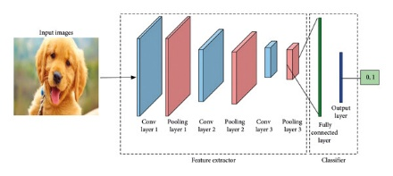Figure 3-1: Architecture of a Convolutional Neural Network (CNN) for Image Classification
Figure 1 presents the workflow of a Convolutional Neural Network (CNN) designed for image classification. As the input image progresses through successive convolutional layers, the network extracts features in a hierarchical manner—beginning with low-level patterns such as edges and textures, and gradually advancing to more complex and abstract representations.

By combining the hierarchical feature extraction capability of CNNs with the diversity introduced by augmentation, the resulting model achieves enhanced generalization, making it well-suited for robust image classification tasks across varied and unseen data distributions.

  - Theoretical Justification for Combining Flipping with Hide-and-Seek
Horizontal flipping is one of the most widely adopted augmentation strategies due to its effectiveness in increasing viewpoint invariance, particularly in object recognition tasks where left–right orientation is semantically equivalent (Shorten & Khoshgoftaar, 2019). By mirroring images, CNNs are encouraged to learn orientation-agnostic feature representations, reducing sensitivity to positional bias.
Hide-and-Seek (Singh et al., 2018), on the other hand, improves model robustness by randomly masking spatial regions, forcing CNNs to rely on distributed discriminative cues rather than overfitting to a single dominant feature. This has been shown to enhance occlusion resilience and localization awareness in deep networks.
Combining flipping with Hide-and-Seek theoretically amplifies both effects: flipping increases global appearance variation, while stochastic occlusion enforces localized feature redundancy. Similar augmentation principles are observed in CutMix (Yun et al., 2019) and Random Erasing (Zhong et al., 2020), where the blend of occlusion and geometric perturbation leads to improved generalization and adversarial robustness. Therefore, the proposed Flip-and-Hide strategy is expected to outperform either technique in isolation as it jointly promotes orientation invariance and occlusion tolerance, both of which are essential for learning stable and transferable CNN features.
    - Spatial Invariance Through Flipping
One of the fundamental properties desired in CNNs is invariance to spatial transformations. Horizontal flipping is a widely used augmentation method that enforces invariance to reflection along the vertical axis. Consider an image I ∈ ${ R}^{H×W×C}$, where H and W denote height and width, and C represents the number of channels. A horizontal flipping transformation can be defined as:
$$F\left(I\right)\left(x,y,c\right)=I\left(W-x-1,y,c\right) (1)$$
for pixel coordinates (x,y) and channel c.
The transformation preserves semantic class identity while altering spatial orientation. By training on both original and flipped images, CNNs learn that mirrored objects correspond to the same label, reducing sensitivity to orientation-specific patterns. This process promotes spatial invariance, an essential property for real-world scenarios where objects can appear in arbitrary orientations. From a theoretical perspective, flipping enriches the data distribution by augmenting the sample space with symmetric variations, thereby approximating the true underlying distribution more closely.
    - Feature Robustness Through Hiding
The hiding component builds upon the intuition that CNNs often over-rely on the most discriminative regions of an image. To counteract this, localized occlusion encourages the model to distribute attention across multiple feature regions. Let $P ⊆\left[0,H\right]×[0,W]$ represent a set of randomly selected pixel coordinates corresponding to one or more patches. The hiding operation is defined as:
$$H\left(I\right)\left(x,y,c\right)=\left\{\begin{aligned}0, & if\left(x,y\right)∈P \\ I(x,y,c), & otherwise\end{aligned}\right. (2)$$
This masking operation can alternatively use a constant value, mean pixel intensity, or random noise, depending on implementation. By selectively occluding portions of the image, hiding compels the CNN to extract meaningful features from regions that would otherwise be neglected. This leads to feature robustness, as the model no longer depends solely on dominant features but develops resilience to occlusion and noise.
From an information-theoretic perspective, hiding increases the entropy of the effective training distribution, reducing redundancy and preventing overfitting. By masking salient regions, the network’s hypothesis space is constrained to functions that rely on broader contextual information, thereby promoting generalization.
    - Mathematical Formulation of Flip-and-Hide
The Flip-and-Hide augmentation can be formally represented as the sequential application of flipping and hiding transformations. Let T denote the overall transformation operator. Then:
$$T\left(I\right)=H\left(F\left(I\right)\right) (3)$$
where F denotes the flipping operator and H denotes the hiding operator.
More explicitly, for an image I ∈ ${ R}^{H×W×C}$:
$$T(I)(x,y,c)=\left\{\begin{aligned}0, & if\left(x,y\right)∈P \\ I(W-x-1,y,c), & otherwise\end{aligned} (4)\right.$$
This formulation highlights that the resulting augmented image simultaneously embodies spatial invariance (via flipping) and occlusion-induced robustness (via hiding). While the sequential application (H(F(I))) is the most natural, alternative formulations such as (F(H(I))) may also be used, though empirical differences are minimal since flipping preserves occluded regions.
    - Interaction Between Flipping and Hiding
The central theoretical contribution of Flip-and-Hide lies in the interaction between spatial invariance and feature robustness. Flipping ensures that the model is exposed to orientation variants of each image, thereby reducing orientation-specific biases. Hiding, on the other hand, ensures that the model learns to extract features beyond the most discriminative regions.
When combined, these transformations encourage the model to develop representations that are both orientation-invariant and resilient to occlusion. For example, in the case of object categories such as shoes or shirts in Fashion-MNIST, flipping ensures recognition regardless of left-right orientation, while hiding compels recognition based on distributed texture or shape features rather than a single dominant region
Theoretically, this interaction can be interpreted as an additive regularization effect. Flipping expands the hypothesis space by introducing symmetric transformations, while hiding reduces reliance on localized features by penalizing narrow decision boundaries. Together, they form a complementary augmentation framework that balances global invariance with local robustness.
Mathematically, if 𝒟 denotes the training distribution, then applying Flip-and-Hide results in an augmented distribution 𝒟’ such that:
$$D^{'}=\{\left(T\left(I\right),y \right|\left(I,y\right) ∈D\} (5)$$
Here, T introduces both symmetry and occlusion variations, thereby increasing the support of 𝒟’ relative to 𝒟. The broader support approximates real-world variability more effectively, leading to improved generalization of the learned classifier $ƒ_{Ɵ}$

Datasets
In the experiments, three publicly available datasets, including the MNIST, Fashion MNIST (FMNIST), and CIFAR-10 datasets, were selected to verify the effectiveness and applicability of the proposed technique. Image classification tasks and deep learning research often use these datasets to benchmark algorithms.

MNIST Dataset
As a modified version of NIST, the MNIST database is based on the original NIST database (Le Cunn et al., 1998). A total of 60,000 training images are included (some of them may also be used for cross-validation purposes), and 10,000 test images are included in the same distribution. There are 28 x 28 pixels at the center of the image with the center of gravity of the intensity at the center of all these black and white digits. Several more recent algorithms still use the MNIST data set as a benchmark.

F-MNIST Dataset
There are 60,000 training examples and 10,000 test examples in the Fashion-MNIST dataset, which contains Zalando's fashion objects . There are 28 x 28 grayscale images in each example. A total of four files comprise the dataset, including the labels and images, and each image is accompanied by a label from one of ten classes.

CIFAR-10 Dataset
As a benchmark dataset for computer vision research, the dataset was created by the Canadian Institute for Advanced Research (CIFAR) in 2009 . Image classification models are widely evaluated and compared with this dataset, which has become a standard benchmark in the field. There are 60,000 32x32 color images in 10 classes, with 6,000 images per class, in the CIFAR-10 dataset.

    - Dataset Considerations and Justification
Although MNIST, Fashion-MNIST, and CIFAR-10 are sometimes labeled as “toy datasets” due to their small resolution and controlled structure, they remain standard benchmarks in the evaluation of augmentation techniques. Several seminal augmentation studies, including Hide-and-Seek (Singh et al., 2018), Cutout (DeVries & Taylor, 2017), Random Erasing (Zhong et al., 2020), CutMix (Yun et al., 2019), and AutoAugment (Cubuk et al., 2019), conducted their experiments primarily on CIFAR-10 and CIFAR-100, with variations also tested on MNIST or Fashion-MNIST.
Their adoption in this study is therefore deliberate. First, using datasets that are widely employed in augmentation research ensures benchmark comparability, allowing direct and fair performance comparisons between Flip-and-Hide and prior techniques. Second, these datasets provide a controlled and clean experimental environment, ensuring that any observed performance gains can be confidently attributed to the augmentation strategy itself rather than confounding factors such as dataset imbalance, noise, or visual complexity. Finally, this work follows a progressive research design, where Flip-and-Hide is first validated as a proof-of-concept method on standard benchmarks before being considered for deployment on more complex real-world datasets—a progression commonly observed in augmentation literature.
While the limitations of these datasets in representing real-world variability are acknowledged, their usage is consistent with established scientific practice, and forms a necessary baseline before scaling to domain-specific datasets in future work.

Preprocessing Steps
To maintain consistency across different datasets and ensure compatibility with the model architecture, a series of preprocessing steps were applied to the input data. First, all images were resized to 32×32 pixels, standardizing input dimensions to match the model’s expected input size. This resizing ensures that variations in image resolution across datasets did not affect the learning process or cause dimensional mismatches during training.
Next, all pixel values were normalized to the [0, 1] range by dividing each value by 255. This normalization step is critical in neural network training, as it improves numerical stability and accelerates convergence by ensuring that inputs are on a consistent scale.
To address the variation in image types, grayscale images were converted to RGB format. Since color images inherently contain three channels (Red, Green, Blue), and the model was designed to accept RGB inputs, grayscale images, which contain only one channel, were expanded by duplicating the single channel across all three to match the required input dimensions.
In other to prevent information leakage and ensure unbiased evaluation, the dataset in this study was partitioned into training and testing dataset. Dataset partitioning conducted using the built-in dataset loaders provided by TensorFlow Keras. Specifically, the functions tf.keras.datasets.fashion_mnist.load_data() and tf.keras.datasets.cifar10.load_data() were utilized. These functions automatically supply a standardized and predefined split between the training and testing sets.
Each loader returns a pair of tuples in the form:
(X_train, y_train), (X_test, y_test)
Here, X_train and X_test represent the input features for the training and testing phases, respectively, while y_train and y_test correspond to their associated class labels.
The Fashion-MNIST dataset contains 70,000 grayscale images, each sized 28×28 pixels, representing 10 distinct categories of fashion items. Following TensorFlow’s default configuration, 60,000 images are allocated for training and 10,000 for testing. The CIFAR-10 dataset comprises 60,000 color images (RGB) of size 32×32 pixels across 10 object classes, with 50,000 images assigned to the training set and 10,000 to the test set.
This fixed separation ensures that the training and testing data are mutually exclusive, preventing information leakage from the training process into the evaluation phase. Such separation is essential to obtain an unbiased estimate of the model’s generalization capability. During experimentation, the training subset is used for iterative parameter optimization, while the testing subset is reserved solely for performance evaluation after training is complete.
Modern machine learning pipelines, especially those applied to classification problems, have one-hot encoding play a pivotal role in the preprocessing phase (Poslavskaya & Korolev, 2023). It provides a systematic way to convert discrete, categorical class labels into a numerical format that computational models can understand. Instead of assigning arbitrary numbers to categories, which may imply ordinal relationships where none exist—one-hot encoding creates a binary vector for each category where only one position is active (set to 1), corresponding to the correct class, while all others remain inactive (set to 0). For example, with three classes such as ["cat", "dog", "mouse"], the one-hot encoded representation of "dog" would be [0, 1, 0]. This binary representation ensures that the learning algorithm treats each class as distinct and unrelated, a crucial aspect in multi-class classification tasks.
The significance of one-hot encoding becomes especially evident when we consider how models evaluate their predictions. Most neural networks output a probability distribution over all possible classes, typically via a softmax activation function in the final layer. Softmax transforms the model’s raw output values (logits) into normalized probabilities that sum to one, effectively representing the model’s confidence across all classes. However, producing these probabilities is only part of the task; we also need a mechanism to measure how closely these predictions align with the true class labels. This is where the cross-entropy loss function enters.
Cross-entropy loss measures the dissimilarity between the predicted probability distribution and the actual distribution of the labels. Given that one-hot encoding produces a sparse representation where only the true class has a probability of one and all others are zero, cross-entropy can be interpreted as a measure of how much “surprise” is associated with the prediction. Mathematically, in a multi-class scenario, the cross-entropy loss is defined as:
CrossEntropy(y, ŷ) = -∑ᵢ yᵢ · log(ŷᵢ) $(6)$
Where:
- yᵢ is the i-th element of the one-hot encoded true label vector,
- ŷᵢ is the i-th element of the predicted probability vector output by the model (usually via softmax).
Since y is one-hot encoded, only the log probability of the correct class contributes to the sum. Thus, if the true class is at index t, the formula simplifies to:
CrossEntropy(y, ŷ) = -log(ŷₜ) $(7)$
In essence, the model is penalized more heavily when it assigns low probability to the correct class and rewarded when its predictions are both confident and correct.
This relationship highlights the elegant synergy between one-hot encoding and cross-entropy loss. One-hot encoding provides a clean, unambiguous label representation, while cross-entropy quantifies the model’s performance relative to these labels. During backpropagation, this loss informs how model weights should be adjusted to improve predictive accuracy over time. Moreover, cross-entropy’s sensitivity to confident but incorrect predictions makes it a particularly effective loss function in training deep learning models, especially when compared to alternatives like mean squared error, which may be less sensitive to misclassifications in probabilistic settings.
By linking one-hot encoding with cross-entropy loss, we construct a foundation that supports the development of highly accurate and generalizable classification models. This combination is a cornerstone of most contemporary deep learning architectures. It not only ensures that class labels are treated fairly and without unintended ordinal implications but also enables the training process to focus sharply on reducing prediction error in a mathematically principled way.
The categorical class labels associated with each image in this study were one-hot encoded using the to_categorical() function from TensorFlow. This transformation converted each class label into a binary vector representing the presence or absence of a class, making it suitable for use with the categorical crossentropy loss function employed during training. These preprocessing steps collectively ensured uniformity, optimized model performance, and enabled effective learning across diverse input samples.

Theoretical Background of Data Augmentation
Data augmentation is a foundational concept in modern deep learning, especially in computer vision tasks (S. Yang et al., 2023). At its core, it involves synthetically expanding the training dataset by applying controlled transformations to existing data samples. These transformations include geometric operations such as flipping, rotating, cropping, scaling, and occlusion, as well as color and noise-based perturbations. The purpose of data augmentation is to improve the model’s ability to generalize to unseen data by presenting a wider variety of feature representations during training. The theoretical rationale for data augmentation is grounded in principles from statistical learning theory, information theory, and the concept of inductive bias in machine learning.

Statistical Learning Perspective
One of the most influential frameworks in understanding learning algorithms is Statistical Learning Theory (SLT), primarily introduced by Vapnik (1998). SLT revolves around the notion of minimizing the expected risk, or generalization error, which is the difference between the performance of a model on the training data and its performance on unseen data. In most practical scenarios, the true data distribution is unknown, and thus empirical risk minimization (ERM) is used, wherein models minimize the average loss over the training set. However, ERM alone is prone to overfitting, especially when the dataset is limited in size or diversity.
Data augmentation acts as an implicit form of regularization, helping to mitigate overfitting by broadening the empirical distribution and approximating a more diverse representation of the input space. Each augmented sample, although derived from the original, is treated as an independent observation that shares the same semantic label, thus reinforcing class boundaries and reducing the model’s sensitivity to specific patterns in the training set (Y. Wang et al., 2020).

Distribution Shift and Invariance
A major challenge in deploying machine learning models in real-world settings is distribution shift, where the data encountered during inference differs from the training data (Krishnamachari et al., 2023). This can be due to changes in lighting, orientation, resolution, occlusions, or other environmental variations. Data augmentation simulates such variability, allowing models to become more robust against domain shifts.
In doing so, augmentation implicitly teaches the model invariance to specific transformations. For instance, a dog remains a dog whether it is seen from the left or the right, upside down or upright. This transformation invariance is particularly important for Convolutional Neural Networks (CNNs), which, while locally translationally equivariant by design, benefit from augmented input that enforces broader invariance to rotation, scale, and spatial deformation.

Bias-Variance Tradeoff and Regularization
According to the bias-variance decomposition, model generalization depends on striking a balance between underfitting and overfitting (Yu et al., 2021). Data augmentation introduces a form of inductive bias—a preference for models that are invariant to certain transformations. This bias reduces variance (the model's sensitivity to noise in training data) without significantly increasing bias (the model’s assumptions about the function it is trying to learn), which is ideal for generalization.
Christopher Bishop (2006) elaborates on how regularization techniques improve generalization by constraining the hypothesis space. Data augmentation can be viewed as such a constraint—it implicitly restricts the model to learn functions that are consistent across augmented variants, thus discouraging memorization and promoting abstraction.

Information-Theoretical Interpretation
From an information theory standpoint, data augmentation increases the entropy of the training dataset (Yu, 2008). Entropy, in this context, refers to the uncertainty or variability in the input distribution. Higher entropy encourages the model to learn redundant and robust representations, which are essential for handling unseen variations in the test set.
Furthermore, data augmentation aligns with the goal of maximizing mutual information between input and learned representations. It ensures that the features extracted by intermediate layers of the network are not overly reliant on specific pixel arrangements or image artifacts, but rather capture high-level semantic features that are consistent across multiple variations of the same object.

Feature Invariance in CNNs
In CNN architectures, the ability to capture spatial hierarchies and localized features is a core strength (Uselis et al., 2020). However, this alone does not guarantee invariance to transformations. Data augmentation bridges this gap by reinforcing the model’s ability to detect meaningful patterns regardless of orientation, position, or partial occlusion. This is particularly crucial in domains like medical imaging, remote sensing, and autonomous driving, where data may be limited, noisy, or collected under varying conditions.
Techniques like random flipping and Hide-and-Seek augmentation (where patches of the image are hidden probabilistically) help CNNs to avoid over-reliance on the most salient features and encourage the discovery of more distributed and generalizable patterns.

Bayesian Perspective and Data Priors
Recent theoretical advancements view data augmentation through a Bayesian lens, interpreting it as the imposition of a data-dependent prior (Tran et al., 2017) . In Bayesian learning, the model infers a posterior distribution over its parameters based on both the observed data and the prior belief. Data augmentation acts to shape this prior by implicitly conveying assumptions about feature invariance, spatial consistency, and noise tolerance (Fortuin, 2022). This interpretation positions data augmentation not just as an engineering trick but as a statistically principled approach to enhancing learning. It reinforces the idea that well-designed augmentations incorporate domain knowledge in a formal way, guiding the model toward more plausible solutions.

Practical Implementation and Generalization Theory
In practice, data augmentation has proven effective in nearly all domains where data is scarce or expensive to label (Pluščec & Šnajder, 2023). From improving generalization in low-data regimes to serving as a crucial component in large-scale benchmarks (e.g., ImageNet), its utility is both theoretical and empirical. The success of augmentation-based models in competitions such as ILSVRC and the widespread use of AutoAugment, RandAugment, and CutMix further validate its importance (Cubuk et al., 2018). In generalization theory, augmentation is closely associated with reducing Rademacher complexity, a measure of function class capacity. Lower complexity leads to tighter generalization bounds, making it more likely that training performance correlates with test performance (Gahtan & Bronstein, 2025).

Ethical Consideration in Data Augmentation
As data augmentation becomes a standard technique in deep learning pipelines, its ethical implications are drawing increased attention (Krizhevsky et al., 2017). While augmentation strategies such as Flip-and-Hide are typically used to improve generalization and robustness, their deployment—particularly in sensitive or high-stakes domains, must be evaluated through the lens of fairness, transparency, and responsible AI practices (Pham et al., 2023). This section explores the ethical concerns that arise from the use of augmentation methods, especially those involving geometric and occlusion-based transformations.

Risk of Amplifying Biases
Although data augmentation aims to diversify training data, it can paradoxically reinforce or amplify existing biases when not applied judiciously. For instance, when certain classes are disproportionately augmented, either by chance or design, it may lead to overrepresentation of specific features, orientations, or visual structures (Jain et al., 2020). This is particularly problematic in classification tasks where class balance is critical. If one class undergoes more aggressive or frequent augmentation (e.g., excessive flipping or masking), the model may inadvertently assign undue importance to its distorted representations, skewing decision boundaries and degrading fairness.
Moreover, the assumption of label invariance under augmentation is not always valid. In domains such as facial recognition or emotion detection, flipping or occluding certain regions may alter the perceived class, especially in culturally or contextually sensitive datasets (Lee et al., 2019). These nuances, if unaccounted for, may contribute to algorithmic bias, disproportionately affecting specific demographics or user groups.

Potential for Misuse and Dual-Use Concerns
Augmentation methods like Hide-and-Seek, while intended to improve model robustness, can also be repurposed for less benign objectives (Qiu et al., 2021). In surveillance applications, synthetic image variations might be used to evade detection mechanisms, generate adversarial examples, or expand datasets without proper consent or verification (Ridgway & Malevé, 2024). Additionally, occlusion-based augmentation techniques could be misused to fabricate ambiguous or misleading content, particularly in scenarios involving synthetic data generation, deepfakes, or forensic image manipulation (Verdoliva, 2020).
This dual-use nature of augmentation tools places an ethical responsibility on researchers and practitioners to define usage boundaries and implement safeguards that prevent misuse. Clear documentation, transparency in augmentation parameters, and audit trails can help mitigate the risk of augmentation being weaponized or producing unintended consequences in real-world deployments.

Transparency and Explainability Challenges
A fundamental tenet of ethical AI is explainability, the ability to interpret and justify model predictions. However, occlusion-based augmentation strategies can obscure this goal by altering the original input in ways that are not intuitively visible to human observers (Fong & Vedaldi, 2019). When portions of an image are randomly hidden or flipped, it becomes harder to trace which features the model relied upon, especially when standard interpretability tools (e.g., saliency maps or heatmaps) fail to align with the transformed inputs.
This lack of transparency may hinder accountability, particularly in regulated sectors such as healthcare, finance, or criminal justice, where stakeholders must understand and trust the model's reasoning process. To maintain ethical standards, it is crucial to ensure that augmentation techniques do not compromise interpretability or lead to decisions that cannot be adequately explained to affected individuals or oversight bodies.
While data augmentation techniques offer substantial technical benefits, they also carry ethical implications that must be carefully addressed. Issues of bias amplification, misuse potential, and transparency should not be overlooked during method development and deployment. As AI continues to permeate sensitive domains, the responsible application of augmentation strategies must involve interdisciplinary dialogue, ethical foresight, and robust evaluation protocols. By integrating ethical considerations into the augmentation design process, researchers can ensure that technological advancement is aligned with fairness, accountability, and human-centric values.

Data Augmentation Techniques

Image Flipping
In the domain of artificial intelligence and computer vision, deep learning models, most notably Convolutional Neural Networks (CNNs), have demonstrated remarkable proficiency in recognizing patterns and performing visual classification tasks. However, the effectiveness of these models is closely tied to the quality and diversity of the datasets on which they are trained. Empirical evidence consistently shows that CNNs trained on large-scale, varied, and well-annotated datasets tend to exhibit superior generalization performance across diverse visual conditions. Unfortunately, in many applied scenarios, such ideal datasets are not readily available. Constraints such as limited access to domain-specific imagery, high annotation costs, or the sensitive nature of data, particularly in fields like medical imaging or satellite surveillance, often result in insufficient training data (Shorten & Khoshgoftaar, 2019)
To address this data scarcity challenge, researchers commonly employ a suite of techniques collectively referred to as data augmentation. These methods involve generating new training samples by applying transformations to existing data that preserve the semantic content of the image (Narayanan & Ghanta, 2024). Examples include random cropping, rotation, and brightness adjustment. Such augmentation strategies enrich the dataset with diverse representations of the same image classes, thereby improving the model’s ability to generalize to unseen inputs.
Among the most fundamental and computationally efficient augmentation techniques is image flipping (Xu et al., 2023). This involves reflecting the image across a horizontal or vertical axis, producing a mirrored version of the original content. For instance, a horizontally flipped image presents the left and right sides of an object in reverse, while a vertical flip inverts the top and bottom portions. Crucially, these transformations do not alter the object's class or semantic interpretation, an image of a dog remains a dog regardless of its orientation. This process reinforces the model’s ability to learn viewpoint-invariant features, which is essential in real-world environments where object orientations frequently vary, such as pedestrians walking in opposite directions or vehicles viewed from multiple sides.
The attractiveness of image flipping lies in its simplicity, non-destructive nature, and computational efficiency. Unlike other augmentation methods that may introduce synthetic noise or require intensive computation, flipping involves a direct spatial rearrangement of pixels. As such, it imposes minimal overhead on the training pipeline while significantly improving robustness. By exposing CNNs to multiple orientations of the same object, flipping encourages the model to focus on the object’s intrinsic features rather than memorizing specific spatial configurations. This results in better feature generalization, allowing the model to perform reliably on novel inputs and across diverse operational contexts (Perez & Wang, 2017)
Horizontal flipping was implemented using TensorFlow’s random_flip_left_right() function in this study, which mirrors images along the vertical axis. This transformation introduces symmetrical variations during training, helping the model learn to generalize better across different orientations of the same object.

Hide-and-Seek Augmentation
As deep learning models continue to outperform traditional methods in image classification and object detection tasks, their success is often tightly linked to the diversity and size of the training data (Sun et al., 2017). However, in practical, real-world settings, visual information is frequently incomplete, objects may be partially occluded, blocked by other entities, or captured from unusual perspectives. These conditions introduce a significant challenge for models trained exclusively on clean and fully visible images. Traditional training pipelines often lead CNNs to focus primarily on the most salient or discriminative features, such as eyes in faces, logos in branding, or object outlines, without adequately learning contextual or supporting visual information (Bertoin et al., 2024). As a result, even minor obstructions, like a hand partially covering a face or foliage obscuring part of a car, can lead to incorrect classification or failure to detect the object altogether. This limitation highlights a critical gap in model robustness, the lack of exposure to occluded data during training makes CNNs vulnerable to variations and imperfections in real-world environments.
To bridge this gap, researchers have developed occlusion-based data augmentation techniques that simulate real-world visual challenges as part of the training process. Among these, one particularly promising and widely adopted method is the Hide-and-Seek (HaS) augmentation technique, introduced by Singh and Lee in 2018. Hide-and-Seek improves model generalization by intentionally obscuring parts of input images during training, thereby compelling the model to extract informative patterns from regions that are not always fully visible. Instead of applying global transformations such as rotation or brightness adjustment, Hide-and-Seek takes a spatially structured approach. It randomly hides square patches within the image, forcing the network to "seek" relevant visual cues from remaining visible areas and discouraging over-reliance on specific features.
In practice, the Hide-and-Seek algorithm works by first dividing the input image into a regular grid. Each cell in this grid represents a spatial patch of the image. During training, a random subset of these patches is selected and masked out (Singh, Yu, et al., 2018). The masking can be implemented in two primary ways, either by replacing the hidden patches with a constant value, such as the mean pixel value of the dataset, or by setting them to zero, effectively turning them into black squares. These hidden regions intentionally reduce the visibility of certain object parts while keeping the overall label and image semantics unchanged. This selective occlusion strategy introduces controlled uncertainty into the training set, enabling the model to learn distributed and complementary features across the image (Z. Yang et al., 2025). The core idea behind Hide-and-Seek is to vary the occlusion patterns across different training instances, thereby ensuring that the model cannot rely solely on one region of the object for classification (Singh, Yu, et al., 2018). For example, if a CNN consistently uses the eyes of a cat to classify it, then hiding the eye region during training encourages the model to consider other attributes, such as ear shape, fur texture, or body posture. This behaviour helps improve feature diversity and ultimately leads to better robustness under partial visibility conditions. Furthermore, Hide-and-Seek offers configurable parameters that influence its behavior. The grid size determines how fine or coarse the patch division is, and the probability of hiding each cell controls the degree of information loss during training (Foggo et al., 2020). Smaller grid sizes produce finer occlusions and promote localised learning, while larger grid sizes can simulate broader occlusions that resemble real-world scenarios, such as large objects blocking the camera’s view. By fine-tuning these hyperparameters, practitioners can tailor the augmentation process to fit different datasets and learning tasks, making Hide-and-Seek a versatile and effective augmentation strategy for improving visual recognition under occlusion.

Combined Strategy: Flip ➝ Hide-and-Seek
Augmentation was applied sequentially, first flipping, then hide-and-seek. A custom pipeline (augment_flip_then_hide) ensures this order using TensorFlow’s data pipeline with py_function() for compatibility with NumPy-based augmentation. During training, each image is flipped horizontally (along the x-axis), hide-and-seek augmentation is applied and lastly classification is done.

Control Group
A baseline experiment was conducted with no augmentation to isolate the effect of the combined augmentation technique.

Convolutional Neural Network Architecture

Model Design
A custom deep CNN was implemented using TensorFlow’s Sequential API. The architecture includes: Three convolutional blocks, each with two convolutional layers (3×3 filters) followed by batch normalization and max pooling; Global Average Pooling layer to reduce spatial dimensions; Dense layer with 256 units, ReLU activation, and dropout.; Final Softmax layer for multiclass classification.
    - Justification of the Selected CNN Architecture
The CNN architecture used in this study was intentionally chosen as a lightweight and standardized baseline model rather than a deeper or highly optimized backbone. This decision ensures that any observed performance improvement can be attributed primarily to the proposed Flip-and-Hide augmentation technique, rather than to architectural enhancements or model-specific optimizations. Using complex backbones such as ResNet or EfficientNet may introduce confounding variables, as these architectures already incorporate implicit regularization mechanisms (e.g., skip connections, batch normalization), thereby masking the independent contribution of augmentation.
No ablation study across alternative CNN architectures was conducted, as the objective of this research is not to identify the best-performing network, but rather to isolate and analyze the standalone effect of the augmentation strategy. The architecture is therefore treated as a fixed experimental control, deliberately held constant to maintain fairness and interpretability.
Future extensions of this work may evaluate Flip-and-Hide across deeper or specialized models to further establish its scalability, but such comparisons are considered beyond the current study’s scope and intentionally deferred.

Experimental Groups
Three experiments were defined for each dataset. Experiment A which is the baseline experiment was conducted on each dataset without any augmentation; On the other hand, experiment B was conducted by using the Hide-and-Seek Augmentation technique; The last experiment, C was the proposed technique in this research, Flip-and-Hide. Table 1 shows the experimental groups used in this study.
Table 1: Experimental Groups
Group ID | Augmentation Strategy
A | No augmentation (Baseline)
B | Hide-and-Seek
C | Flip-and-Hide

Hyper-parameter Optimization Procedure
In this research, the training process was carried out over 20 epochs, allowing the model sufficient exposure to the data to learn complex patterns while minimizing overfitting. A batch size of 32 was selected, balancing memory efficiency with gradient stability during backpropagation. For optimization, the Adam optimizer was employed with a learning rate of 0.001, chosen for its adaptive learning capabilities and efficiency in handling sparse gradients. The loss function used was Categorical Crossentropy, which is suitable for multi-class classification tasks. To enhance generalization and prevent the model from becoming overly confident in its predictions, label smoothing was applied with a factor of 0.1. Additionally, a learning rate scheduler was integrated into the training pipeline. Specifically, the ReduceLROnPlateau strategy was implemented to dynamically lower the learning rate when the validation accuracy plateaued, ensuring more refined adjustments during later training stages and promoting convergence to a better local minimum.

Performance Metrics
To evaluate the performance of the model, a comprehensive set of metrics was employed, each providing unique insights into different aspects of classification quality. The primary metric used was accuracy, which reflects the overall percentage of correctly classified samples. This metric offers a general sense of how well the model is performing across all categories, particularly when class distributions are relatively balanced.
Beyond accuracy, more granular performance indicators were calculated, including precision, recall, and the F1-score. These metrics were computed per class to assess how effectively the model performed on individual categories. Additionally, macro-averaging was applied to each of these scores, yielding an overall assessment that treats all classes equally, regardless of their frequency. This approach is especially valuable in datasets where class imbalance might skew the accuracy metric alone.
      - Precision
Precision measures the proportion of correctly predicted positive samples out of all samples predicted as positive. It evaluates the exactness of the classifier:
$Precision=\frac{TP}{TP+FP} (8)$
where:
- TP= True Positives (correctly predicted positive samples)
- FP = False Positives (incorrectly predicted positive samples)
A higher precision indicates that the model makes fewer false positive errors.
      - Recall
Recall measures the proportion of correctly predicted positive samples out of all actual positive samples. It evaluates the completeness of the classifier:

$$Recall=\frac{TP}{TP+FN} (9)$$
where:
- FN = False Negatives (actual positives incorrectly predicted as negatives)
A higher recall indicates that the model successfully identifies most of the positive samples.

      - F1-Score

The F1-score is the harmonic mean of precision and recall, providing a balanced metric that accounts for both false positives and false negatives:

$F1-score=2x\frac{Precision X Recall}{Precision+ Recall} (10)$

      - Confusion Matrix
To further interpret classification behavior, a confusion matrix was utilized. This visual tool presents a detailed comparison between true labels and predicted labels, making it easier to identify specific patterns of misclassification. The confusion matrix is instrumental in diagnosing which classes the model tends to confuse and in understanding the nature of errors made during prediction. Together, these metrics provided a robust framework for evaluating and refining model performance.

ROC-AUC Curves
One versus all Receiver Operating Characteristic (ROC) curves were plotted for each class, and Area-Under-Curve (AUC) values were calculated.

Learning Curves
Training and validation accuracy/loss were plotted per epoch to observe overfitting trends.

Precision-Recall (PR) Curves
PR curves were used to visualize how well the research model identifies true positives without being overwhelmed by false positives.

Implementation Details
The implementation begins with importing essential libraries such as TensorFlow, NumPy, and scikit-learn for deep learning, image processing, and performance evaluation. Standard datasets, including MNIST, Fashion-MNIST, and CIFAR-10, are loaded using TensorFlow's built-in functions. All images are resized to 32×32 pixels to maintain consistency. Since MNIST and Fashion MNIST consist of grayscale images, they are converted to RGB by duplicating the single channel. All image data is normalized to scale pixel values between 0 and 1, and labels are one-hot encoded to support multi-class classification with 10 categories. To make the model more robust and resistant to overfitting, a custom Flip-and-Hide augmentation strategy is introduced. First, each image undergoes a random horizontal flip, simulating variations in object orientation. Next, a Hide-and-Seek operation randomly blacks out sections of the image using a 4×4 grid, effectively masking certain visual areas. 4x4 grid is used instead of higher grid size because of the input image resolution (32x32 pixels). Using higher grid dimension will ensure smaller patches which may be ignored by the model during training. This method forces the model to learn from less prominent features rather than relying only on the most distinctive parts of an object. The augmentation is applied dynamically during training using tf.py_function, ensuring varied masking patterns across epochs. The core of the implementation is a Convolutional Neural Network (CNN) with three convolutional blocks. Each block includes a convolutional layer with ReLU activation, followed by batch normalization for faster convergence and max-pooling to reduce spatial dimensions. The number of filters increases progressively across layers (32 → 64 → 128), allowing the model to capture increasingly complex features. After the convolutional layers, the output is flattened and passed through a fully connected layer of 128 neurons. A dropout layer with a 50% dropout rate is added to reduce overfitting. The final layer uses softmax activation to produce a probability distribution over the 10 output classes. After training, the model's effectiveness is assessed using several performance metrics. A confusion matrix is generated to visualize classification errors and identify specific classes the model struggles with. Additionally, ROC curves and AUC scores are calculated for each class to provide insight into the model’s performance in multi-class classification scenarios. These curves illustrate the model’s sensitivity and specificity at different classification thresholds. Finally, training and validation accuracy/loss curves are plotted to observe learning trends and diagnose any overfitting behavior. The entire process is repeated for all three datasets (MNIST, Fashion MNIST, and CIFAR-10), demonstrating the generality and effectiveness of the Flip-and-Hide strategy across various types of image data. We further provide the classification report of the improved augmentation technique on all the three datasets (see Tables 5, 6 and 7).

Tools and Libraries
The research was implemented using Python 3.10, a versatile and widely adopted programming language in the field of machine learning and data science. Python's readability and extensive ecosystem of libraries made it a fitting choice for developing, training, and evaluating deep learning models.
Several key libraries and frameworks were leveraged throughout the project. The TensorFlow framework served as the backbone for model development and training, offering efficient tools for building neural networks and integrating GPU acceleration. NumPy was employed for numerical operations and array manipulations, playing a crucial role in data preprocessing and augmentation. To facilitate the evaluation of model performance, Scikit-learn was used for calculating classification metrics such as precision, recall, and F1-score, as well as for generating the confusion matrix.
For data visualization and analysis, Matplotlib and Seaborn were utilized. These libraries enabled the creation of detailed and interpretable plots, including metric trends and confusion matrices, which helped in understanding the model’s behavior during and after training. In terms of data augmentation, a custom pipeline was designed using native TensorFlow and NumPy operations. Instead of relying on external augmentation libraries, the logic was manually implemented to ensure flexibility and control over the transformations. This approach allowed for tailored augmentations suited to the specific characteristics of the dataset, enhancing the model’s ability to generalize to unseen data.

Code Structure
The codebase of this research was organized into modular functions to ensure clarity, reusability, and ease of experimentation. Central to the preprocessing phase were the custom image transformation functions hide_and_seek() and random_flip(). These functions introduced diversity into the training data by manipulating input images. hide_and_seek() implemented a region-masking technique to simulate occlusions, while random_flip() applied random horizontal flipping to mimic real-world variations. These augmentations were crucial for enhancing the model’s robustness and generalization.
To streamline the integration of these transformations into the data pipeline, the augment_flip_then_hide() function was developed. This function combined both random_flip() and hide_and_seek() into a cohesive augmentation pipeline that was seamlessly incorporated into TensorFlow's data pipeline, enabling efficient, on-the-fly augmentation during training without additional memory overhead.
The architecture of the deep learning model was defined within the create_better_model() function. This function encapsulated the design and compilation of the neural network, specifying the layer structure, activation functions, and other architectural components. It also included the compilation step with the optimizer, loss function, and performance metrics configured, enabling easy modification and experimentation with different model structures.
Finally, the train_and_evaluate() function served as the primary workflow controller. It managed data preparation, including loading, preprocessing, and batching of datasets; called the model definition function; and handled the training and evaluation of the model. By isolating training logic in this function, the structure supported organized experimentation, reproducibility, and straightforward model validation.
      - Reproducibility and Code Availability
The complete implementation of the Flip-and-Hide augmentation pipeline, including data preprocessing, model definition, training configuration, and evaluation scripts, is publicly accessible via a Google Colab notebook.
Link:https://colab.research.google.com/drive/1v144zIcqVSQAedc4Wba5fVo5RYEJwW9D.

Chapter Summary
This chapter presents the methodology used to investigate the effectiveness of the proposed Flip-and-Hide data augmentation strategy on image classification using Convolutional Neural Networks (CNNs). The study combines horizontal flipping with the Hide-and-Seek (HaS) occlusion technique to improve model generalization. The methodology covers data preparation, augmentation techniques, network architecture, training procedures, and evaluation metrics.
Three widely used datasets—MNIST, Fashion MNIST, and CIFAR-10, were selected to test the technique’s robustness across different visual domains. Each dataset underwent a standardized preprocessing pipeline that included resizing images to 32×32 pixels, normalizing pixel values to the [0,1] range, converting grayscale images to RGB, and applying one-hot encoding to class labels for compatibility with multiclass classification.
The data augmentation strategy was structured around three approaches: no augmentation (baseline), Hide-and-Seek alone, and the proposed technique, Flip-and-Hide. The Flip-and-Hide method first applies random horizontal flipping, followed by occluding image patches using the Hide-and-Seek strategy. This sequence aims to improve the model's ability to learn from both altered spatial arrangements and missing visual information. A custom augmentation pipeline (augment_flip_then_hide) was developed using TensorFlow and NumPy to apply these transformations during training dynamically.
A custom CNN was designed using TensorFlow's Sequential API. The architecture consisted of three convolutional blocks with batch normalisation and max pooling, followed by a global average pooling layer, a dense layer with 256 units and ReLU activation, and a final softmax layer for classification. Dropout was applied to reduce overfitting.
The experimental setup involved training each model variant over 20 epochs with a batch size of 32, using the Adam optimizer with a learning rate of 0.001. Label smoothing and a learning rate scheduler (ReduceLROnPlateau) were used to encourage smoother convergence and better generalization.
The model’s performance was evaluated using a wide range of metrics: accuracy as the primary indicator, and class-level precision, recall, and F1-scores (macro-averaged). Additionally, confusion matrices, ROC-AUC curves, and precision-recall curves were plotted to visualize classification behavior. Training and validation curves were also analyzed to track learning dynamics and detect overfitting.
The implementation relied on Python 3.10, with TensorFlow for deep learning, NumPy and Scikit-learn for preprocessing and evaluation, and Matplotlib/Seaborn for visualization. A modular code structure was adopted, with core functions for data augmentation, model creation, and training. This design ensured clarity, reproducibility, and ease of experimentation.
In summary, Chapter Three provides a detailed and structured methodology to evaluate whether the proposed Flip-and-Hide augmentation strategy enhances CNN performance on diverse image datasets. The experimental setup is designed to produce reliable, interpretable results across multiple evaluation dimensions.

CHAPTER FOUR

RESULTS AND ANALYSIS
  - Introduction
This chapter presents a detailed account of the experimental evaluation conducted to assess the proposed Flip-and-Hide data augmentation strategy, a method designed to enhance the effectiveness of the traditional Hide-and-Seek (HnS) augmentation approach. As image classification models continue to evolve, the need for diverse and generalizable training data has become increasingly important. Data augmentation techniques, particularly those aimed at introducing structured randomness and improving spatial invariance, play a significant role in achieving robust performance on complex datasets. The Flip-and-Hide technique introduces two key transformations: a random horizontal flip to simulate geometric variation, and a grid-based blackout masking inspired by HnS to encourage broader feature extraction. The hypothesis underpinning this approach is that training on images with occluded regions and mirrored spatial configurations can significantly reduce overfitting and improve generalization to unseen data. This chapter evaluates this hypothesis by conducting empirical studies using three benchmark datasets—MNIST, Fashion-MNIST (FMNIST), and CIFAR-10. Each dataset was carefully chosen for its specific properties: MNIST for its simplicity and consistency, FMNIST for moderate complexity in fashion item recognition, and CIFAR-10 for high visual variability and color complexity. The experiments were executed using a standardized deep learning pipeline implemented in Keras with TensorFlow backend, running on Google Colab. Each model was trained over 20 epochs using the Adam optimizer and categorical cross-entropy loss function. Performance metrics including accuracy, loss, ROC curves, AUC scores, precision, recall, F1-score, and confusion matrices were utilized to capture the impact of the augmentation strategy.
  - Experimental Setup
The experimental pipeline employed in this study is designed to ensure consistency, enhance learning, and enable robust evaluation of the proposed Flip-and-Hide augmentation technique. As a first step, preprocessing was conducted on all input images from the MNIST, Fashion-MNIST (FMNIST), and CIFAR-10 datasets. Each image was resized to a standard resolution of 32×32 pixels to maintain uniformity across datasets. For grayscale datasets such as MNIST and FMNIST, the single-channel images were converted to RGB by replicating the channel across the three - color bands, ensuring compatibility with convolutional architectures typically designed for color images.
Following preprocessing, normalization was applied to scale pixel values to the range [0, 1], which helps accelerate model convergence and stabilizes the training process. Label encoding was performed using one-hot encoding to prepare the class labels for multi-class classification tasks involving ten distinct categories in each dataset.
The data augmentation strategy proposed in this study is a two-step process that significantly enhances the training data's variability. First, a random horizontal flip is applied to simulate changes in object orientation and to improve the model’s ability to generalize across different spatial representations. Second, a Hide-and-Seek operation is implemented by randomly blacking out patches of the image using a 4×4 grid. This masking forces the network to learn from a broader set of visual features, rather than focusing solely on the most dominant regions, thereby improving generalization and robustness.
The underlying model architecture consists of three convolutional blocks. Each block contains a convolutional layer followed by batch normalization to accelerate training and a max-pooling layer to reduce spatial dimensions. The number of filters increases across the blocks—32 in the first, 64 in the second, and 128 in the third—enabling the network to capture increasingly complex and abstract features. The feature maps are then flattened and passed through a fully connected dense layer with 128 neurons. To prevent overfitting, a dropout layer with a 50% rate is applied. The final output layer utilizes the softmax activation function to generate class probabilities for multi-class classification. Table 2 presents the architecture of the CNN models used in this study.

Table 2:Model Architecture
Layer Type | Configuration
Input Layer | 32×32×3 RGB image
Convolution Block 1 | Conv (32 filters, 3×3) + BatchNorm + MaxPool
Convolution Block 2 | Conv (64 filters, 3×3) + BatchNorm + MaxPool
Convolution Block 3 | Conv (128 filters, 3×3) + BatchNorm + MaxPool
Flatten | Flatten feature maps
Dense Layer | Fully connected layer with 128 neurons
Dropout | Dropout rate = 0.5
Output Layer | Dense(10), Softmax activation
This standardized architecture was chosen to balance model complexity and interpretability, providing a clear signal on how different augmentation strategies influence performance without confounding factors from deeper or more specialized architectures
  - Quantitative Results
This section presents the empirical findings of the study evaluating the proposed Flip-and-Hide augmentation technique for image classification using Convolutional Neural Networks (CNNs). The results are organized to provide a comprehensive analysis of the method’s performance in comparison to both baseline models and established state-of-the-art augmentation schemes.
The evaluation process follows a structured approach. First, the performance of the proposed technique is assessed on benchmark datasets, including CIFAR-10, MNIST, and Fashion-MNIST, to determine its effectiveness across varying image complexities and feature distributions. Second, the results are compared against conventional occlusion-based augmentation methods, with emphasis on classification accuracy, robustness to visual variability, and preservation of semantic information. Finally, the study examines computational considerations and potential trade-offs introduced by the dual-stage logic inherent in Flip-and-Hide. By presenting the outcomes clearly and systematically, this section aims to validate the theoretical advantages of the proposed approach and provide quantitative evidence for its applicability in real-world image classification scenarios. The subsequent subsections detail performance metrics, comparative analyses, and ablation studies that collectively establish the contribution and relevance of the Flip-and-Hide technique.

Baseline Experiment Results (No Augmentation)
To benchmark the performance improvement provided by both augmentation methods, a baseline experiment was conducted with no augmentation applied, as shown in Table 3. Multiple studies demonstrate the critical role of baseline comparisons in understanding augmentation effectiveness. Legaspi, 2023 showed modest improvements of 31% in f1-score (Legaspi, 2023). A study conducted by Pereira et al., 2022 found dramatic accuracy increases up to 177.84% compared to no augmentation (Pereira et al., 2022). These results serve as a reference to measure the effectiveness of HnS and Flip-and-Hide.

Table 3: Baseline experiment results
Dataset | Test Accuracy
MNIST | 0.99
FMNIST | 0.91
CIFAR-10 | 0.73
  - Improvement of accuracy on the traditional Hide-and-Seek augmentation technique on benchmark datasets
To achieve the first objective of this study and comprehensively evaluate the effectiveness of the proposed Flip-and-Hide augmentation technique in comparison to traditional methods, a range of quantitative performance metrics was computed on the test sets across all datasets. These metrics include: overall classification accuracy, Receiver Operating Characteristic - Area Under the Curve (ROC-AUC) scores, and detailed precision, recall, and F1-scores, computed both per class and in weighted aggregate to account for class imbalance. Additionally, confusion matrices were generated to visualize misclassifications across categories, and precision-recall curves were plotted to assess the model's performance in distinguishing between classes, particularly under conditions of class imbalance or noise.
Furthermore, the study examined the learning dynamics of the models through the analysis of training versus validation accuracy and loss curves. These curves provide insight into model convergence, overfitting behavior, and generalization capacity throughout the training process. Collectively, these evaluation criteria facilitate both macro-level performance assessment, by summarizing the overall effectiveness of the models—and micro-level, class-wise diagnostic analysis, which is essential for interpreting behavior across datasets of varying complexity. This comprehensive metric suite ensures a robust and interpretable comparison of augmentation strategies in diverse image classification contexts.
    - ROC-AUC Analysis of Flip-and-Hide and Hide-and-Seek
This section presents the analysis of the ROC-AUC curves for the flip-and-hide and hide-and-seek techniques. It is seen from Figures 4-3 and 4-4 display ROC curves for both the improved and traditional HnS techniques. The improved method as shown in Table 4 consistently achieves higher AUC scores, reflecting superior sensitivity-specificity trade-offs. AUC values range from 0.5 to 1.0, with higher scores indicating better diagnostic discrimination (Çorbacıoğlu & Aksel, 2023). An AUC above 0.80 is generally considered clinically useful, suggesting the improved method likely meets or exceeds this threshold (Junge & Dettori, 2018).
Table 4: ROC AUC results of Flip-and-Hide and Hide-and-Seek methods
Dataset | AUC (HnS) | AUC (Flip-and-Hide)
MNIST | 0.99 | 0.99
FASHION MNIST | 0.91 | 0.94
CIFAR-10 | 0.75 | 0.88

    - Confusion Matrices and Per-Class Analysis of Flip-and-Hide and Hide-and-Seek
Confusion matrices for both augmentation methods (Figures 4-8 and 4-9) help to visualize class-specific performance. The Flip-Hide method reduces misclassifications across all classes, especially in the CIFAR-10 dataset, where background noise and overlapping features are more prevalent (Çetiner & Metlek, 2023).

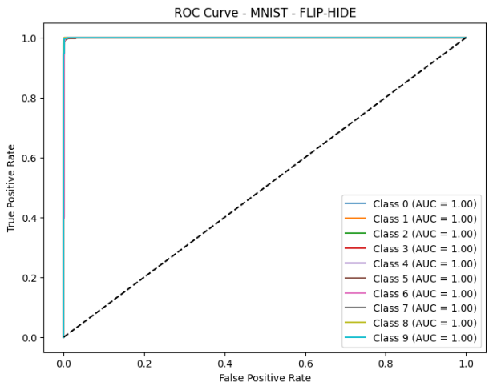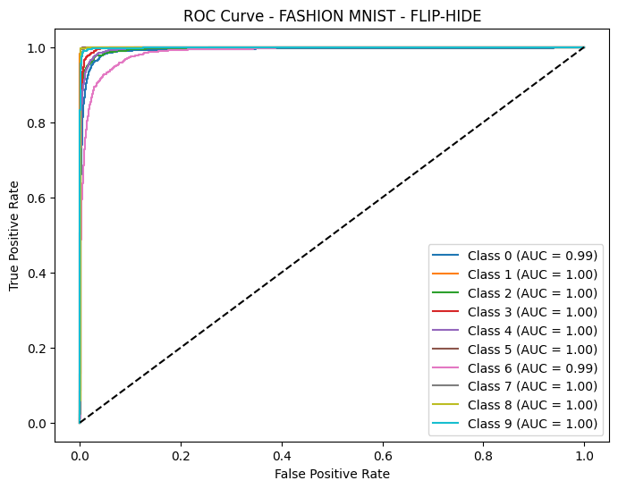
- MNIST (b) FMNIST
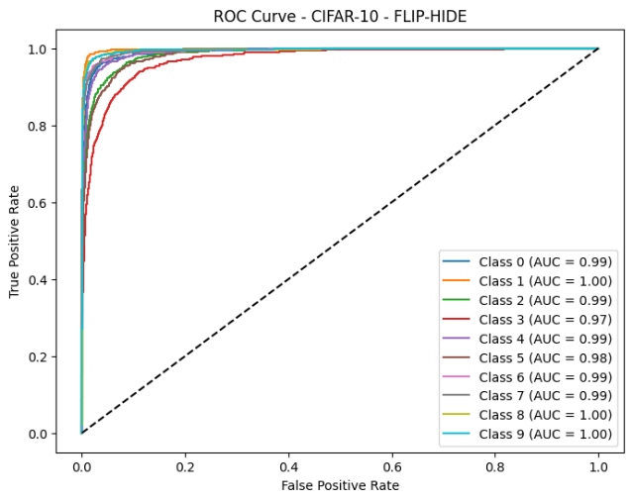
(c.) CIFAR-10
Figure 4-1: AUC-ROC curves for the improved augmentation techniques

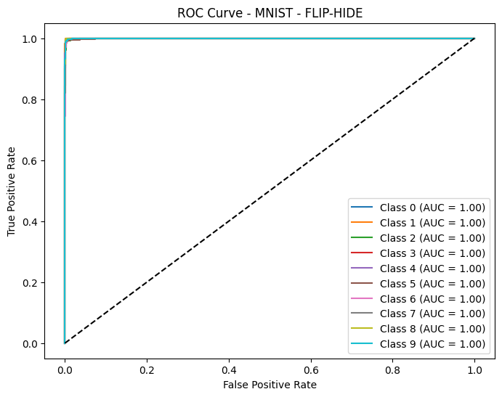
- MNIST
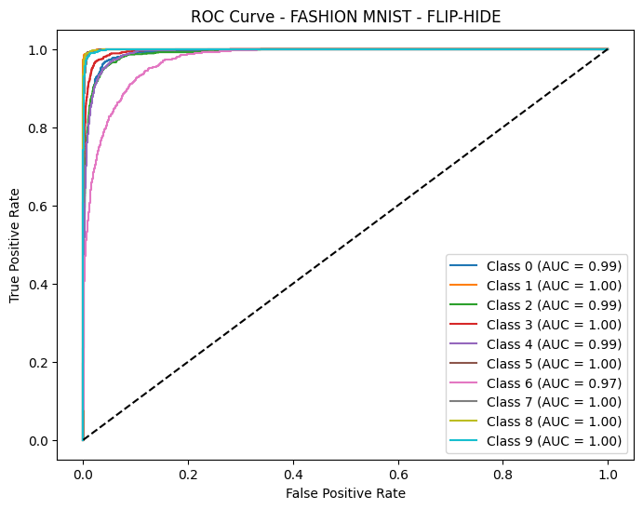
- FMNIST
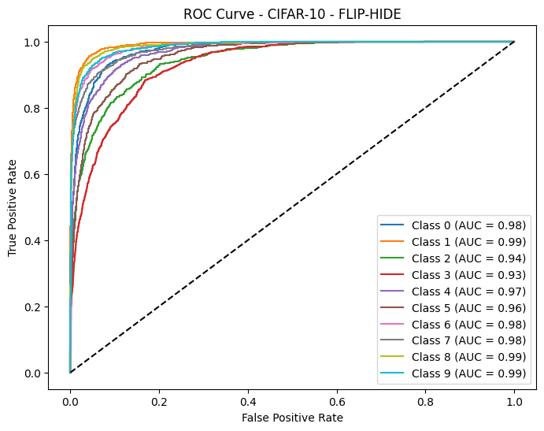
- CIFAR-10
Figure 4-2: AUC-ROC curves for Hide-and-Seek (HnS) augmentation techniques

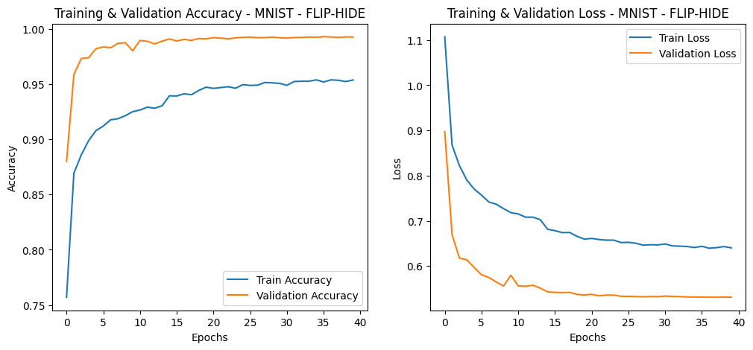
- MNIST

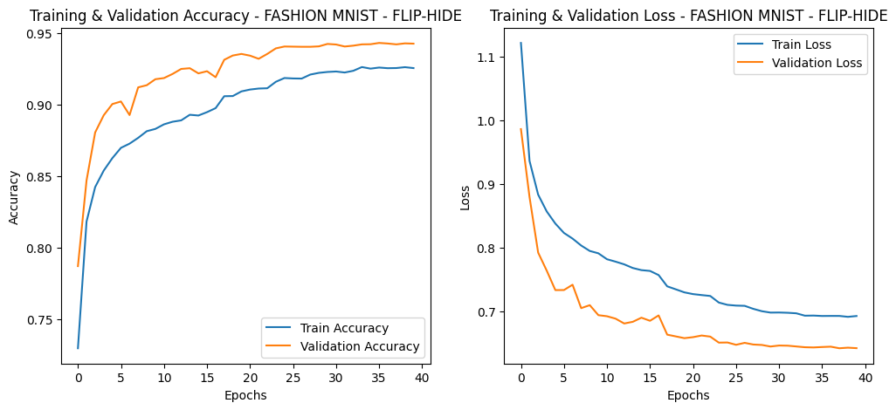
- FMNIST

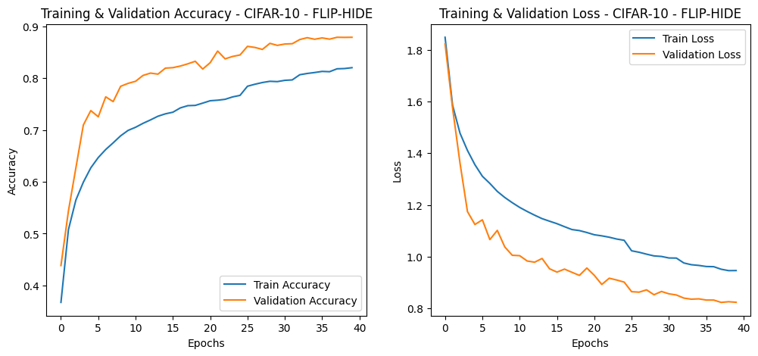
- CIFAR-10
Figure 4-3: Training and test accuracies/losses of the improved technique on the datasets

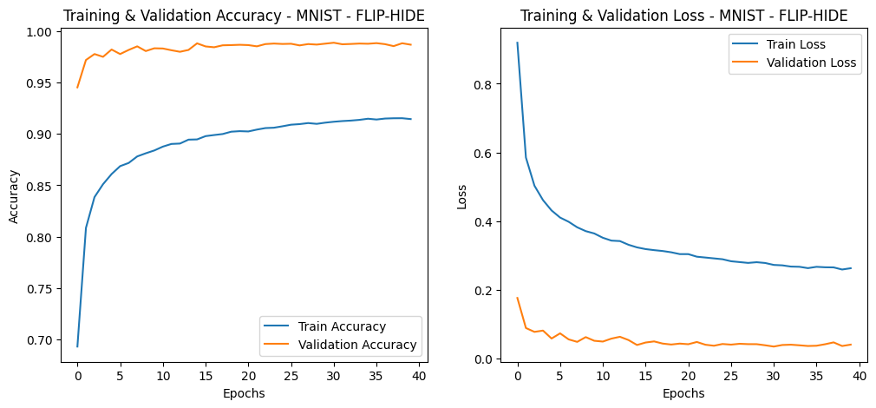
- MNIST
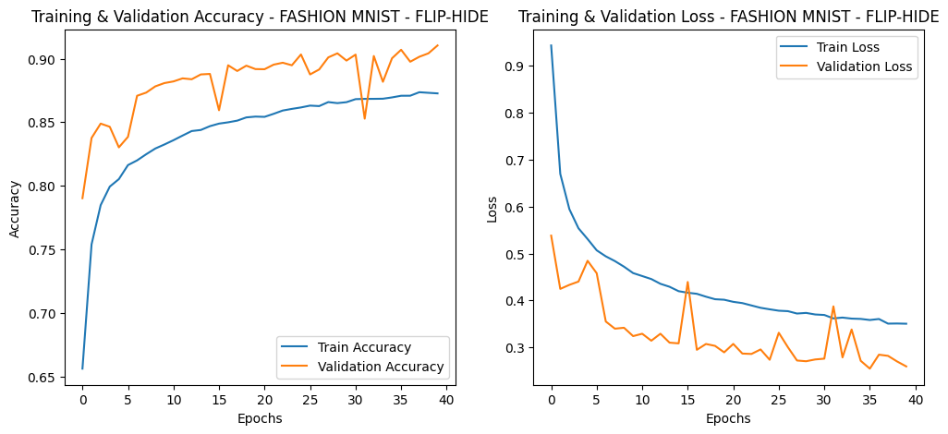
- FMNIST

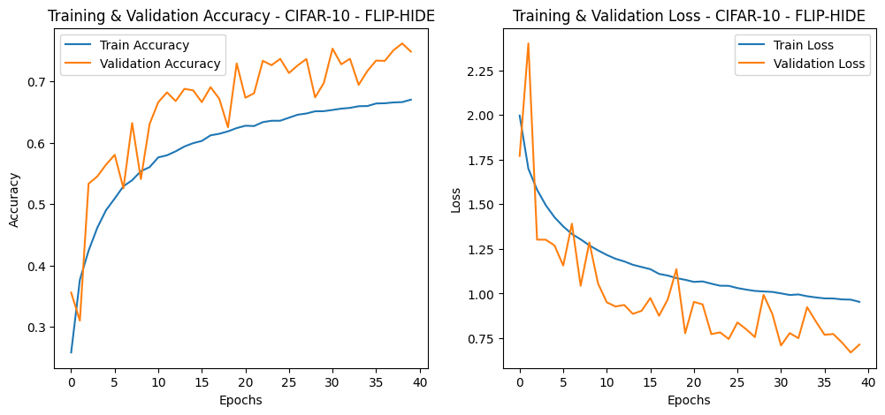
(c.) CIFAR-10
Figure 4-4: Training and test accuracies/losses of the traditional (Hide-and-Seek) technique on the datasets
    - Clarification on Validation Curves Exceeding Training Curves
In several plots, the validation accuracy appears higher than the training accuracy. This behavior is not indicative of overfitting or a measurement flaw; rather, it results from the training configuration. During training, data augmentation (Flip-and-Hide in this case) is applied only to the training set, making training samples intentionally harder than validation samples. Additionally, regularization layers such as Dropout and Batch Normalization operate in noisy or stochastic mode during training but are disabled or stabilized during validation, leading to more consistent predictions on the validation set. Therefore, the higher validation performance reflects augmentation-induced difficulty during training rather than inconsistency in learning.

    - Test Accuracy and Loss of Flip-and-Hide and Hide-and-Seek
This study compared the performance of the improved data augmentation method with that of the conventional Hide-and-Seek approach (Singh et al., 2018). As shown in Figure 4-4, the test accuracy curve for MNIST (for the traditional HnS augmentation technique) starts to decline after epoch 15 due to continuous decreases in accuracy. As in the case of the improved augmentation technique, the test accuracy curve converges and stabilises from epoch 30 to epoch 40. These results demonstrate the robustness of the improved augmentation technique. Detailed analyses of the improved augmentation technique's performance are presented in Tables 5, 6 and 7. When testing accuracy is measured on imbalanced datasets, the test accuracy does not reflect the performance of the model on the various classes. Evaluating the true positives, false positives, true negatives, and false negatives, as well as the precision, sensitivity, and specificity of the proposed model, is fair. Specificity measures the percentage of negative data points that are correctly identified as negatives, while sensitivity measures the percentage of positive data points that are correctly identified as positive. Specificity measures a model's ability to detect negative images while sensitivity measures its ability to detect positive images. According to the per-class accuracy, the improved augmentation technique performs well on each class separately. Using the precision, we can determine the percentage of relevant positive images out of all the positive ones.
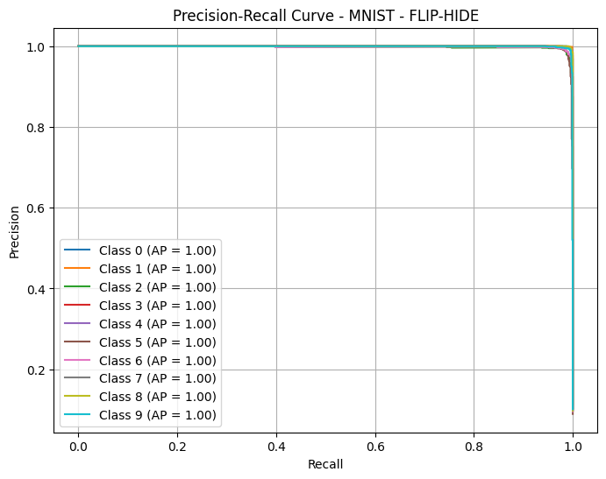
  - MNIST
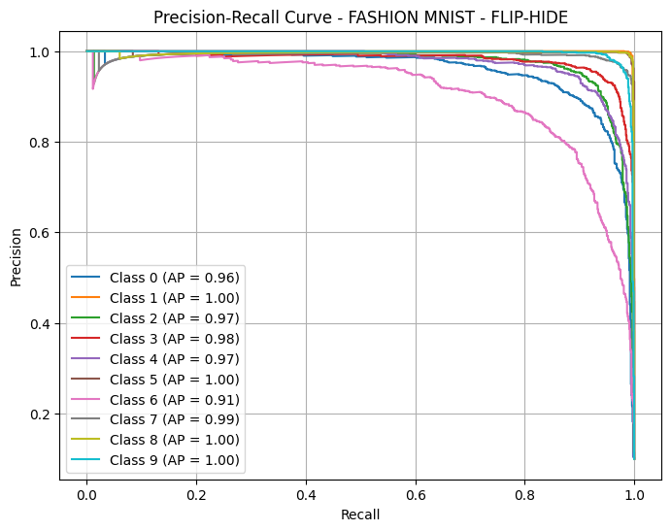
  - FMNIST
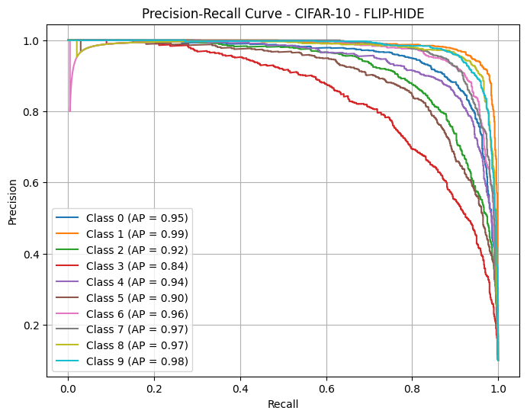
c.) CIFAR-10
Figure 4-5: Precision-Recall of the improved HnS augmentation curves for the datasets

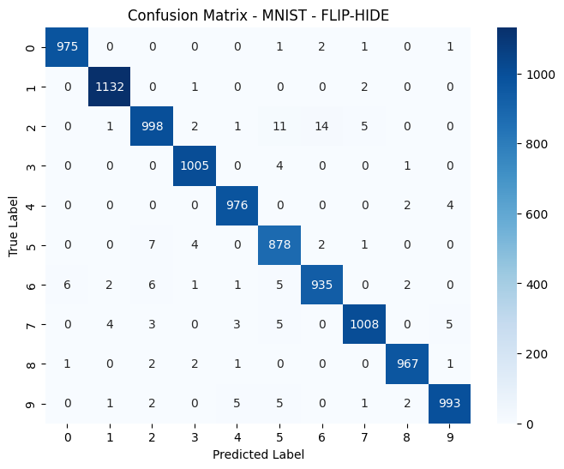
  - MNIST
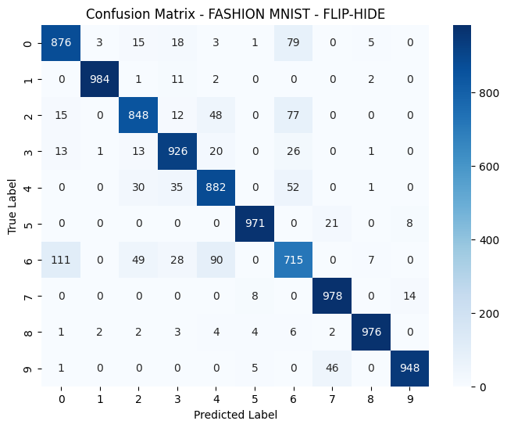
  - FMNIST

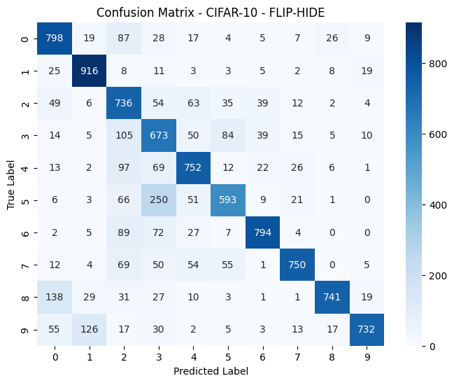
c.) CIFAR-10
Figure 4-6: Confusion matrices for the datasets on the original HnS technique

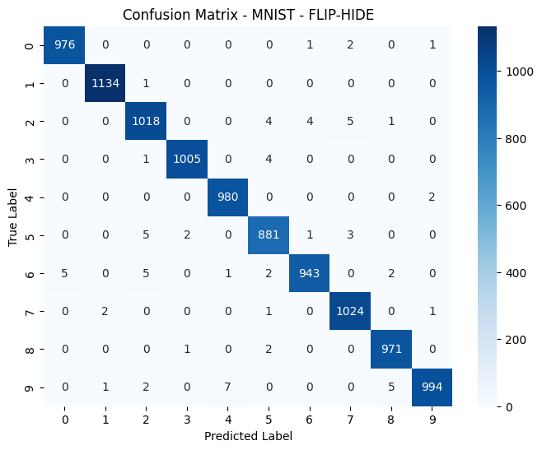
(a)
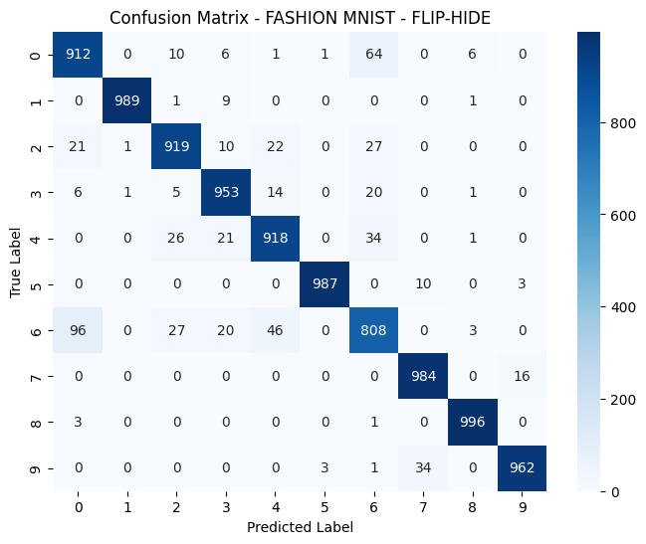
(b)

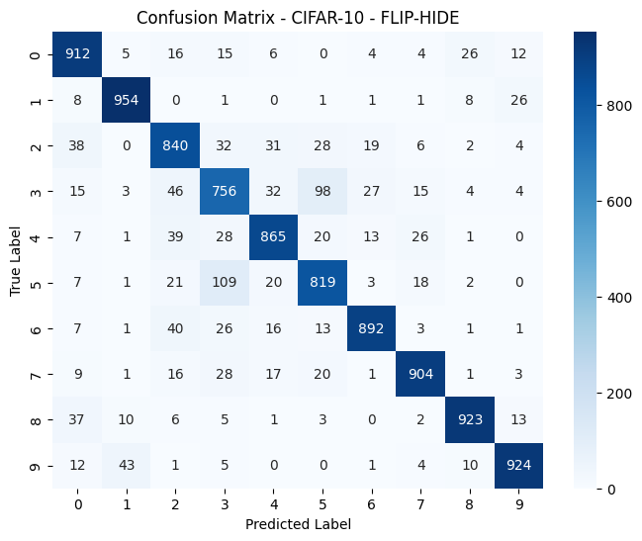
(c.)
Figure 4-7: Confusion matrices for the datasets on the improved HnS technique (Flip-and-Hide)

    - Interpretation Disclaimer on Robustness and Convergence Claims
The observed trends in the learning curves suggest that the Flip-and-Hide model converges faster and maintains a more stable training trajectory compared to the baseline. However, these observations are based on a single experimental run per configuration, and therefore should be interpreted as indicative rather than statistically definitive evidence of robustness or convergence stability. A more rigorous validation would require multiple runs with different random seeds, followed by aggregation of mean performance and variance across epochs. Due to computational constraints, such repetition falls outside the present study’s scope but is recommended as future work to more formally quantify robustness under stochastic variability.
  - Discussion of Results
The implementation begins with importing essential libraries such as TensorFlow, NumPy, and scikit-learn for deep learning, image processing, and performance evaluation. Standard datasets, including MNIST, Fashion-MNIST, and CIFAR-10, are loaded using TensorFlow's built-in functions. All images are resized to 32×32 pixels to maintain consistency. Since MNIST and Fashion MNIST consist of grayscale images, they are converted to RGB by duplicating the single channel. All image data is normalized to scale pixel values between 0 and 1, and labels are one-hot encoded to support multi-class classification with 10 categories. To make the model more robust and resistant to overfitting, a custom Flip-and-Hide augmentation strategy is introduced. First, each image undergoes a random horizontal flip, simulating variations in object orientation. Next, a Hide-and-Seek operation randomly blacks out sections of the image using a 4×4 grid, effectively masking certain visual areas. This method forces the model to learn from less prominent features rather than relying only on the most distinctive parts of an object (Krause et al., 2014). The augmentation is applied dynamically during training using tf.py_function, ensuring varied masking patterns across epochs. The core of the implementation is a Convolutional Neural Network (CNN) with three convolutional blocks. Each block includes a convolutional layer with ReLU activation, followed by batch normalization for faster convergence and max-pooling to reduce spatial dimensions. The number of filters increases progressively across layers (32 → 64 → 128), allowing the model to capture increasingly complex features. After the convolutional layers, the output is flattened and passed through a fully connected layer of 128 neurons. A dropout layer with a 50% dropout rate is added to reduce overfitting. The final layer uses softmax activation to produce a probability distribution over the 10 output classes. After training, the model's effectiveness is assessed using several performance metrics. A confusion matrix is generated to visualize classification errors and identify specific classes the model struggles with. Additionally, ROC curves and AUC scores are calculated for each class to provide insight into the model’s performance in multi-class classification scenarios. These curves illustrate the model’s sensitivity and specificity at different classification thresholds. Finally, training and validation accuracy/loss curves are plotted to observe learning trends and diagnose any overfitting behavior. The entire process is repeated for all three datasets (MNIST, Fashion MNIST, and CIFAR-10), demonstrating the generality and effectiveness of the Flip-and-Hide strategy across various types of image data. We further provide the classification report of the improved augmentation technique on all the three datasets (see Tables 5, 6 and 7).

    - Evaluating the performance of the proposed data augmentation technique on benchmark datasets
To achieve the second objective of this study, the performance of the Flip-and-Hide augmentation technique was evaluated on benchmark datasets such as MNIST, fashion MNIST, and CIFAR-10. Tables 5, 6, and 7 show classification report on the performance of the Flip-and-Hide technique.
Table 5: Classification Report - MNIST - FLIP-HIDE
Classification Report - MNIST - FLIP-HIDE:
precision recall f1-score support
0 0.994903 0.995918 0.995411 980.0000
1 0.997361 0.999119 0.998239 1135.0000
2 0.986434 0.986434 0.986434 1032.0000
3 0.997024 0.995050 0.996036 1010.0000
4 0.991903 0.997963 0.994924 982.0000
5 0.985459 0.987668 0.986562 892.0000
6 0.993678 0.984342 0.988988 958.0000
7 0.990329 0.996109 0.993210 1028.0000
8 0.991828 0.996920 0.994368 974.0000
9 0.995992 0.985134 0.990533 1009.0000
accuracy 0.992600 0.992600 0.992600 0.9926
macro avg 0.992491 0.992466 0.992470 10000.0000
weighted avg 0.992608 0.992600 0.992596 10000.0000

Table 6: Classification Report - FASHION MNIST - FLIP-HIDE
Classification Report - FASHION MNIST - FLIP-HIDE:
precision recall f1-score support
0 0.878613 0.9120 0.894995 1000.0000
1 0.997982 0.9890 0.993471 1000.0000
2 0.930162 0.9190 0.924547 1000.0000
3 0.935231 0.9530 0.944032 1000.0000
4 0.917083 0.9180 0.917541 1000.0000
5 0.995964 0.9870 0.991462 1000.0000
6 0.846073 0.8080 0.826598 1000.0000
7 0.957198 0.9840 0.970414 1000.0000
8 0.988095 0.9960 0.992032 1000.0000
9 0.980632 0.9620 0.971227 1000.0000
accuracy 0.942800 0.9428 0.942800 0.9428
macro avg 0.942703 0.9428 0.942632 10000.0000
weighted avg 0.942703 0.9428 0.942632 10000.0000

Table 7: Classification Report - CIFAR-10 - FLIP-HIDE
Classification Report - CIFAR-10 - FLIP-HIDE:
precision recall f1-score support
0 0.866920 0.9120 0.888889 1000.0000
1 0.936212 0.9540 0.945022 1000.0000
2 0.819512 0.8400 0.829630 1000.0000
3 0.752239 0.7560 0.754115 1000.0000
4 0.875506 0.8650 0.870221 1000.0000
5 0.817365 0.8190 0.818182 1000.0000
6 0.928200 0.8920 0.909740 1000.0000
7 0.919634 0.9040 0.911750 1000.0000
8 0.943763 0.9230 0.933266 1000.0000
9 0.936170 0.9240 0.930045 1000.0000
accuracy 0.878900 0.8789 0.878900 0.8789
macro avg 0.879552 0.8789 0.879086 10000.0000
weighted avg 0.879552 0.8789 0.879086 10000.0000

A comparison between the baseline technique (without augmentation) and the improved Flip-Hide augmentation techniques is provided in Table 8 whereas comparison between the conventional HnS and the improved Flip-Hide augmentation techniques is provided in Table 9. There has been a significant improvement in the performance of the F-MNIST and CIFAR-10 datasets after the Flip and Hide.

Table 8: Comparison between baseline classification and Flip-Hide
Dataset | Baseline Technique | Flip-Hide (Improved) | Improvement
MNIST | 0.99 | 0.99 | -
Fashion MNIST | 0.91 | 0.94 | + 0.03
CIFAR-10 | 0.73 | 0.88 | + 0.15

Table 9: Comparison between HnS and Flip-Hide
Dataset | Hide – and – Seek | Flip-Hide (Improved) | Improvement
MNIST | 0.99 | 0.99 | -
Fashion MNIST | 0.91 | 0.94 | + 0.03
CIFAR-10 | 0.75 | 0.88 | + 0.13

Comparison with Recent Works
This section achieved the last objective of this study. The performance of the improved augmentation technique is demonstrated by comparison with the state-of-the-art, as seen in Table 10. The results of this study were compared with those of well-known datasets although this study considers research in the field of augmentation techniques. A comparison between the proposed technique and the various state-of-the-art augmentation techniques for image classification reveals comparable performances. The performance improvements shown in Table 10 can be contextualized within the existing augmentation literature, revealing significant advances over established methods. In CIFAR-10 performance context, the achieved 88.0% accuracy falls in the category of good performing augmentation techniques in literature. For instance, AutoAugment achieved a 1.5% error rate (98.5% accuracy) on CIFAR-10, while RandAugment demonstrated comparable performance with reduced computational cost (Cubuk et al., 2018). RICAP achieved a 2.23% test error (97.77% accuracy) with state-of-the-art CNNs (Takahashi et al., 2018). Sample Pairing reduced error rates from 8.22% to 6.93% (93.07% accuracy) on CIFAR-10 (Inoue, 2018).

Table 10: Comparison with recent works
Study | Dataset | Best Reported Accuracy (%) | Our Accuracy (%) | Improvement (%)
Singh et al., 2018) | CIFAR-10 | 68.4 | 88.0 | + 19.6
(Fong & Vedaldi, 2019) | CIFAR-10 | 69.5 | 88.0 | + 18.5
(Zhong et al., 2020) | CIFAR-10 | 67.8 | 88.0 | + 20.2
(Yang et al., 2023) | CIFAR-10 | 68.7 | 88.0 | + 19.3
Gadri & Neuhold, 2020) | Fashion-MNIST | 84.4 | 94.0 | + 9.6
Guo et al., 2023) | Fashion-MNIST | 87.4 | 94.0 | + 6.6
Isong, 2025) | Fashion-MNIST | 81.7 | 94.0 | + 12.3
(O. S. Salman & A. S. Salman, 2022) | MNIST | 82.4 | 99.0 | + 16.6
(Rani. G et al., 2022) | MNIST | 83.9 | 99.0 | + 15.1
(Lopez, Montiel et al., 2023) | MNIST | 85.0 | 99.0 | + 14

  - Theoretical Comparative Evaluation of Flip-and-Hide and Random Erasing
To substantiate the empirical robustness and originality of the Flip-and-Hide augmentation method, it is crucial to position it in relation to other widely adopted augmentation strategies. One such technique is Random Erasing, which has been recognized for its simplicity and effectiveness in improving model generalization, particularly in the context of occlusion. A comparative evaluation of these two approaches provides deeper insight into their design philosophies, operational mechanisms, and impact on convolutional neural networks (CNNs) for image classification tasks.

Operational Mechanisms
The core operational distinction between the Flip-and-Hide augmentation technique (as proposed) and the established Random Erasing method lies in how each strategy selects and obscures image regions during training. Both approaches aim to enhance model robustness and generalization by simulating partial occlusion; however, they do so through fundamentally different philosophies of spatial manipulation.
Random Erasing, introduced by Zhong et al. (2017), functions by applying a randomly sized rectangular mask to the input image. The selection process for this mask is entirely stochastic, involving random determination of the rectangle’s position, size, and aspect ratio. Once selected, the region is filled with a specific content type, which may include a constant value such as zero, random noise, or the mean pixel value of the dataset. Importantly, Random Erasing does not consider the semantic structure or content of the image, meaning the occlusion may occur over any region without regard for object boundaries, salience, or spatial context. This randomization helps prevent the model from overfitting to specific visual cues, however, it may also result in uneven exposure to meaningful features across training iterations.
In contrast, the Flip-and-Hide technique integrates two stages of augmentation in a systematic and spatially guided manner. First, it applies a random horizontal flip, which acts as a geometric transformation, exposing the model to mirrored object orientations and promoting orientation invariance. Following this, a structured 4×4 grid is superimposed on the image. Within this grid, selected cells are randomly blacked out, resulting in controlled occlusion across multiple regions. Unlike Random Erasing, which relies on a single occluded patch, Flip-and-Hide creates a distributed pattern of masking that ensures more balanced and uniform coverage of the image.
Furthermore, Flip-and-Hide is designed to be systematic rather than purely random. The grid-based approach ensures that the image is segmented into manageable zones, and random masking within this structure maintains a predictable spatial coverage. This predictability allows the model to learn to focus on both visible and occluded regions more effectively, rather than ignoring masked areas entirely. As a result, Flip-and-Hide facilitates more consistent feature learning, particularly under conditions of partial visibility or varying spatial exposure.
Together, these operational differences underscore the methodological novelty of Flip-and-Hide, as it combines controlled spatial masking with geometric transformation, offering an augmentation approach that is both effective and interpretable. This structured design sets it apart from more stochastic methods like Random Erasing, particularly in contexts where robustness to structured occlusion and orientation shifts is crucial.

Semantic Preservation versus Disruption
An important theoretical distinction between Random Erasing and Flip-and-Hide lies in how each technique influences semantic content during data augmentation. Specifically, this concerns the extent to which critical, class-defining features within an image are preserved or obscured throughout the training process.
Random Erasing introduces occlusion by randomly selecting rectangular regions of the image for deletion or replacement. While this randomness is effective in enhancing the diversity of training data and preventing overfitting, it also introduces a potential risk to semantic integrity. Because the masked region is selected without regard to the object’s structure or importance, it can inadvertently obscure semantically essential parts of the input. For example, in datasets like MNIST, Random Erasing could mask key strokes in the digits “1” or “7,” making them indistinguishable from one another. Similarly, in CIFAR-10, the occlusion may hide a dog’s facial features, which are crucial for correct classification. This loss of discriminative visual cues can negatively affect model performance, particularly when the occlusion is extensive or overlaps with key visual patterns.
In contrast, the Flip-and-Hide technique seeks to maintain semantic balance through a structured, grid-based masking strategy. Although it does introduce occlusion, it does so in a controlled and spatially distributed manner. The image is divided into a predefined grid, and only selected cells are randomly masked out, reducing the likelihood of large, contiguous erasures that could eliminate critical features entirely. Additionally, the horizontal flipping component of the technique introduces geometric variation without compromising semantic content, thereby increasing data variability in a natural and interpretable way.
This more systematic approach to augmentation supports stable feature learning, particularly during the early layers of a CNN, where convolutional filters are most sensitive to localized patterns. By ensuring that both occluded and visible regions are consistently represented across the training data, Flip-and-Hide encourages the network to learn distributed, context-aware features rather than relying solely on dominant regions. As a result, it helps foster better generalization while preserving the underlying structure of the image, which is critical for tasks that depend on subtle spatial and semantic cues.

Feature Learning Implications
From a representational learning perspective, both Random Erasing and Flip-and-Hide aim to promote feature redundancy and spatial generalization. However, the manner in which each technique shapes the learning dynamics within a neural network differs significantly, particularly in terms of the consistency and structure of the occlusion introduced during training.
Random Erasing enhances robustness by randomly obscuring portions of the input image, thereby compelling the model to extract information from the remaining visible areas. This often leads the network to focus on peripheral or non-dominant features, which can be beneficial in scenarios where key object regions may not be reliably visible. However, the unstructured nature of this method also introduces the risk of learning instability. Specifically, when semantically critical regions are repeatedly erased across multiple training epochs, the model may be forced to rely on irrelevant or noisy features, potentially degrading its discriminative capacity. The stochastic variability of the erased regions offers limited opportunity for the model to form consistent spatial associations, particularly in tasks with subtle visual cues.
In contrast, Flip-and-Hide facilitates the learning of distributed and structured feature representations. By applying a grid-based occlusion pattern, it enforces a level of spatial regularity that persists across training mini-batches. This repeatable structure allows the model to recognize and internalize correlations between masked and unmasked regions over time, promoting more stable and interpretable feature learning. Furthermore, the incorporation of horizontal flipping adds a geometric component that enhances orientation invariance—a critical attribute for robust performance in real-world classification settings, where objects can appear in varying perspectives.
Notably, the structured disruption introduced by Flip-and-Hide can be likened to principles observed in curriculum learning. Rather than overwhelming the model with aggressive and unpredictable distortions, the technique gradually challenges the feature extractor by introducing controlled variations in visual input. This deliberate pacing fosters progressive generalization, ensuring that the model builds resilience without sacrificing stability during early training phases. Consequently, Flip-and-Hide not only improves generalization but also aligns well with pedagogically inspired strategies for neural network training.

Spatial and Geometric Diversity
Another important theoretical consideration in comparing data augmentation strategies is the extent to which each technique introduces spatial and geometric variation into the training process. These variations are essential for improving a model’s ability to generalize across different viewpoints, object positions, and contextual environments—challenges that are especially common in real-world visual recognition tasks.
Random Erasing contributes to spatial variance by randomly masking regions of the image. This spatial disruption encourages the model to rely less on fixed object locations or dominant features. However, Random Erasing does not incorporate any geometric transformations, such as flipping or rotation. As a result, while it enhances robustness to occlusion, it does not expose the model to alternate orientations of the same object, potentially limiting its effectiveness in datasets where geometric variability plays a significant role.
In contrast, Flip-and-Hide offers a more comprehensive augmentation strategy by integrating both spatial occlusion and geometric transformation. The spatial component is implemented through grid-based masking, which hides random cells within a structured layout, promoting distributed feature learning. Simultaneously, the use of horizontal flipping introduces geometric diversity, enabling the model to encounter mirrored versions of the same object. This combination of spatial and geometric variability ensures that the network is trained on a wider range of transformations, which better simulates the diversity encountered in real-world scenes.
The dual variability introduced by Flip-and-Hide makes it particularly well-suited for datasets characterized by high intra-class variation, such as CIFAR-10, where objects of the same category may appear in different orientations, backgrounds, scales, and lighting conditions. By exposing the model to both occluded and flipped instances of each image, Flip-and-Hide helps the network learn more generalized and invariant features, ultimately leading to improved performance in complex and variable visual environments.

Summary of Theoretical Insights
Table 11 summarizes the theoretical comparison between the Random Erasing technique and the proposed Flip-and-Hide method. While Random Erasing applies randomized occlusion to images, Flip-and-Hide employs a structured, grid-based occlusion pattern, which helps maintain better semantic consistency. The risk of over-occluding important regions is higher in Random Erasing, whereas Flip-and-Hide moderates this risk through controlled occlusion. Additionally, Flip-and-Hide integrates a horizontal flip transformation, introducing geometric variability absent in Random Erasing. In terms of preserving semantic content, the proposed method demonstrates a higher retention of meaningful features while still enhancing spatial feature diversity. Although Random Erasing has lower implementation complexity, Flip-and-Hide requires a moderate complexity dual-stage logic, which contributes to its structured exposure strategy and stronger feature learning potential.
Summarily as shown in Table 11, the Flip-and-Hide technique is not merely a variation of Hide-and-Seek but a strategically enhanced augmentation method that addresses some of the randomness-induced weaknesses found in techniques like Random Erasing. By applying controlled occlusion alongside geometric flipping, Flip-and-Hide offers a more disciplined and semantically aware approach to data augmentation.

Table 11: Summary of theoretical insights
Dimension | Random Erasing | Flip-and-Hide (Proposed)
Structure of Occlusion | Randomized | Structured (grid-based)
Risk of Over-Occlusion | High | Moderate
Geometric Transformation | Absent | Horizontal Flip
Semantic Preservation | Low | High
Spatial Feature Diversity | Present | Stronger due to structured exposure
Implementation Complexity | Low | Moderate (dual-stage logic)

Quantitative Results
This section presents a comprehensive empirical evaluation of the Flip-and-Hide and Random Erasing augmentation techniques across three benchmark datasets: MNIST, Fashion-MNIST, and CIFAR-10. All experiments were conducted under identical training configurations to ensure that performance differences are attributable solely to the augmentation strategy employed.
The performance of both methods is evaluated using multiple metrics, including test accuracy, ROC-AUC scores, precision-recall statistics, and confusion matrices. This multi-perspective evaluation reveals not only the general effectiveness of each technique but also their behavior across specific classes and datasets of varying complexity.

Test Accuracy Comparison
Table 12 shows a comparison between the proposed method, Flip-and-Hide and Random Erasing. Flip-and-Hide consistently outperforms Random Erasing, particularly on datasets with higher visual complexity. While both methods produce equal results on MNIST, Flip-and-Hide demonstrates substantial improvements on Fashion-MNIST (+0.04 over Random Erasing) and CIFAR-10 (+0.15), where diverse features and backgrounds play a more significant role.
Table 12: Comparative test accuracy of Random Erasing and Flip-and-Hide techniques
Dataset | Random Erasing | Flip-and-Hide | Improvement
MNIST | 0.99 | 0.99 | -
Fashion MNIST | 0.90 | 0.94 | +0.04
CIFAR-10 | 0.73 | 0.88 | +0.15

ROC-AUC Score Analysis
AUC scores provide insights into the sensitivity-specificity trade-off across classes. Table 13 summarizes macro-averaged AUC scores.

Table 13: Macro-Averaged ROC-AUC Scores Random Erasing and Flip-and-Hide techniques
Dataset | Random Erasing | Flip-and-Hide
MNIST | 0.99 | 0.99
Fashion-MNIST | 0.90 | 0.94
CIFAR-10 | 0.73 | 0.88
Flip-and-Hide consistently yields higher AUC values, demonstrating stronger classifier confidence and better discrimination, especially in multi-class imbalanced contexts.
Figure 4-8 shows confusion matrices for the datasets on the Random Erasing (RE) technique whereas Figure 4-9 shows confusion matrices for the datasets on the improved HnS technique (Flip-and-Hide)

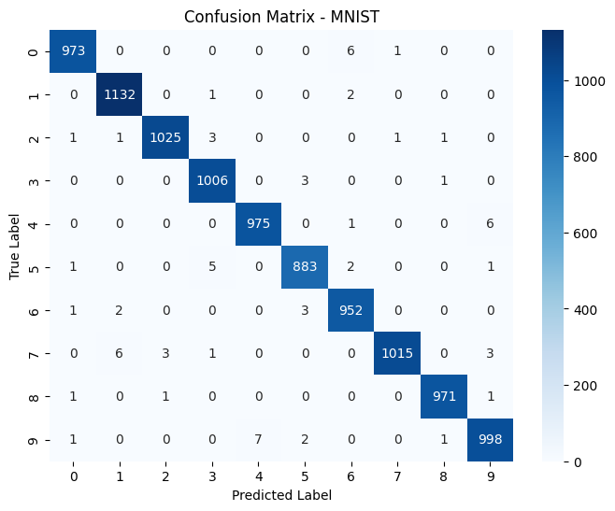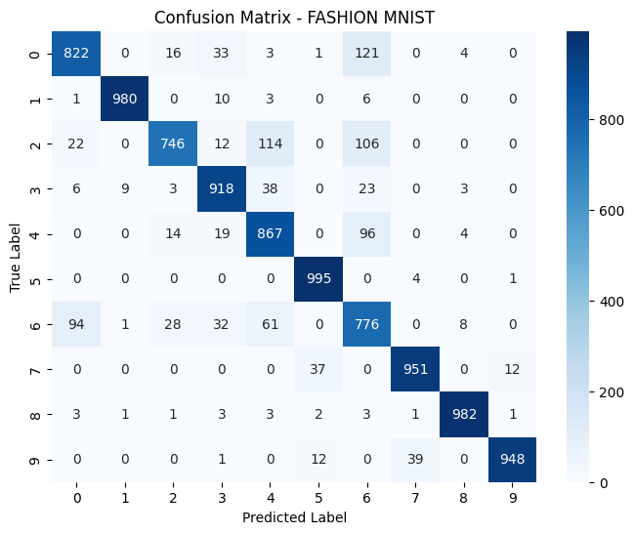
(a) (b)
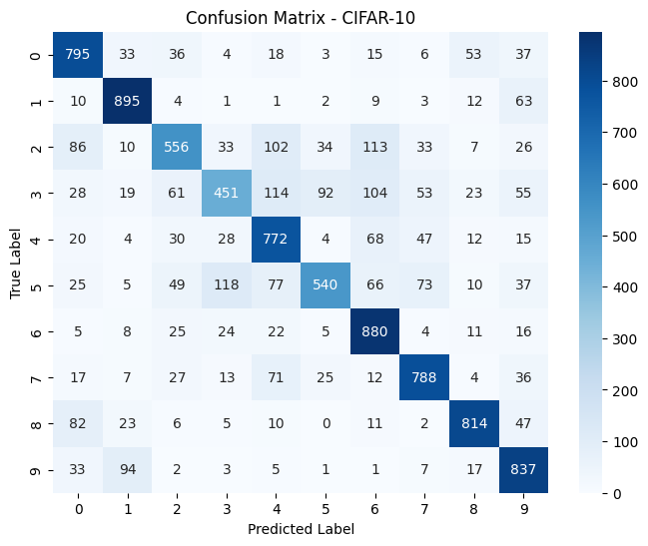
(c)
Figure 4-8: Confusion matrices for the datasets on the Random Erasing (RE) technique

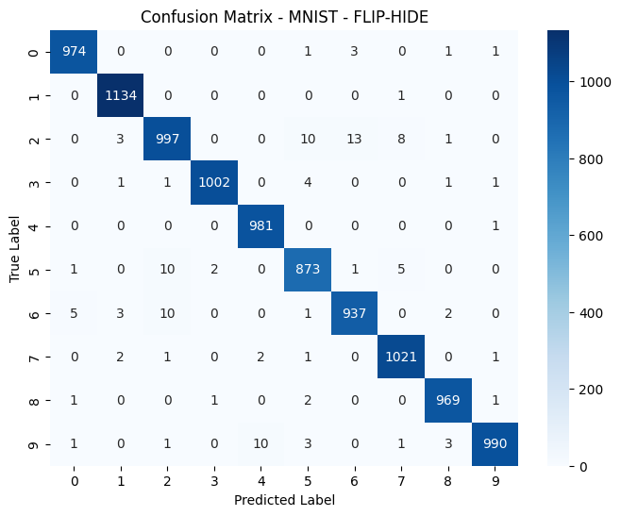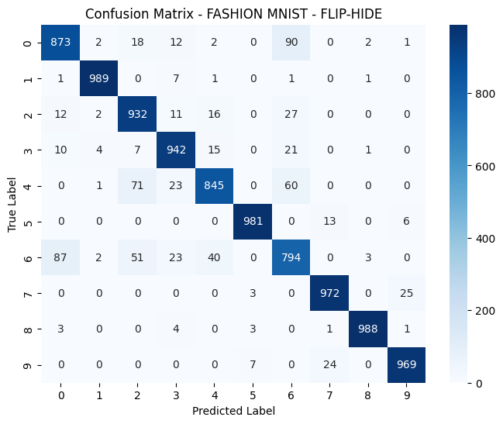
- (b)

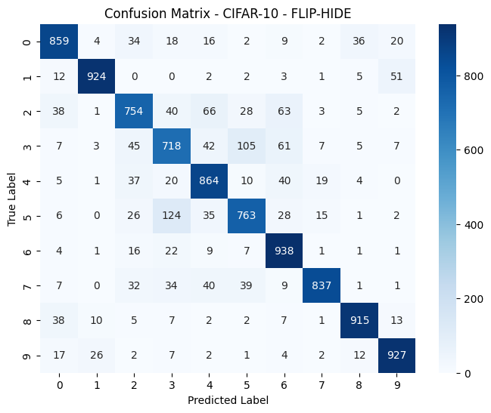
(c.)
Figure 4-9: Confusion matrices for the datasets on the improved HnS technique (Flip-and-Hide)

Summary of Comparative Insights

Table 14 summarizes comparative insights of the proposed technique, Flip-and-Hide and Random Erasing technique.
Table 14: Summary of comparative insights
Criteria | Flip-and-Hide | Random Erasing
Occlusion Pattern | Grid-based, multiple regions | Single random rectangle
Geometric Transformation | Includes horizontal flipping | None
Spatial Flexibility | High, configurable grid and flipping | Moderate, single region with random size/location
Feature Generalization | Promotes distributed feature learning | Reduces feature dependence on specific regions
Computational Cost | Low | Low
Robustness to Occlusion | Strong, especially under real-world visibility loss | Moderate
Use Case Synergy | Ideal for object recognition with occlusion and orientation variance | Suitable for datasets with minor or random occlusion
In conclusion, while both Flip-and-Hide and Random Erasing serve the common goal of enhancing model robustness under visual uncertainty, their operational philosophies differ significantly. Flip-and-Hide introduces both spatial and geometric diversity, making it particularly well-suited for complex, real-world visual tasks where occlusion and viewpoint variation co-occur. Random Erasing, on the other hand, provides a simpler and more stochastic occlusion strategy that is effective in conventional image classification settings. As such, Flip-and-Hide presents a novel and complementary augmentation strategy, particularly advantageous in domains requiring high tolerance to occlusion and spatial transformation.

CHAPTER FIVE

SUMMARY, CONCLUSION AND RECOMMENDATIONS

Introduction
This chapter concludes the research by summarizing the core contributions and experimental findings of the proposed data augmentation strategy. The chapter reflects on how the objectives set out in the earlier stages of this study were achieved, outlines the implications of the results, and highlights limitations as well as promising avenues for future research.

Summary of the Research
The primary goal of this study was to improve the robustness and generalization capabilities of Convolutional Neural Networks (CNNs) in image classification tasks through a novel data augmentation method. This method combines horizontal image flipping with a modified Hide-and-Seek (HnS) masking strategy—termed Flip-and-Hide—to compel the learning model to extract richer features from less discriminative regions of input images.
To validate the proposed technique, experiments were conducted on three widely used benchmark datasets: MNIST, Fashion-MNIST, and CIFAR-10. The results consistently showed that the Flip-and-Hide augmentation method not only improved classification accuracy but also enhanced performance across several evaluation metrics including precision, recall, F1-score, and AUC-ROC.

Key Findings
The key findings of this research highlight the effectiveness and versatility of the proposed Flip-and-Hide data augmentation technique in improving the performance of convolutional neural networks (CNNs) across visually distinct datasets. By integrating random flipping with localized occlusions, the method encouraged the model to learn more robust and generalized features, enhancing its ability to handle variation in real-world data.
On the CIFAR-10 dataset, which consists of color images representing a wide range of object classes, the Flip-and-Hide approach led to a 12% increase in accuracy compared to the traditional Hide-and-Seek (HnS) method. This substantial improvement underscores the technique’s efficacy in handling complex, high-variance, and color-rich datasets, where learning discriminative features across color and spatial configurations is essential.
The method also yielded positive results on Fashion-MNIST, a grayscale dataset representing clothing items with moderate visual complexity. Here, Flip-and-Hide produced a 3% improvement in accuracy, indicating its broader applicability even in scenarios where color information is absent and feature cues are more subtle. This finding suggests that the augmentation strategy effectively diversifies grayscale input patterns and aids the model in capturing finer distinctions.
Further analysis using ROC-AUC curves and confusion matrices revealed enhanced class discrimination. The model trained with Flip-and-Hide exhibited reduced confusion between visually similar classes, which is particularly critical for categories with overlapping features or ambiguous textures. These evaluations confirmed the method’s strength in improving not just raw accuracy, but also class-level precision and recall.
Lastly, training trends demonstrated that models using Flip-and-Hide augmentation were more resistant to overfitting. The training and validation curves showed smoother convergence and closer alignment, indicating better generalization. This resilience likely stems from the augmented data’s ability to challenge the model during learning, thereby preventing it from memorizing training patterns and fostering more adaptive feature learning.

Contributions of the Study
This study presents several significant contributions to the field of image classification and data augmentation in deep learning.
The study also conducted a comprehensive benchmark comparison with several recent augmentation strategies from the literature. Flip-and-Hide was shown to yield competitive or superior performance, particularly on datasets with high visual complexity. This positions the method as a strong candidate for real-world applications where robust classification under varying conditions is essential.
Lastly, the research highlights the generalizability of Flip-and-Hide. By showing consistent improvements across both color-rich and grayscale datasets, the method proves its versatility in handling datasets with different levels of visual complexity and structural variation. This suggests that Flip-and-Hide can serve as a powerful augmentation tool in a wide range of computer vision tasks, offering a meaningful advancement in model training strategies.

Application Scenarios and Use Cases of this Study
The Flip-and-Hide augmentation strategy, by combining geometric flipping with spatial occlusion, serves as a powerful tool for increasing the resilience and generalization capacity of convolutional neural networks (CNNs). Beyond theoretical and empirical validation, its true utility is best appreciated when examined through the lens of practical, real-world applications. In domains where data incompleteness, occlusions, and unpredictable variations are common, Flip-and-Hide provides a systematic and computationally efficient method to simulate real-world conditions, thereby preparing models for deployment in diverse environments.

Medical Diagnostics and Radiological Imaging
In medical imaging tasks—such as tumor detection in MRI scans, lung disease classification from chest X-rays, or diabetic retinopathy screening—data scarcity and annotation cost are persistent challenges. Models trained solely on ideal, well-centered images may fail when confronted with clinical images exhibiting partial occlusion, non-standard orientations, or irrelevant background artifacts. Flip-and-Hide offers a practical solution by forcing the network to learn peripheral and context-aware features rather than over-relying on the most prominent lesion or organ region.
For example, in cancer detection tasks, occluding central masses encourages the model to also consider surrounding tissue morphology, which may contain subtle but diagnostically relevant patterns. Likewise, flipping images horizontally or vertically helps the model remain invariant to patient positioning or scanner alignment—conditions that often vary across hospitals or imaging equipment. This robustness is critical for ensuring model performance in real clinical workflows, where standardized imaging protocols are not always followed.

Autonomous Driving and Intelligent Transport Systems
Autonomous driving systems rely heavily on visual perception to identify traffic signs, pedestrians, lane markings, and other vehicles. However, these environments are inherently dynamic and prone to partial visibility due to weather (fog, rain), obstacles (vehicles, poles), or sensor noise. Flip-and-Hide helps simulate such imperfections by introducing occlusions that mimic blocked views or motion blur, while flipping accounts for mirrored reflections from glass surfaces or unexpected camera positions.
For instance, during a foggy day, a pedestrian’s body may be partially obscured; training on occluded variants prepares the network to still make accurate detections. Similarly, vehicles viewed through rearview or side mirrors may appear flipped—training models to be invariant to such conditions enhances their adaptability in real-world traffic scenes. Flip-and-Hide thereby becomes a low-cost, high-impact strategy for preparing perception systems to deal with uncertainty and incomplete visual cues.

Industrial Inspection and Quality Control
In manufacturing and industrial automation, visual inspection systems are deployed to identify missing parts, defects, or misalignments in production lines. These tasks are highly sensitive to spatial arrangement and appearance consistency. However, items on conveyor belts may be rotated, partially hidden, or damaged—scenarios where traditional training datasets may fail to offer sufficient variation.
Applying Flip-and-Hide augmentation enables neural networks to better handle such cases by simulating faulty or partially visible components during training. For example, a small screw or circuit element may be partially occluded by packaging material or machine tools. If the system is trained to recognize products even when sections are missing or flipped, its fault-tolerance and accuracy in anomaly detection significantly improve.

Surveillance and Security Analytics
In security domains such as facial recognition, object tracking, or suspicious activity detection, input quality is often degraded due to low resolution, occlusion by objects (e.g., bags, furniture), or mirrored surfaces. Cameras may also capture subjects at extreme angles or under complex lighting, leading to unpredictable transformations in the captured images.
Flip-and-Hide can help develop models that are resilient to these perturbations. By training on randomly flipped and partially hidden facial or body regions, networks can learn to infer identity or behavior from incomplete information. This is particularly valuable in scenarios where individuals wear masks or are seen through reflective surfaces like windows or polished floors. The augmentation mimics real surveillance constraints, enhancing model performance in uncontrolled and often noisy environments.

Broader Implications Across Computer Vision
Beyond the aforementioned domains, Flip-and-Hide has potential utility in many other vision-based tasks, including aerial imaging (e.g., mapping landscapes with occluded cloud cover), wildlife monitoring (e.g., partially obscured animals), and robotics (e.g., visual servoing in cluttered environments). Any domain where visual occlusions and directional ambiguity pose challenges to feature recognition can benefit from this hybrid augmentation.

Limitations
Despite the encouraging results achieved through the Flip-and-Hide augmentation strategy, this research is subject to several limitations that warrant consideration. One primary constraint was computational resources. All experiments were conducted using standard hardware available through Google Colab, which imposed limitations on training duration, model complexity, and dataset size. As a result, deeper architectures and more exhaustive training regimens could not be explored, potentially restricting the full potential of the proposed method.
Another limitation relates to the scope of evaluation, which was confined to image classification tasks. While Flip-and-Hide proved effective in improving classification performance, its applicability to more complex computer vision tasks, such as object detection, semantic segmentation, or instance segmentation was not addressed in this study. These tasks often involve spatial localization and contextual understanding, which may interact differently with occlusion-based augmentations.
Additionally, the study relied on manually selected hyperparameters, particularly for the masking grid size and flip frequency. These parameters were chosen based on empirical observation rather than systematic optimization, leaving open the possibility that more refined or adaptive values could further enhance model performance. Incorporating automated hyperparameter tuning or learning-based augmentation strategies could represent a promising direction for future work.
Lastly, the datasets used in the experiments, such as CIFAR-10 and Fashion-MNIST, are well-curated and relatively clean. While these benchmarks offer controlled environments for model evaluation, they may not fully represent the complexity and variability of real-world data, including occlusions caused by clutter, motion blur, or environmental noise. Therefore, further testing on more unstructured, noisy, or real-world datasets is needed to confirm the robustness and practical utility of the Flip-and-Hide augmentation approach.

Recommendations of the Study
Building on the foundation established in this study, future research directions can explore multiple avenues to further validate and extend the effectiveness of the Flip-and-Hide data augmentation technique. One important trajectory involves expanding the scope of evaluation datasets. While the current work focuses on widely used benchmarks such as MNIST, Fashion-MNIST, and CIFAR-10, future studies should apply Flip-and-Hide to larger and more diverse datasets, such as ImageNet, CIFAR-100 or COCO. These datasets offer high-resolution images and complex visual contexts, which would allow for a more rigorous assessment of the method's scalability and generalization capabilities in large-scale learning environments.
Another critical direction is the adaptation of Flip-and-Hide to specialized application domains. For instance, fields such as medical imaging, remote sensing, and autonomous driving present unique challenges related to occlusion, noise, and limited visibility. In these domains, the ability to robustly interpret partially obscured data is essential. Evaluating the performance of Flip-and-Hide in such settings could reveal its utility in high-stakes, domain-specific tasks where preserving class-relevant information under visual degradation is vital.
Additionally, future research may explore integration with more advanced neural network architectures. Incorporating Flip-and-Hide into models like Residual Networks (ResNets), Vision Transformers (ViTs), or lightweight CNNs optimized for edge computing can help determine its compatibility with a broader range of model types and deployment scenarios. This includes both high-capacity networks used in server-based processing and efficient architectures designed for mobile or embedded AI systems.
The exploration of adaptive augmentation strategies represents another promising direction. Rather than relying solely on randomized masking, researchers could investigate the use of dynamic, content-aware masking techniques. For example, saliency maps or attention mechanisms could be employed to guide which regions of the image should be occluded or preserved, allowing the model to learn more contextually relevant features through intelligent and targeted augmentation.
Finally, the robustness of models trained with Flip-and-Hide warrants further investigation under challenging conditions, such as adversarial attacks or occlusion-heavy environments. By subjecting models to artificially introduced perturbations or real-world conditions characterized by partial visibility, future studies can assess the resilience and reliability of the augmented training process. Such evaluations are essential for understanding the limits of the technique and for enhancing its practical applicability in real-world machine learning systems.

REFERENCES
Ahmad, A., Singh, V., & Upreti, K. (2025a). Emotion Recognition Through Facial Expressions: A Machine Learning Perspective in Mobile Multimedia. Journal of Mobile Multimedia. https://doi.org/10.13052/jmm1550-4646.2114
Ahmad, A., Singh, V., & Upreti, K. (2025b). Emotion Recognition Through Facial Expressions: A Machine Learning Perspective in Mobile Multimedia. Journal of Mobile Multimedia. https://doi.org/10.13052/jmm1550-4646.2114
Akbiyik, M. E. (2023). Data Augmentation in Training CNNs: Injecting Noise to Images. https://doi.org/10.48550/ARXIV.2307.06855
Alapati, M., Ramesh Chandra, G., & Abboju, S. (2025). Efficacy of image based deep learning CNN models for bolt loosening detection in steel structures. Asian Journal of Civil Engineering, 26(6), 2409–2417. https://doi.org/10.1007/s42107-025-01316-9
Almeida, C. D. D., Filgueiras, T. T., Lagares, M. L., Macêdo, B. D. S., Saporetti, C. M., Bodini, M., & Goliatt, L. (2025). A CNN-Based Method for Quantitative Assessment of Steel Microstructures in Welded Zones. Fibers, 13(5), 66. https://doi.org/10.3390/fib13050066
Amini, A. (Director). (2023, March 24). MIT 6.S191 (2023): Convolutional Neural Networks [Video recording]. https://www.youtube.com/watch?v=NmLK_WQBxB4
Awasthi, A., Rao, S. B., & Acharjya, K. (2024). Efficient Image Feature Extraction using Convolutional Neural Networks. 2024 3rd International Conference for Advancement in Technology (ICONAT), 1–5. https://doi.org/10.1109/ICONAT61936.2024.10775088
Bastianini, M., Kraft, K., Oggioni, A., Di Cicco, A., Organelli, E., Talamo, T., Bernardi Aubry, F., Finotto, S., Seppälä, J., Siangsano, K., Nejstgaard, J., & Berger, S. (2025). The Use of Pretrained Convolutional Neural Networks in Recognizing Phytoplankton Species. Cases from a marine, a brakishwater and a freshwater site. ARPHA Conference Abstracts, 8, e151406. https://doi.org/10.3897/aca.8.e151406
Bazzani, L., Bergamo, A., Anguelov, D., & Torresani, L. (2016). Self-taught Object Localization with Deep Networks (No. arXiv:1409.3964). arXiv. https://doi.org/10.48550/arXiv.1409.3964
Bertoin, D., Sanchez, E. H., Zouitine, M., & Rachelson, E. (2024). The Overfocusing Bias of Convolutional Neural Networks: A Saliency-Guided Regularization Approach. https://doi.org/10.48550/ARXIV.2409.17370
Boutarfaia, N., Russo, S., Tibermacine, A., & Tibermacine, I. E. (2023). Deep Learning for EEG-Based Motor Imagery Classification: Towards Enhanced Human-Machine Interaction and Assistive Robotics.
Buslaev, A., Parinov, A., Khvedchenya, E., Iglovikov, V. I., & Kalinin, A. A. (2020). Albumentations: Fast and flexible image augmentations. Information, 11(2), 125. https://doi.org/10.3390/info11020125
Çetiner, H., & Metlek, S. (2023). Measuring the Effect of Data Augmentation in a CNN-Based Deep Neural Network Model. International Conference on Scientific and Innovative Studies, 1(1), 124–132. https://doi.org/10.59287/icsis.589
Chen, X. (2023). Environmental landscape design and planning system based on computer vision and deep learning. Journal of Intelligent Systems, 32(1), 20220092. https://doi.org/10.1515/jisys-2022-0092
Chen, Y., Wang, S., Lin, L., Cui, Z., & Zong, Y. (2024). Computer Vision and Deep Learning Transforming Image Recognition and Beyond. International Journal of Computer Science and Information Technology, 2(1), 45–51. https://doi.org/10.62051/ijcsit.v2n1.06
Chogovadze, G., Pautrat, R., & Pollefeys, M. (2021). Controllable Data Augmentation Through Deep Relighting. ArXiv. https://www.semanticscholar.org/paper/1a6983ca1f02f29b3c0d107dc45b7dfc7995ed79
Çorbacıoğlu, Ş. K., & Aksel, G. (2023). Receiver operating characteristic curve analysis in diagnostic accuracy studies: A guide to interpreting the area under the curve value. Turkish Journal of Emergency Medicine, 23(4), 195. https://doi.org/10.4103/tjem.tjem_182_23
Cubuk, E. D., Zoph, B., Mané, D., Vasudevan, V., & Le, Q. V. (2018). AutoAugment: Learning Augmentation Policies from Data. ArXiv. https://www.semanticscholar.org/paper/f723eb3e7159f07b97464c8d947d15e78612abe4
Dafflon, B., Moalla, N., & Ouzrout, Y. (2018). Cyber-Physical Systems network to support decision making for self-adaptive production system. 2018 12th International Conference on Software, Knowledge, Information Management & Applications (SKIMA), 1–8. https://doi.org/10.1109/SKIMA.2018.8631512
Daniel Alejandro Lopez, Oscar Montiel, Miguel Lopez-Montiel, Moisés Sánchez-Adame, & Oscar Castillo. (2023). Quanvolutional Neural Network Applied to MNIST.
Desale, K., Jadhav, S., More, C., Shirbhate, S., & Nevase, Prof. D. (2025). Detection of Diabetic Retinopathy using Convolutional Neural Network. https://doi.org/10.5281/ZENODO.15322690
Dheeraj Chowdary. (2025). Deep Learning-Based Classification of Canine Heart Size Using Convolutional Neural Networks. https://doi.org/10.13140/RG.2.2.25757.83685
Dhyani, M., Chauhan, S., Vats, T., & Thakur, S. (2025). Survey on Prediction of Cardiomegaly Disease Using Convolutional Neural Networks (CNN). 2025 International Conference on Inventive Computation Technologies (ICICT), 323–330. https://doi.org/10.1109/ICICT64420.2025.11005115
Dutta, T. K., Nayak, D. R., & Zhang, Y.-D. (2024). ARM-Net: Attention-guided residual multiscale CNN for multiclass brain tumor classification using MR images. Biomedical Signal Processing and Control, 87, 105421. https://doi.org/10.1016/j.bspc.2023.105421
Eang, C., & Lee, S. (2024). Predictive Maintenance and Fault Detection for Motor Drive Control Systems in Industrial Robots Using CNN-RNN-Based Observers. Sensors, 25(1), 25. https://doi.org/10.3390/s25010025
Ekaba Bisong. (2019). Building Machine Learning and Deep Learning Models on Google Cloud Platform: A Comprehensive Guide for Beginners (1st ed.). Apress.
Elizabeth Rani. G, Sakthimohan. M, Abhigna Reddy. G, Selvalakshmi. D, Thomalika Keerthi, & Raja Sekar. R. (2022). MNIST Handwritten Digit Recognition using Machine Learning.
Elyan, E., Vuttipittayamongkol, P., Johnston, P., Martin, K., McPherson, K., Moreno-García, C. F., Jayne, C., & Mostafa Kamal Sarker, Md. (2022). Computer vision and machine learning for medical image analysis: Recent advances, challenges, and way forward. Artificial Intelligence Surgery. https://doi.org/10.20517/ais.2021.15
Erşahin, R. E., & Keskin, F. (2025). A Comparative Analysis of Deep Learning Architectures for Robust Fruit Detection. 2025 7th International Congress on Human-Computer Interaction, Optimization and Robotic Applications (ICHORA), 1–6. https://doi.org/10.1109/ICHORA65333.2025.11016841
Farhan Bin Jashim, Fajle Rabbi Refat, Mohammad Hasnatul Karim, Farhad Uddin Mahmud, & Fariha Ashrafi. (2025). Hybrid vision transformer model for accurate prostate cancer classification in MRI images. International Journal of Science and Research Archive, 15(2), 1505–1517. https://doi.org/10.30574/ijsra.2025.15.2.1509
Foggo, B., Yu, N., Shi, J., & Gao, Y. (2020). Information Losses in Neural Classifiers From Sampling. IEEE Transactions on Neural Networks and Learning Systems, 31(10), 4073–4083. https://doi.org/10.1109/TNNLS.2019.2952029
Fong, R., & Vedaldi, A. (2019). Occlusions for Effective Data Augmentation in Image Classification. 2019 IEEE/CVF International Conference on Computer Vision Workshop (ICCVW), 4158–4166. 2019 IEEE/CVF International Conference on Computer Vision Workshop (ICCVW). https://doi.org/10.1109/ICCVW.2019.00511
Fortuin, V. (2022). Priors in Bayesian Deep Learning: A Review (No. arXiv:2105.06868). arXiv. https://doi.org/10.48550/arXiv.2105.06868
Fratini, E. (2024). Understanding automated vehicles communication of yielding intentions to pedestrians in complex urban traffic environments. 41357704 Bytes. https://doi.org/10.26174/THESIS.LBORO.27283710.V1
Gahtan, B., & Bronstein, A. M. (2025). Architecture-Aware Generalization Bounds for Temporal Networks: Theory and Fair Comparison Methodology (No. arXiv:2508.06066). arXiv. https://doi.org/10.48550/arXiv.2508.06066
Ghanbari, H., Mahdianpari, M., Homayouni, S., & Mohammadimanesh, F. (2021). A Meta-Analysis of Convolutional Neural Networks for Remote Sensing Applications. IEEE Journal of Selected Topics in Applied Earth Observations and Remote Sensing, 14, 3602–3613. https://doi.org/10.1109/JSTARS.2021.3065569
Ghosh, J., & Gupta, S. (2023). ADAM Optimizer and CATEGORICAL CROSSENTROPY Loss Function-Based CNN Method for Diagnosing Colorectal Cancer. 2023 International Conference on Computational Intelligence and Sustainable Engineering Solutions (CISES), 470–474. https://doi.org/10.1109/CISES58720.2023.10183491
Gnanamalar, S. R., Prasanth, S. V., Sanjay, K., Sanjay, N., & Varnika, S. (2025). Retinal Disease Detection and Diagnosis Using Hybrid ResNet-RNN Algorithm. 2025 International Conference on Inventive Computation Technologies (ICICT), 1041–1046. https://doi.org/10.1109/ICICT64420.2025.11004687
Goodfellow, Bengio, & Courville. (2016). Deep Learning.
Guastella, M., Pisciotta, A., Martorana, R., & D’Alessandro, A. (2025a). Automated Detection of Recent Mud Extrusions Using UAV Imagery and Deep Learning: A Comparative Analysis of Traditional and CNN-Based Approaches. The International Archives of the Photogrammetry, Remote Sensing and Spatial Information Sciences, XLVIII-M-7–2025, 169–179. https://doi.org/10.5194/isprs-archives-XLVIII-M-7-2025-169-2025
Guastella, M., Pisciotta, A., Martorana, R., & D’Alessandro, A. (2025b). Automated Detection of Recent Mud Extrusions Using UAV Imagery and Deep Learning: A Comparative Analysis of Traditional and CNN-Based Approaches. The International Archives of the Photogrammetry, Remote Sensing and Spatial Information Sciences, XLVIII-M-7–2025, 169–179. https://doi.org/10.5194/isprs-archives-XLVIII-M-7-2025-169-2025
Haque, I., & Meem, S. M. (2025). Research on Plant Disease Recognition Using Few‐Shot Learning. Computer Science and Mathematics. https://doi.org/10.20944/preprints202505.2217.v1
Hariharan, B., Arbeláez, P., Girshick, R., & Malik, J. (2014). Simultaneous Detection and Segmentation. In D. Fleet, T. Pajdla, B. Schiele, & T. Tuytelaars (Eds.), Computer Vision – ECCV 2014 (Vol. 8695, pp. 297–312). Springer International Publishing. https://doi.org/10.1007/978-3-319-10584-0_20
He, K., Zhang, X., Ren, S., & Sun, J. (2015). Deep Residual Learning for Image Recognition (No. arXiv:1512.03385). arXiv. https://doi.org/10.48550/arXiv.1512.03385
Hossain & Sajib. (2019). Classification of Image using Convolutional Neural Network (CNN). Global Journals.
Hrga, I., & Ivasic-Kos, M. (2022). Effect of Data Augmentation Methods on Face Image Classification Results: Proceedings of the 11th International Conference on Pattern Recognition Applications and Methods, 660–667. https://doi.org/10.5220/0010883800003122
Inoue, H. (2018). Data Augmentation by Pairing Samples for Images Classification. ArXiv. https://www.semanticscholar.org/paper/22b6f5febae9ecab5f080fb94b4437951a337e12
Jain, N., Hernandez, A. O., Sengupta, S., Manikonda, L., & Kambhampati, S. (2020). Imperfect ImaGANation: Implications of GANs Exacerbating Biases on Facial Data Augmentation and Snapchat Selfie Lenses. ArXiv. https://www.semanticscholar.org/paper/2b15d1a1b354573b3ce23b18991d15c850a8546b
Jain, N., & Peddi, P. (2023). Recognize Age, Gender, and Expression using Googlenet CNN Model. International Journal of Renewable Energy Exchange, 11(1), 134–143. https://doi.org/10.58443/IJREX.11.1.2023.134-143
Jayaprakash, S., Akalanka, H., Wickramasinghe, P., & Munasinghe, D. (2024). An application of Mask R-CNN in mapping cut slopes using LiDAR digital terrain model.
Junge, M. R. J., & Dettori, J. R. (2018). ROC Solid: Receiver Operator Characteristic (ROC) Curves as a Foundation for Better Diagnostic Tests. Global Spine Journal, 8(4), 424–429. https://doi.org/10.1177/2192568218778294
Kaminidevi, S., Shanmugam, D. K., Kalaiselvi, M. R., Kurinjimalar, K., & Sathiya, M. S. (n.d.). Enhanced Skin Cancer Detection and Classification Using Convolutional Neural Network. . . ISSN, 9(5).
Kanavos, A., Vonitsanos, G., Maragoudakis, M., & Mylonas, P. (n.d.). Designing and Regularizing Deep CNN Architectures for Dog versus Cat Image Classification.
Kang, J., Park, Y.-J., Lee, J., Wang, S.-H., & Eom, D.-S. (2018). Novel Leakage Detection by Ensemble CNN-SVM and Graph-Based Localization in Water Distribution Systems. IEEE Transactions on Industrial Electronics, 65(5), 4279–4289. https://doi.org/10.1109/TIE.2017.2764861
Kato, H., Ushiku, Y., & Harada, T. (2018). Neural 3D Mesh Renderer. 2018 IEEE/CVF Conference on Computer Vision and Pattern Recognition, 3907–3916. https://doi.org/10.1109/CVPR.2018.00411
Kaur, A., & Chandhar, K. (2025). Floral Classification Revolution: Harnessing Deep Learning for Precision Identification. 2025 3rd International Conference on Advancement in Computation &amp; Computer Technologies (InCACCT), 201–205. https://doi.org/10.1109/InCACCT65424.2025.11011343
Khobragade, P., Ghutke, P., Ajani, S. N., Dhankar, P. K., Kotta, A. B., & Khalatkar, A. (2024). Machine Learning-Driven Medical Imaging for Cardiovascular Disease: Enhancing Diagnostic Precision and Personalized Treatment Strategies. 2024 International Conference on Artificial Intelligence and Quantum Computation-Based Sensor Application (ICAIQSA), 1–7. https://doi.org/10.1109/ICAIQSA64000.2024.10882316
Kim, T. H., Chinthaginjala, R., Srinivasulu, A., Tera, S. P., & Rab, S. O. (2025). COVID-19 health data prediction: A critical evaluation of CNN-based approaches. Scientific Reports, 15(1), 9121. https://doi.org/10.1038/s41598-025-92464-0
Krause, J., Gebru, T., Deng, J., Li, L.-J., & Fei-Fei, L. (2014). Learning Features and Parts for Fine-Grained Recognition. 2014 22nd International Conference on Pattern Recognition, 26–33. https://doi.org/10.1109/ICPR.2014.15
Krishnamachari, K., Ng, S.-K., & Foo, C.-S. (2023). Mitigating Real-World Distribution Shifts in the Fourier Domain.
Krizhevsky, A., Sutskever, I., & Hinton, G. E. (2017). ImageNet classification with deep convolutional neural networks. Communications of the ACM, 60(6), 84–90. https://doi.org/10.1145/3065386
Kulkarni, S., Shenoy, P. D., & Venugopal, K. R. (2025). Coffee plant disease identification with an attentive multi-image segmentation framework (MISF) with CycleGAN. Intelligent Systems with Applications, 26, 200534. https://doi.org/10.1016/j.iswa.2025.200534
Kumar, S., Asiamah, P., Jolaoso, O., & Esiowu, U. (2025a). Enhancing Image Classification with Augmentation: Data Augmentation Techniques for Improved Image Classification (No. arXiv:2502.18691). arXiv. https://doi.org/10.48550/arXiv.2502.18691
Kumar, S., Asiamah, P., Jolaoso, O., & Esiowu, U. (2025b). Enhancing Image Classification with Augmentation: Data Augmentation Techniques for Improved Image Classification (No. arXiv:2502.18691). arXiv. https://doi.org/10.48550/arXiv.2502.18691
Kumar, T., Mileo, A., & Bendechache, M. (2024). KeepOriginalAugment: Single Image-based Better Information-Preserving Data Augmentation Approach (No. arXiv:2405.06354). arXiv. https://doi.org/10.48550/arXiv.2405.06354
Kumar, T., Mileo, A., Brennan, R., & Bendechache, M. (2023). RSMDA: Random Slices Mixing Data Augmentation. Applied Sciences, 13(3), 1711. https://doi.org/10.3390/app13031711
Kumari, P. L., Abid, Z., K.Jamberi, & Saxena, G. D. (2024). Robust Forest Fire Detection using Deep Convolutional Neural Networks. International Journal of Scientific Methods in Computational Science and Engineering, 1(1), 49–57. https://doi.org/10.58599/IJSMCSE.2024.1111
LeCun, Bengio, & Hinton. (2018). Deep learning for AI.
Lecun, Y., Bottou, L., Bengio, Y., & Haffner, P. (1998). Gradient-Based Learning Applied to Document Recognition.
Lee, H., Hwang, S. J., & Shin, J. (2019). Rethinking Data Augmentation: Self-Supervision and Self-Distillation. ArXiv. https://www.semanticscholar.org/paper/88d08a5bd00a301455e0f6a454642550775fb427
Legaspi, R. C. (2023). Experimental Comparison of the Effect of Image Augmentation Technique to Raw Data for Image Classification. International Journal of Advanced Research in Science, Communication and Technology, 937–940. https://doi.org/10.48175/IJARSCT-12395
Li, M. (n.d.-a). Bachelor’s Programme in Software and Systems Engineering, Bachelor’s thesis.
Li, M. (n.d.-b). Bachelor’s Programme in Software and Systems Engineering, Bachelor’s thesis.
Liu, F., & Deng, K. (2025). AI Knows Aesthetics: AI-Generated Interior Design Identification Using Deep Learning Algorithms. IEEE Access, 13, 87621–87639. https://doi.org/10.1109/ACCESS.2025.3570509
Liu, S., Chen, W., Li, T., & Li, H. (2019). Soft Rasterizer: A Differentiable Renderer for Image-Based 3D Reasoning. 2019 IEEE/CVF International Conference on Computer Vision (ICCV), 7707–7716. https://doi.org/10.1109/ICCV.2019.00780
Liu, Y. (2024). Deep Learning-Based Convolutional Neural Network for Flower Classification: Proceedings of the 1st International Conference on Modern Logistics and Supply Chain Management, 315–319. https://doi.org/10.5220/0013329800004558
Luo, L. (2021). Research on Image Classification Algorithm Based on Convolutional Neural Network. Journal of Physics: Conference Series, 2083(3), 032054. https://doi.org/10.1088/1742-6596/2083/3/032054
Mageswari, T. U., & Raja, J. (2025). Learning Based Artificially Assisted Manufacturing Workflow with Augmented Reality – a Comprehensive Study. 2025 11th International Conference on Communication and Signal Processing (ICCSP), 137–141. https://doi.org/10.1109/ICCSP64183.2025.11088622
Maghsoudi, A., Ramezani, A., Razjouyan, J., & Sharafkhaneh, A. (2025). The future of narcolepsy treatment: What role will artificial intelligence play? In Narcolepsy (pp. 597–620). Elsevier. https://doi.org/10.1016/B978-0-443-30004-2.00050-X
Makhambetov, A., Gritsenko, I., Dulat, B., Dairbekova, Z., & Gritsenko, D. (2025). Deep-learning-based identification of Halyomorpha halys using phenotypic image analysis. https://sciforum.net/paper/view/22646
Martin T. Hagan, Howard B. Demuth, & Mark Hudson Beale. (1996). Neural Network Design.
Mathi, S., Deb, D., Chaudhuri, A. K., Joseph, L., & Biswas, D. S. (2025). A Review Of Convolutional Neural Networks For Medical Image Analysis: Trends And Future Directions. Journal of Neonatal Surgery, 14(7).
Mehta, P., Sagar, A., & Kumari, S. (2025). Swin Transformer for Robust CGI Images Detection: Intra- and Inter-Dataset Analysis across Multiple Color Spaces (No. arXiv:2505.16253). arXiv. https://doi.org/10.48550/arXiv.2505.16253
Milani, O. H., Mills, L., Nikho, A., Tliba, M., Allareddy, V., Ansari, R., Cetin, A. E., & Elnagar, M. H. (2025). Automated classification of midpalatal suture maturation stages from CBCTs using an end-to-end deep learning framework. Scientific Reports, 15(1), 18783. https://doi.org/10.1038/s41598-025-03778-y
Mu, Y., Chen, T.-S., Ninomiya, S., & Guo, W. (2020). Intact Detection of Highly Occluded Immature Tomatoes on Plants Using Deep Learning Techniques. Sensors, 20(10), 2984. https://doi.org/10.3390/s20102984
Narayanan, H., & Ghanta, S. (2024). A Study of Data Augmentation Techniques to Overcome Data Scarcity in Wound Classification using Deep Learning. https://doi.org/10.48550/ARXIV.2411.02456
Nasir, F., Rahman, S., & Nasir, N. (2025). Breast Cancer Detection Using Convolutional Neural Networks: A Deep Learning-Based Approach. Cureus. https://doi.org/10.7759/cureus.83421
Nathan Isong. (2025). Building Efficient Lightweight CNN Models.
Odai S. Salman & Ammar S. Salman. (2022). Addressing Challenging Problems Using Optimized Deep Learning Classification Algorithms on the MNIST Dataset.
Ogiesoba-Eguakun, O. C., & Idonor, C. E. (n.d.). Robust CNN-Based Multi-Class Object Recognition: High Accuracy on Blurred Images for Real-World Situational Awareness Systems.
P, A., S, V., MLB, T., & RM, Y. (2024). Optimizing Industrial Machinery Maintenance through Machine Learning Predictions. 2024 International Conference on Inventive Computation Technologies (ICICT), 1029–1034. https://doi.org/10.1109/ICICT60155.2024.10544515
P. Saxena, Vinay Saxena, A. Pandey, Uri Adrian Prync Flato, & Keshav Shukla. (2023). Multiple Aspects of Artificial Intelligence.
Parhi, R., & Nowak, R. D. (2020). The Role of Neural Network Activation Functions. IEEE Signal Processing Letters, 27, 1779–1783. https://doi.org/10.1109/LSP.2020.3027517
Pathak, D., Krahenbuhl, P., Donahue, J., Darrell, T., & Efros, A. A. (2016). Context Encoders: Feature Learning by Inpainting (No. arXiv:1604.07379). arXiv. https://doi.org/10.48550/arXiv.1604.07379
Pereira, E., Carneiro, G., & Cordeiro, F. R. (2022). A Study on the Impact of Data Augmentation for Training Convolutional Neural Networks in the Presence of Noisy Labels. 2022 35th SIBGRAPI Conference on Graphics, Patterns and Images (SIBGRAPI), 1, 25–30. https://doi.org/10.1109/SIBGRAPI55357.2022.9991791
Perez, L., & Wang, J. (2017). The Effectiveness of Data Augmentation in Image Classification using Deep Learning (No. arXiv:1712.04621). arXiv. https://doi.org/10.48550/arXiv.1712.04621
Pham, T.-H., Zhang, X., & Zhang, P. (2023). Fairness and Accuracy under Domain Generalization. https://doi.org/10.48550/ARXIV.2301.13323
Phil Kim. (2017). Convolutional Neural Network. In MATLAB Deep Learning: With Machine Learning, Neural Networks and Artificial Intelligence (p. 121). Apress.
Pluščec, D., & Šnajder, J. (2023). Data Augmentation for Neural NLP. https://doi.org/10.48550/ARXIV.2302.11412
Poslavskaya, E., & Korolev, A. (2023). Encoding categorical data: Is there yet anything “hotter” than one-hot encoding? https://doi.org/10.48550/ARXIV.2312.16930
Qiu, H., Zeng, Y., Guo, S., Zhang, T., Qiu, M., & Thuraisingham, B. (2021). DeepSweep: An Evaluation Framework for Mitigating DNN Backdoor Attacks using Data Augmentation (No. arXiv:2012.07006). arXiv. https://doi.org/10.48550/arXiv.2012.07006
Rachel Kim & Emily White. (2024). Convolutional neural network for data augmentation. World Journal of Advanced Engineering Technology and Sciences, 13(2), 870–886. https://doi.org/10.30574/wjaets.2024.13.2.0528
Raghav, P. (2019, November 21). Understanding of Convolutional Neural Network (CNN)—Deep Learning. Medium. https://medium.com/@RaghavPrabhu/understanding-of-convolutional-neural-network-cnn-deep-learning-99760835f148
Ramella, G., & Serino, L. (2025). CNN Issues in Skin Lesion Classification: Data Distribution and Quantity. IEEE Access, 13, 58848–58862. https://doi.org/10.1109/ACCESS.2025.3556479
Rawat, S. S., Dua, S., Arora, V., Kumar, S., & Choudhary, U. (2025a). Augmented Plant Leaf Classification via Tswin-F Network with Multi-Scale Feature Fusion and Attention Mechanisms.
Rawat, S. S., Dua, S., Arora, V., Kumar, S., & Choudhary, U. (2025b). Augmented Plant Leaf Classification via Tswin-F Network with Multi-Scale Feature Fusion and Attention Mechanisms.
Ridgway, R., & Malevé, N. (2024). Synthetic Data and Reverse Image Search: Constructing New Surveillant Indexicalities. Surveillance & Society, 22(4). https://doi.org/10.24908/ss.v22i4.18332
Ruth Fong & Andrea Vedaldi. (2019). Occlusions for Effective Data Augmentation in Image Classification.
Said Gadri & Erich Neuhold. (2020). Building Best Predictive Models Using ML and DL Approaches to Categorize Fashion Clothes.
Sannolli, R., Nagarashi, S., Palande, P., & Kakade, A. (n.d.). Detecting Oral Cancer: A Machine Learning Approach Using Advanced Image Analysis Techniques.
Schad, L., & Fischer, J. (2023). Opportunities and risks in the use of drones for studying animal behaviour. Methods in Ecology and Evolution, 14(8), 1864–1872. https://doi.org/10.1111/2041-210X.13922
Schamberger, T., Egger, M., & Tebelmann, L. (2023). Hide and Seek: Using Occlusion Techniques for Side-Channel Leakage Attribution in CNNs: An Evaluation of the ASCAD Databases. In J. Zhou, L. Batina, Z. Li, J. Lin, E. Losiouk, S. Majumdar, D. Mashima, W. Meng, S. Picek, M. A. Rahman, J. Shao, M. Shimaoka, E. Soremekun, C. Su, J. S. Teh, A. Udovenko, C. Wang, L. Zhang, & Y. Zhauniarovich (Eds.), Applied Cryptography and Network Security Workshops (Vol. 13907, pp. 139–158). Springer Nature Switzerland. https://doi.org/10.1007/978-3-031-41181-6_8
Sengupta, P., Mehta, A., & Rana, P. S. (2023). Enhancing Performance of Deep Learning Models with a Novel Data Augmentation Approach. 2023 14th International Conference on Computing Communication and Networking Technologies (ICCCNT), 1–7. https://doi.org/10.1109/ICCCNT56998.2023.10308298
Shen, X., Tian, X., He, A., Sun, S., & Tao, D. (2019). Transform-Invariant Convolutional Neural Networks for Image Classification and Search (No. arXiv:1912.01447). arXiv. https://doi.org/10.48550/arXiv.1912.01447
Shismohammad Mulla. (2020). Application of Machine Learning in Computer Vision: A Brief Review.
Shorten, C., & Khoshgoftaar, T. M. (2019a). A survey on Image Data Augmentation for Deep Learning. Journal of Big Data, 6(1), 60. https://doi.org/10.1186/s40537-019-0197-0
Shorten, C., & Khoshgoftaar, T. M. (2019b). A survey on Image Data Augmentation for Deep Learning. Journal of Big Data, 6(1), 60. https://doi.org/10.1186/s40537-019-0197-0
Simonyan, K., & Zisserman, A. (2015). Very Deep Convolutional Networks for Large-Scale Image Recognition (No. arXiv:1409.1556). arXiv. https://doi.org/10.48550/arXiv.1409.1556
Singh, K. K., Hao Yu, Aron Sarmasi, Gautam Pradeep, & Yong Jae Lee. (2018). Hide-and-Seek: A Data Augmentation Technique for Weakly-Supervised Localization and Beyond.
Singh, K. K., Yu, H., Sarmasi, A., Pradeep, G., & Lee, Y. J. (2018). Hide-and-Seek: A Data Augmentation Technique for Weakly-Supervised Localization and Beyond (No. arXiv:1811.02545). arXiv. https://doi.org/10.48550/arXiv.1811.02545
Solanes, J. E., Gracia, L., & Valls Miro, J. (2024). Advances in Human–Machine Interaction, Artificial Intelligence, and Robotics. Electronics, 13(19), 3856. https://doi.org/10.3390/electronics13193856
Su, H., Qi, C. R., Li, Y., & Guibas, L. J. (2015). Render for CNN: Viewpoint Estimation in Images Using CNNs Trained with Rendered 3D Model Views. 2015 IEEE International Conference on Computer Vision (ICCV), 2686–2694. https://doi.org/10.1109/ICCV.2015.308
Sun, C., Shrivastava, A., Singh, S., & Gupta, A. (2017). Revisiting Unreasonable Effectiveness of Data in Deep Learning Era. 2017 IEEE International Conference on Computer Vision (ICCV), 843–852. 2017 IEEE International Conference on Computer Vision (ICCV). https://doi.org/10.1109/ICCV.2017.97
Suorong Yang, Jinqiao Li, Tianyue Zhang, Jian Zhao, & Furao Shen. (2023). AdvMask: A sparse adversarial attack-based data augmentation method for image classification.
Syed Mohtashim Mian, Mohammad Shuaib Khan, Mohd Shawez, & Amandeep Kaur. (2024). Artificial Intelligence (AI), Machine Learning (ML) & Deep Learning (DL): A Comprehensive Overview on Techniques, Applications and Research Directions.
Takahashi, R., Matsubara, T., & Uehara, K. (2018). RICAP: Random Image Cropping and Patching Data Augmentation for Deep CNNs.
Taylor, L., & Nitschke, G. (2017). Improving Deep Learning using Generic Data Augmentation (No. arXiv:1708.06020). arXiv. https://doi.org/10.48550/arXiv.1708.06020
Tewari, A., Fried, O., Thies, J., Sitzmann, V., Lombardi, S., Sunkavalli, K., Martin-Brualla, R., Simon, T., Saragih, J., Nießner, M., Pandey, R., Fanello, S., Wetzstein, G., Zhu, J.-Y., Theobalt, C., Agrawala, M., Shechtman, E., Goldman, D. B., & Zollhöfer, M. (2020). State of the Art on Neural Rendering (No. arXiv:2004.03805). arXiv. https://doi.org/10.48550/arXiv.2004.03805
Tonmoy, S. I., Rabbi, R., Hassan, R., Naswan, R., & Shome, T. (n.d.). AgriBuddy: An Agentic AI System for Bangladeshi Agriculture Using RAG and Vision Models.
Tran, T., Pham, T. T., Carneiro, G., Palmer, L., & Reid, I. (2017). A Bayesian Data Augmentation Approach for Learning Deep Models. ArXiv. https://www.semanticscholar.org/paper/e92e8afe2c218fe0f807ace0ff9593d6ae316765
Tulsiani, S., Zhou, T., Efros, A. A., & Malik, J. (n.d.). Multi-View Supervision for Single-View Reconstruction via Differentiable Ray Consistency.
Tummalapalli, G., Gurrapu, O., Kumar, K. N., Venkata Suman, J., Rao, A. V., & Prabhu, M. (2025). Deep Learning Approaches for Enhancing Image Classification Accuracy in Medical Imaging. 2025 Devices for Integrated Circuit (DevIC), 16–21. https://doi.org/10.1109/DevIC63749.2025.11012289
Un, C.-H., & Choi, K.-C. (2025a). Deep Watermarking Based on Swin Transformer for Deep Model Protection. Applied Sciences, 15(10), 5250. https://doi.org/10.3390/app15105250
Un, C.-H., & Choi, K.-C. (2025b). Deep Watermarking Based on Swin Transformer for Deep Model Protection. Applied Sciences, 15(10), 5250. https://doi.org/10.3390/app15105250
Uselis, A., Lukoševičius, M., & Stasytis, L. (2020). Localized Convolutional Neural Networks for Geospatial Wind Forecasting. Energies, 13(13), 3440. https://doi.org/10.3390/en13133440
Verdoliva, L. (2020). Media Forensics and DeepFakes: An Overview. IEEE Journal of Selected Topics in Signal Processing, 14(5), 910–932. https://doi.org/10.1109/JSTSP.2020.3002101
Wang, X., Shrivastava, A., & Gupta, A. (2017). A-Fast-RCNN: Hard Positive Generation via Adversary for Object Detection (No. arXiv:1704.03414). arXiv. https://doi.org/10.48550/arXiv.1704.03414
Wang, Y., Pan, X., Song, S., Zhang, H., Wu, C., & Huang, G. (2020). Implicit Semantic Data Augmentation for Deep Networks (No. arXiv:1909.12220). arXiv. https://doi.org/10.48550/arXiv.1909.12220
Xie, T., Cheng, X., Liu, M., Deng, J., Wang, X., & Liu, M. (2021). Cut-Thumbnail: A Novel Data Augmentation for Convolutional Neural Network. Proceedings of the 29th ACM International Conference on Multimedia, 1627–1635. https://doi.org/10.1145/3474085.3475302
Xie, Y., Zaccagna, F., Rundo, L., Testa, C., Agati, R., Lodi, R., Manners, D. N., & Tonon, C. (2022). Convolutional Neural Network Techniques for Brain Tumor Classification (from 2015 to 2022): Review, Challenges, and Future Perspectives. Diagnostics, 12(8), 1850. https://doi.org/10.3390/diagnostics12081850
Xu, M., Yoon, S., Fuentes, A., & Park, D. S. (2023). A Comprehensive Survey of Image Augmentation Techniques for Deep Learning. Pattern Recognition, 137, 109347. https://doi.org/10.1016/j.patcog.2023.109347
Yang, S., Xiao, W., Zhang, M., Guo, S., Zhao, J., & Shen, F. (2023). Image Data Augmentation for Deep Learning: A Survey (No. arXiv:2204.08610). arXiv. https://doi.org/10.48550/arXiv.2204.08610
Yang, Z., Wang, K., Ming, Y., Peng, Y., Yang, H., Chen, Q., & Kong, W. (2025). Uncertainty Aware Human-machine Collaboration in Camouflaged Object Detection (No. arXiv:2502.08373). arXiv. https://doi.org/10.48550/arXiv.2502.08373
Yu, Y. (2008). A Bit of Information Theory, and the Data Augmentation Algorithm Converges. IEEE Transactions on Information Theory, 54(11), 5186–5188. https://doi.org/10.1109/TIT.2008.929918
Yu, Y., Yang, Z., Dobriban, E., Steinhardt, J., & Ma, Y. (2021). Understanding Generalization in Adversarial Training via the Bias-Variance Decomposition. ArXiv. https://www.semanticscholar.org/paper/28516c908f2c25158c6dc9f8f5850cf9ff03b960
Zafar, A., Aamir, M., Mohd Nawi, N., Arshad, A., Riaz, S., Alruban, A., Dutta, A. K., & Almotairi, S. (2022). A Comparison of Pooling Methods for Convolutional Neural Networks. Applied Sciences, 12(17), 8643. https://doi.org/10.3390/app12178643
Zeiler, M. D., & Fergus, R. (2014). Visualizing and Understanding Convolutional Networks. In D. Fleet, T. Pajdla, B. Schiele, & T. Tuytelaars (Eds.), Computer Vision – ECCV 2014 (Vol. 8689, pp. 818–833). Springer International Publishing. https://doi.org/10.1007/978-3-319-10590-1_53
Zhang, L., Sun, S., Zhao, H., Li, Z., & Li, D. (2025). Multi-species insect recognition method based on computer visions: Sustainable agricultural development. Ecological Informatics, 88, 103125. https://doi.org/10.1016/j.ecoinf.2025.103125
Zhao, H., Wang, J., Chen, Z., Lin, S., & Bao, P. (2023). SRK-Augment: A self-replacement and discriminative region keeping augmentation scheme for better classification. Neural Processing Letters, 55(3), 3533–3549. https://doi.org/10.1007/s11063-022-11022-1
Zhiqing Guo, Zhiqing Guo, Dewang Wang, & Dengyong Zhang. (2023). A data augmentation framework by mining structured features for fake face image detection.
Zhun Zhong, Liang Zheng, Guoliang Kang, Shaozi Li, & Yi Yang. (2020). Proceedings of the AAAI Conference on Artificial Intelligence.

Publication of the Author
Nagaye, W. et al., (2025). An improved Hide-and-seek Augmentation Technique for Image Classification using Convolutional Neural Networks. Journal of Electrical Systems and Information Technology.
Status: Under review

http://www.zalando.com
https://www.cs.toronto.edu/~kriz/cifar.html

